

**ENVIRONMENTAL AND SOCIAL MANAGEMENT PLAN (ESMP)**

**FOR**

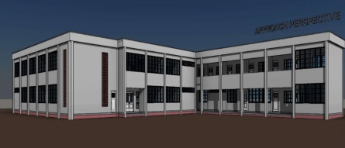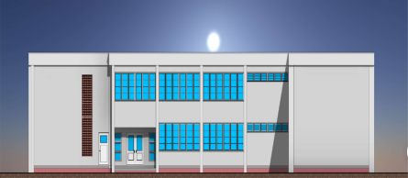

**AFRICA CENTRE OF EXCELLENCE FOR NEGLECTED**

**TROPICAL DISEASE AND FORENSIC**

**BIOTECHNOLOGY**

**(ACENTDFB)**

**Prepared by**

**ACENTDFB**

**ABU Zaria, Main Campus, Samaru**



**January 2023**

TABLEOFCONTENTS…………………………………………………………………...iv

LIST OF TABLES xxviii

LIST OF FIGURES xxviii

LIST OF PLATES xxviii

LIST OF ABBREVIATIONS AND ACRONYMS xxix

EXECUTIVE SUMMARY xxxi

CHAPTER ONE 1

INTRODUCTION 1

1.1 Background 1

1.2 Project Aims and Objectives 2

1.7 Applicable International, Federal, and State Laws and Regulations 6

1.8 Applicable World Bank Operational Safeguards Policies 8

CHAPTER TWO 12

RELEVANT DESIGN/CONSTRUCTION ACTIVITIES 12

2.0 Introduction 12

2.1 Project Design 12

2.1.1 Teaching Section 12

2.1.2 Administrative Section 12

2.1.3 Research Section 13

2.1.4 Design Consideration 13

2.1.5 Commissioning Laboratory Facilities 14

2.7 Project Location 14

2.7.1 General Description of the Proposed Project Site 14

2.7.1 Project Site Setting 16

2.8 Summary of activities to be undertaken during each of the project phases 17

2.9 Project Schedule 18

CHAPTER THREE 19

BIOPHYSICAL AND SOCIO ECONOMIC CHARATERISTICS 19

3.1 INTRODUCTION 19

3.1.1 Data Acquisition Methodology and Approach 19

3.2 Description of Biophysical Environment 20

*3.2.1.1 Ambient Air Temperature* 20

*3.2.1.2 Wind Speed and Direction* 21

*3.2.1.3* *Relative Humidity* 22

*3.2.1.4 Rainfall Pattern* 22

Figure 3.6: Average Annual Rainfall distribution from 1991 to 2021 (NIMET, 2022) 22

*3.2.2 Air quality and noise level within the proposed site* 22

3.4 Socio-Economic Environment 26

*3.4.1* *Population* 26

*3.4.2 Socio-economic Characteristics and Health Condition* 26

3.5.1 Gender Base Profile 26

3.5.2 Discussion of socioeconomics result 27

3.5.3 Vulnerable Groups 28

CHAPTER FOUR 30

4.0 POTENTIAL ADVERSE ENVIRONMENTAL AND SOCIAL IMPACTS 30

4.1 Introduction 30

**4.2** **Impact Identification** 30

4.3 Potential Social and Environmental Impacts 31

4.4 Impact Discussion 32

4.4.1 Beneficial Impacts 32

4.4.2 Adverse Impacts 33

CHAPTER FIVE 40

5.0 ENVIRONMENTAL SOCIAL MANAGEMENT AND MONITORING PLAN 40

5.1 Impact Mitigation Measures 40

5.2 GBV Risks and Management Measures 40

5.2.1 Measures taken to Mitigate GBV/SEA/SH Risks 40

5.3 Environmental and Social Management and Monitoring Plan 41

5.2 Roles and Responsibilities for ESMP Implementation 56

5.2. Roles and Responsibilities in Implementing the ESMP 56

5.3 General Health and Safety Procedures 57

5.4 Grievance Redress Process 58

5.4.1 Objective and Purpose of Grievance Redress Mechanism 58

5.4.2 Potential Grievances/Disputes 58

5.4.3 Redress Mechanism 58

5.3 Processing and Resolution of Grievances 59

5.6 Functions of the Grievance Redress Team/Committee 61

Capacity Building Plan 61

5.8 Estimated Costs to Implement the ESMP 62

CHAPTER SIX 63

6.0 STAKEHOLDER ENGAGEMENT 63

6.1 INTRODUCTION 63

6.1 Stakeholders Engagement Programme 64

6.2 Methodology for Community and Stakeholder Engagement 64

6.2.1 Instruments of Data Collection/Feedback Mechanism 64

6.3 Summary of the Consultation with Stakeholder 66

Conclusion and Recommendations 68

REFERENCES 69

Annex 1: Stakeholders Consultation Attendance Sheet 70

*Annex 2:* *Consultation programme Photos* 71

Annex 3: Assessment Instrument 72

Annex 4: Physiochemical and microbiological characteristics of soil of proposed site for 75

Annex 5: Physiochemical and Microorganism Characteristic of Water (Ground Water and Surface Water) Within the Proposed Site 76

Annex 6: Waste Management Plan 77

Annex 7: Traffic Management Plan 82

Annex 8: Security Plan 83

Annex 9: Occupational Health and Safety (OHS) 84

Annex 10: Code of Conduct 86

Annex 11: Employer’s ESHS Requirements for Works 93

LIST OF TABLES

Table 2.1 Gantt chart showing Project Schedule 18

Table 3.1: Summary of the baseline data collected during the fieldwork 19

Table 3.2: Air quality and noise level measurement within the proposed site 22

Table 3.3: Gender Base Profile for Study Community 26

Table 3.4: Demographic characteristic of the respondents in ABU Community 27

Table 4.1: Risk Assessment Matrix 31

Table 4. 2: Risk Matrix Explanation 31

Table 5.1: Potential Impact Mitigation and Monitoring 42

Table 5.2: Grievance Redress Committee Members 59

Table 5.3: Logbook Format 60

Table 5.4: Steps in Handling Grievances 60

5.4.3.1 Registration of Complaints 61

5.4.3.2 Determining and Implementing the Redress Action 61

5.4.3.3 Verifying the Redress Action 61

5.4.3.4 Monitoring and Evaluation 61

Table 5.5: Capacity Building Content 62

Table 5.6: Summary of ESMP Implementation Budget 63

Table 6.1: Instrument of data collection 64

Table 6.2: Instruments of Consultation/ Data Collection and Target Groups 65

Table 6.3: Summary of Consultation with Stakeholders 66

LIST OF FIGURES

Figure 1.1: ACENTDFB Organogram 11

Figure 2.1: Ground Floor Plan 12

Figure 2.2: First Floor Plan 13

Figure 2.3: Approach Perspective 14

Figure 3.4: Map of Kaduna State Showing Project LGA/ State 15

Figure 2.3: Typical Wind Rose for the Prevailing Direction of wind across the project area 21

LIST OF PLATES

Plate 2.1: Project Site 23

Plate 2.2: Project site showing consultant on site…………………………………………………….17

Plate 3.1: Vegetation in the study area……………………………………………………………….23

Plate 3.2: Samaru stream & Sassakawa parking lot Borehole…………………………………………33

Plate 3.3: Freshwater vegetation on Ganga Uku Seasonal Stream Consultant taking water sample 25

Plate 3.4: Consultation program and Site description at ABU, Zaria. 71

LIST OF ABBREVIATIONS AND ACRONYMS

ABU Ahmadu Bello University

ACE Africa Centre of Excellence

ACENTDFB Africa Centre of Excellence for Neglected Tropical Diseases and Forensic Biotechnology

AVP Available Phosphorus

BOD Biochemical Oxygen Demand

CO2 Carbon Dioxide

COD Chemical Oxygen Demand

DO Dissolve Oxygen

EA Environmental Audit

EIA Environmental Impact Assessment

EAs Environmental Assessment

ECEC Effective Cation Exchange Capacity

EPC Engineering Procurement and Construction

ERP Emergency Response Plan

ESA Environmental Safeguard Audit

ESIA Environmental and Social Impact Assessment

ESMF Environmental and Social Management Framework

ESMP Environmental and Social Management Plan

ESO Environmental Safeguard Officer.

ESP Exchange Sodium Percentage

EZ Electrical Conductivity

FEPA Federal Environmental Protection Agency

FGD Focus Group Discussion

FGN Federal Government of Nigeria

FMEnv Federal Ministry of Environment

FPIT Federal Project Implementation Unit

HEMP Hazard and Effect Management Process

GPS Global Positioning System

HSE Health, Safety and Environment

H2S Hydrogen Sulfide

IIF Incident and Injury Free

ISO International Safety Organization

KSG Kaduna State Government

KSEPA Kaduna State Environmental Protection Agency

KSURP Kaduna State Urban and Regional Planning

LF Lymphatic Filariasis

LGA Local Government Area

M & E Monitoring and Evaluation

MOU Memorandum of Understanding

NESREA National Environmental Standards and Regulations Enforcement Agency

NH2 Hydrazine

NO2 Nitrogen Dioxide

NTD Neglected Tropical Diseases

NIMET Nigerian Meteorological Agency

OP/BP Operational Policies / Bank Procedures

PG Post Graduate

FGD Focus Group Discussion

PIT Project Implementation Team

PPMSD Physical Planning and Municipal Services Development

PPE Personal Protective Equipment

PPP Public-Private Partnership

PMT Project Management Team

SDW Sanitary and Domestic Waste

SO2  Sulfur Dioxide

SSI Semi Structured Interviewed

TC Tropical Continental Air mass

TDS Total Dissolved Solid

TM Tropical Maritime Air mass

ToR Terms of Reference

TVOCs Total Volatile Organic Compounds

WB World Bank

IT’S World Health Organization

# EXECUTIVE SUMMARY

**ES1 INTRODUCTION**

Africa Higher Education Centre of Excellence (ACE) project was established in 2013 in collaboration with the World Bank (WB) to promote regional specialization among member universities in Africa. The centre has drawn on specialized departments and faculty in higher education institutions (universities) in West and Central Africa. The centre has successfully supported institutions and students across Africa through improved teaching and research conditions and scholarships. Nineteen Centers of Excellence were established in the West African regional, distributed across several countries which included Benin, Burkina Faso, Cameroon, Ghana, Nigeria, Senegal, The Gambia, and Togo. Ten (10) ACE Centre (Health (4), Agriculture (3) and STEM (3) were established in Nigeria.

Ahmadu Bello University Zaria was selected amongst the beneficiaries of the project in Nigeria. The Africa Center of Excellence for Neglected Tropical Diseases (NTDs) and Forensic Biotechnology in Ahmadu Bello University, Zaria” (ACENTDFB) is one of the ten ACE Centers in Nigeria. There are presently 17 African Centers of Excellence in Nigeria

The ACENTDFB initial focus areas of research are on three of the neglected tropical diseases, which were later expanded to include an additional three; **African trypanosomiasis**, **Lymphatic Filariasis (LF)**/**Onchocerciasis**, **Rabies.** Other diseases recently included**; Dengue fever**, **Schistosomiasis** and **Trachoma.**

It will also build capacity in forensic biotechnology for solving regional problems associated with criminal gangs, immigration issues, accident, and natural disasters.

Functional biochemistry and molecular biology laboratories working on each of the NTDs are available, but needed to be upgraded with additional equipment to assure excellence in research.

In collaboration with the World Bank, the Centre is to drive molecular Research and innovation on:

1. Novel standardized molecular diagnostic tools for the characterization of these parasites in their natural habitants which would be used to map the burden and distribution of pathogen in the region.
2. Developing and maintaining pathogen Samples and strain repositories.
3. To develop a vaccine development facility for innovative vaccination approaches on animal’s economic relevance and many more.
4. To construct a functional NTD laboratory and a Crime laboratory (Moot court).
5. To strategize for disposal laboratory and animal waste. (Generation, utilization and disposal of animal models in accordance as embodied in the Protocol on Protection and Welfare of Animals).
6. To conduct field work, this involves collection of disease vectors, isolation of clinical isolates of the disease-causing organisms, storage and disposal of the same.

The Centre is aimed at providing a reliable template to address problems of NTD and its impact on the socioeconomic development and health of the community in developing countries.

The Centre is proposing to construct a befitting accommodation for its staff to enable them perform effectively and efficiently.The proposed building project has been assessed to have potential adverse impacts that are site specific, limited in number, reversible and triggered environmental assessment policies of the World Bank (WB) OP/BP 4.01 and the ABU Physical Planning and Municipal Services Department. (PPMSD)

For effective management, monitoring and reporting of project related risks, ACENDFB, will develop and implement an Environmental and Social Management System during the lifecycle of the project. This will ensure close collaboration and support from the sponsors. These documents however serve as a safeguard tool to identity and mitigate every impact that may arise from the rehabilitation and construction activities.

**ES2 ESMP Objectives**

The overall objective of the ESMP is to ensure project compliance with applicable national environmental and social legal requirements and the World Bank’s environmental and social safeguards. Further, the ESMP aims to identify environmental and socio-economic benefits of the project as well as identifying potential adverse environmental and socio-economic impacts.

The ESMP document also describes measures to prevent, minimize, mitigate and or compensate for identified potential environmental and social impacts within the framework of Environmental, Occupational Health & Safety (OHS) and Community Health and Safety (Corporate Social Responsibility - CSR). It provides a logical framework within which identified negative environmental and socio– economic impacts can be mitigated and monitored. In addition, it assigns responsibilities of actions to various actors and provides a time-frame within which the mitigation measures and monitoring can be carried out.

**Applicable World Bank Operational Safeguards Policies**

Two of the World Bank Operational Safeguards Policies are triggered under this Project as described in table below

Applicable ESS and Applicability to ACENTDFB ABU Zaria Project

|  |  |  |
| --- | --- | --- |
| **Triggered Policy** | **Reason for Application of Standard to the Project** | **How it will be addressed by the project** |
| OP/BP4.01 Environmental Assessment | Proposed construction works will result in environmental and social impacts attributed to generation of waste, noise/air pollution, movement of heavy-duty vehicles & traffic issues, occupational health & safety risks, risks associated with labour influx, community health & safety risks amongst others. However, these impacts are limited, site specific and can be mitigated. | This ESMP contains measures to address the identified risks and includes other MSIPs like waste management plan, OHS plan, community health & safety plan amongst others. |
| OP/BP4.11 Cultural Physical Resources | During the excavation and earthworks, contractors may encounter physical and cultural resources such as artefacts, tombstones, historical/cultural landmarks | A Physical and Cultural Resources Management Plan has been included in annex 9 of this ESMP |

**ES3 BIOPHYSICAL AND SOCIO ECONOMIC CHARATERISTICS**

Baseline environmental assessments of the project area were conducted from the 11th _ 13th of April, 2022, 22th – 24th of April, 2022 and the 18th – 20th May, 2022 to determine the existing environmental condition (both natural and human environments) prior to the commencement of the project. The information/data on the environmental condition of the study area were acquired through desktop research and field visit. Materials that were consulted included reports on feasibility study of the proposed project site, previous environmental surveys in the area, publications, textbooks, maps etc.

Information was gathered during the stakeholder consultation and socio-economic baseline study undertaken within the University community. Information relating to the biophysical aspects of the site was captured through these interactions and details are also presented. The additional information gathered from the campus relates to ecosystem services and livelihood aspects within the study area.

**ES4 PROJECT LOCATION**

The proposed project will be located within the main Campus of the Ahmadu Bello University Zaria in between the Biotech Building and the Old Students Hostel, beside the foreign Students Hostel near the Sassakawa Parking Lot. The project site is located on Latitude 110 5’ 7” N, Longitude 70 43’ 11” E with elevation of 640m above sea level. Ahmadu Bello University Zaria is one of the largest educational institutions in Nigeria and Sub-Sahara Africa.

**ES5 PROJECT DESCRIPTION**

The design proposal consists of 2 offset, parallel rectangular wings housing the teaching section and the Research section respectively, connected by the administrative wing at the centre, linking the 2 through a central corridor. The teaching wing has the moot Court and the crime Scene on the ground floor. A store is provided close to the Crime Scene for storing materials and equipment. A courtyard is also close by, in case of outdoor crime scene. On the upper floor of this wing are accommodated the class rooms and staff room. There is a direct access to this wing without interference with the other wings.

**ES6 ADVERSE ENVIRONMENTAL AND SOCIAL IMPACT /MITIGATION MEASURES**

The potential and associated impacts of the proposed project were identified and evaluated using standard procedures. Various source references including past project experience, professional judgment and knowledge of both the project environment and project activities were used in the assessment. The associated and potential impacts of the proposed project as well as the proffered mitigations are summarized below.

Positive/Beneficial Impacts

* The proposed project is expected to be largely beneficial to the students and staff of the University, the Nation and the region at large, it is envisaged to increase enrolment of students for research and development amongst others.
* Short term employment will also be created for locals within the school and around the project location especially as unskilled workers.
* Presence of contractor workers will lead to Increase in revenue for petty traders of food, water etc. due to patronage.

Negative/Adverse Impacts

The proposed construction is within ABU Main campus. Some of the potential adverse impacts include:

* Risk of aquifer over-exploitation and pollution of ground water resources due to borehole drilling.
* Occupational health & safety risks from civil works and operation of machinery could lead to injuries, accidents for workers.
* Poor labour and working conditions could lead to ill-health, grievances, discrimination etc.
* Waste generated from construction activities such as cement, wood, iron rods etc. could lead to environmental pollution if poorly managed. This could also lead to public health concerns especially for the students
* Electrical and electronic wastes such as electrical wires, sockets etc. could lead to toxicity if poorly managed
* Risk of increased air and noise pollution, if Contractor harnesses water from the river for construction works, or discharges wastewater into the river/streams.
* Poor labour and working conditions could lead to ill-health, grievances, discrimination etc.

**ES7: ENVIRONMENTAL SOCIAL MANAGEMENT AND MONITORING PLAN**

As part of this ESMP, a project specific E&S management and monitoring plan has been designed. The environmental and social management and monitoring plan for matrix presents site-specific mitigation measures for potential negative impacts of the project. The matrix also presents the plan for monitoring compliance, defines the costs for mitigation and monitoring, frequency of monitoring, parameters to be monitored, and responsibilities for mitigation and monitoring. Additionally, training programs to enhance capacity as well as budget estimates to ensure implementation. Most of the mitigation measures are the obligation of the Contractor. Consequently, the project team will provide the ESMP to the selected contractor to guide the preparation of their bids taking into account the mitigation measures and associated costs in this ESMP and other provisions and guidance as provided therein.

The summary of the cost for the implementation of the ESMP is presented in the Table 1 below. The total costs of the ESMP including costs for mitigation and monitoring and capacity building is estimated as: Ten Million, Three Hundred and Twenty-Nine Thousand Naira (₦10,329,000.00.00) only.

|  |  |  |  |
| --- | --- | --- | --- |
| **S/N** | **Item** | **Responsibility** | **Estimated Cost (NGN)** |
| 1 | Mitigation | Contractor / PIU (Project) | 6,110,000 |
| 2 | Monitoring | ACENTDFB Project, MDAs | 930,000 |
| 3 | Capacity Building | ACENTDFB Project, Contractor, GRCs, DPPW&S, FMU | 500,000 |
| 4 | Disclosure Costs | PIU | 1,850,000 |
| 5 | **Sub Total** | | 9,390,000.00 |
| 6 | Contingency (10%) | | 9390,000 |
| 7 | **Total Budget** | | 10,329,000.00 |

**Grievance Redress Mechanism (GRM)**

The project is in an established institution which already has mechanisms in place for grievance redress and will be built on by the project, specifically, complaint form is provided on the ACENTDFB website <https://acentdfb.abu.edu.ng/>, designated phone number will be provided by the project, Grievance Redress Committees at the project and management level. Ultimately, the project will ensure all grievances received are addressed timely and efficiently. A standalone procedure for responding to allegations of GBV/sexual exploitation and abuse (SEA)/ sexual harassment (SH) has been established which adopts the Survivor’s centered approach and confidentiality.

**ES 8: Stakeholder Consultation**

Stakeholder consultation process took place on 22nd – 24th April, 2022 in the project area of influence. Continuous consultations should be held with project stakeholders throughout the lifecycle of the project to keep them informed and provide an avenue to receive suggestions and complaints.

**CONCLUSION**

The project has short term and low cumulative impacts on the environment. The proposed development project explains the various economic and social benefits not only to the local communities within the project area, but to the entire nation as a whole, particularly in supporting international research and bringing foreign exchange to the educational and economic sector respectively. The negative environmental impacts that have been identified and are associated with the implementation of this project are minimal and could be addressed by implementing the mitigation measures proposed to ensure that they pose no threat to the environment and to the community. These measures are part of the projects’ component and will bring no added cost in the implementation process.

In addition to assessing operational aspects and monitoring, assessments shall also consider compliance with agreed objectives and targets, and the effectiveness of the ESMP and its implementation programs. The ESMP shall, therefore, be subject to ongoing review and development to ensure that it remains appropriate for all aspects of the project.

# CHAPTER ONE

# INTRODUCTION

## Background

Africa Higher Education Centre of Excellence (ACE) project was established in 2013 in collaboration with the World Bank (WB) to promote regional specialization among member universities in Africa. The centre has drawn on specialized departments and faculty in higher education institutions (universities) in West and Central Africa. The centre has successfully supported institutions and students across Africa through improved teaching and research conditions and scholarships. Nineteen Centers of Excellence were established in the West African regional, distributed across several countries which included Benin, Burkina Faso, Cameroon, Ghana, Nigeria, Senegal, The Gambia, and Togo. Ten (10) ACE Centre (Health (4), Agriculture (3) and STEM (3)) were established in Nigeria.

The World Bank in collaboration with the project is focusing on strengthening 22 existing institutions in West Africa. The investment is around US$8million per institutions. The 22 Centre’s were completely selected using criteria bench marked on the best international practice and pursuing same goals. Their goals however, is to strengthen post graduate programs for regional students’ body and offer specialized causes for industrialized professionals in the region. To establish a regional faculty body, improve their facility and attract additional top-level faculty. To provide good learning resource laboratories and minor rehabilitation of existing facilities, and to establish linkages with companies, government agencies and research Centre’s for work. Other goals are to place learning input into the curricular, consultancies and join research.

Ahmadu Bello University Zaria was selected amongst the beneficiaries of the project in Nigeria. The Africa Center of Excellence for Neglected Tropical Diseases (NTDs) and Forensic Biotechnology in Ahmadu Bello University, Zaria” (ACENTDFB) is one of the ten ACE Centers in Nigeria. There are presently 17 African Centers of Excellence in Nigeria

The ACENTDFB initial focus areas of research are on three of the neglected tropical diseases, which were later expanded to include an additional three; **African trypanosomiasis**, **Lymphatic Filariasis (LF)**/**Onchocerciasis**, **Rabies.** Other diseases recently included**; Dengue fever**, **Schistosomiasis** and **Trachoma.**

**1.1.1 Project Components and Objectives**

**Component 1:** Establishing new Africa Centres of Excellence and scaling up well-performing existing Africa Centres of Excellence (ACE) for development impact. This component aims to build and strengthen the capacity of competitively selected ACE Impact centres based in higher education institutions across West and Central Africa.

* Sub-component 1.1 will establish new centers of excellence for skills and knowledge for development challenges. About 30 centers will be competitively selected based on pre-established selection criteria to receive funding from ACE Impact Project.
* Sub-component 1.2: Scaling up well-performing ACEs: This sub-component will provide additional funding and support to approximately 12 existing ACEs (currently supported through ACE I) to enable them to scale-up their activities.
* Sub-component 1.3 Additional support to the best Engineering and Technology ACE institutions: Institutions will be selected to host an engineering and technology-focused ACE Impact center with capacity in other engineering and technology disciplines.

**Component 2:** Regional Partnerships and Scholarships. Component 2 seeks to expand the regional scope of impact of the ACEs funded under Component 1 by providing demand-side funding for partnering institutions and regional students to buy the training and services from the ACEs that are most relevant:

* Sub-component 2.1 will support regional institutional partnerships between higher education institutions and the ACEs (under component 1 of the proposed project) to strengthen the capacity of the higher education institutions.
* Sub-component 2.2 will finance two types of regional scholarships to support primarily the training of the next generation of faculty for higher education institutions in the region.

**Component 3:** Enhancing Regional Policy making, Monitoring, and Facilitation. Component 3 will support regional policy making for higher education and regional project monitoring and facilitation. Component 3 will fund, through a Regional IDA grant of US$10 million to the Association of African Universities (AAU), the facilitation of the ACE Impact project’s regional activities and support to centres under the project.

The **Project Development Objective** of the ACE II Project is to improve the quality, quantity and development impact of postgraduate education in selected universities through regional specialization and collaboration.

The Africa Center of Excellence for Neglected Tropical Diseases (NTDs) and Forensic Biotechnology (ACENTDFB) in Ahmadu Bello University, Zaria is one of the of the beneficiaries of ACE Centre’s in Nigeria and Africa.

The ACENTDFB initial focus areas of research were on three of the neglected tropical diseases, which were later expanded to include an additional three. African trypanosomiasis, Lymphatic Filariasis (LF)/Onchocerciasis, Rabies, Dengue fever, Schistosomiasis and Trachoma

1.2 Project Aims and Objectives

The Centre is aimed at providing a reliable template to address problems of NTD and its impact on the socioeconomic development and health of the community in developing countries.

It will also build capacity in forensic biotechnology for solving regional problems associated with criminal gangs, immigration issues, accident, and natural disasters.

Functional biochemistry and molecular biology laboratories working on each of the NTDs are available, but needed to be upgraded with additional equipment to assure excellence in research.

In collaboration with the World Bank, the Centre is to drive molecular Research and innovation on:

* Novel standardized molecular diagnostic tools for the characterization of these parasites in their natural habitants which would be used to map the burden and distribution of pathogen in the region.
* Developing and maintaining pathogen Samples and strain repositories.
* To develop a vaccine development facility for innovative vaccination approaches on animal’s economic relevance and many more.
* To construct a functional NTD laboratory and a Crime laboratory (Moot court).
* To strategize for disposal laboratory and animal waste. (Generation, utilization and disposal of animal models in accordance as embodied in the Protocol on Protection and Welfare of Animals).
* To conduct field work which involves collection of disease vectors, isolation of clinical isolates of the disease-causing organisms, storage and disposal of the same.

**1.3 Rationale for ESMP**

The proposed building project will involve construction activities that can cause negative environmental and social impacts due to the nature of works. Some of the potential negative impacts that would arise during the construction works will include: generation of hazardous and non-hazardous wastes, noise/air pollution, accident from movement of equipment and materials to site, occupational health & safety risks, risks associated with labour influx (security threat, gender-based violence (GBV) in particular Sexual Exploitation and Abuse due to labour influx, increase in STIs/STDs), grievance, among others.

The proposed sub- project has been classified under category ‘’B’’ project of the Nigeria EIA Act and assessed to have potential adverse impacts that are site specific, limited in number, reversible and triggered environmental assessment policies of the World Bank (WB) OP/BP4.01 and OP/BP4.11Cultural/Physical Resources. The ACENTDFB has engaged the services of Environmental Consultant with an experience in national and international legislations to carry out the ESMP studies to identify potential environmental and social impacts and mitigation measures required to implement these projects.

The Centre has contracted Messer Structed Nigeria Limited a civil and building engineering company to carry out the construction project in line with best standards and practice. The company is ready to provide its client with professional service to complete their project safely, on time, on budget and with high quality standard. The ESMP is to be utilized by the contractors, commissioned by ACENTDFB for the sub-projects, and will form the basis of site-specific management plans that will be prepared by the contractors as part of their construction methodology prior to works commencing.

As the proponent for the sub-projects, it is our objective to avoid, where practical, unacceptable adverse environmental, social and/or economic impacts. In the circumstance that an impact cannot be avoided, Project Implementing Unit and Project Management (who will be responsible for the management of the project) are committed to the implementation of appropriate mitigation measures. For clarity in the management structure, Project Management will consult PIU on matters relating to environmental health and safety performance. Project Management will however, have overall responsibility for planning, implementation, monitoring and enforcement of activities associated with this ESMP, while the World Bank will periodically visit to ensure the proper use of the facility and sustainability of the project. The Association of African University Association (AAU) will continue with its role for providing a forum for cooperation and exchange of information on higher education and research policies to ensuring quality assurance in the formulation of the ESMP.

After several options were analyzed, the decision to embark on the project is to increase the accessibility and capacity of the people to research and development in neglected tropical diseases and forensic biotechnology. This option is therefore considered the most viable and recommended for implementation.

**1.4 ESMP Objectives**

* To assess the impact of the sub-projects to environment, human health and safety, physical cultural issues. The ESMP shall identify the risk early before commencement of the sub- projects with the view of mitigating against such issues.
* The ESMP shall provide cultural guide lines to avoid any adverse impacts these sub-projects will have on the surrounding areas of the university.
* Describe the measures required to implement the activities of the sub-projects, related management and mitigation commitments;
* Describe specific additional measures required to implement contract related international best practices, and approval conditions stipulated by the World Bank’s safeguard policies, Nigeria’s Federal Ministry of Environment and NESREA requirements;
* Identify the roles and responsibilities of the environmental and social management stakeholders of the project; and
* Communicate the environmental and social expectations and requirements throughout the project tenure.

While all contractors and sub-contractors shall comply with, and apply the ESMP requirements as applicable to the tasks they are employed to undertake, some of the measures and procedures outlined in this proposal are commitments made by Project Management of ACENTDFB, and therefore remain responsible for their implementation. It should however be recognized that practical implementation of many of the measures may rest with contractors and sub-contractors and consequently, ACENTDFB will require the implementation of a robust review/audit program, as may be described in the proposed ESMP, to measure and ensure that they are executed on their behalf appropriately.

The Environmental and Social Management Plan (ESMP) provides a logical framework within which identified negative environmental and socio–economic impacts can be mitigated and monitored. In addition, the ESMP assigns responsibilities of actions to various actors and provides a timeframe within which mitigation measures and monitoring can be done.

The ESMP covers information on the management and/or mitigation measures that will be taken into consideration to address impacts in respect of the project life cycle.

Mitigation measures proposed in the ESMP are designed to bring the project into full compliance with pertinent national laws and regulations as well as World Bank safeguard operational policies, and IFC Environmental Health and Safety guidelines. These Guidelines cover the following elements:

* Environment
* Occupational Health and Safety
* Community Health and Safety (Corporate social Responsibility)

World Bank Operational policies are designed to ensure that World Bank-financed projects are environmentally and socially sound and sustainable, and that potential negative environmental impacts are avoided wherever possible, and/or mitigated.

**1.5 Methodology/Approach**

The Consultant and the Safeguards Team of PMT (ACENTDFB) - to the extent possible – identified and compiled the readily available technical data and information concerning the project elements and the project areas. In addition, site visits and investigations, including interviews and discussions, have been conducted to allow preparing the ESMP with the least uncertainties.

Baseline surveys were performed in order to assess the existing conditions at the project site. In preparing the Environmental and Social Impact Assessment, the PMU considered the following standards, regulations, and laws to ensure full compliance with the National and International laws and regulations. Data collection for the baseline studies are presented in Table 3.1. annex 10

**1.6 Scope of the ESMP**

The scope of services undertaken by the Consultant included the preparation of the ESMP with the aim to define and reach requirements of the project sponsors and local environmental regulations regarding the following:

* Beneficial and Adverse Impacts
* Mitigation and enhancement programs
* Monitoring programs
* Consultations
* Complementary initiatives
* Responsibilities and institutional arrangements
* Estimated costs
* Implementation schedules and reporting

## 1.7 Applicable International, Federal, and State Laws and Regulations

The national and state level legal framework relevant to the project is presented in the table 3 below.

Table 2: National and State level legal framework relevant for the Assignment

| **Regulatory Framework** | **Description** | **Project Compliance** |
| --- | --- | --- |
| National Policy on the Environment, 1989. Revised 2016 | The policy identifies key sectors requiring integration of environmental concerns and sustainability with development and presents their specific guidelines | ACENTDFB will abide by the provisions and processes of the National Environmental Policy which ensures environmental protection and sustainability of projects |
| Environmental Impact Assessment (EIA) Act CAP E12 LFN 2004 | The Environmental Impact Assessment (EIA) Act CAP E12 LFN 2004 provides guidelines for activities of development projects for which EIA is mandatory in Nigeria. According to the act, category II projects such as the ACENTDFB requires only a partial EIA/EMP, which will focus on mitigation and Environmental planning measures, | An ESMF was prepared for ACE to provide a framework to address environmental and social concerns under the project in compliance with the World Bank’s OP 4.01 Environmental Assessment.  This ESMP has been prepared in compliance with the World Bank’s Operational Policies and the Nigerian EIA law, as a site-specific management and mitigation plan to address potential negative impacts. |
| National Environmental (Sanitation and Wastes Control) Regulations (2009) | The purpose of the Regulation is the adoption of sustainable and environment friendly practices in environmental sanitation and waste management to minimize pollution. The Instrument amongst others makes provisions for the control of solid wastes and hazardous wastes. | A waste management plan including categories of the project waste, management plan including costs and responsibilities is included in the ESMP. |
| National Environmental (Soil Erosion & Flood Control) Regulations (S.I. 12) 2011 | The purpose of these Regulations is to establish technically feasible and economically reasonable standards and procedures to achieve appropriate level of management and conservation practices to abate soil erosion, siltation and sedimentation of the waters of Nigeria, due to soil erosion and flood aggravated by non-agricultural earth-disturbing activities. | Measures to avoid/minimize such practices are contained in the ESMP including reclamation of borrow pits and recommendation for proper termination of drainage & culverts in the engineering designs. |
| National Environmental (Air Quality Control) Regulations, 2014 | Includes recommended measures to prevent, minimize, and control air emissions from combustion processes fueled by gaseous, liquid and solid fossil fuels designed to deliver electrical or mechanical power, steam, heat, or any combination of these, regardless of the fuel type, and stipulates limits for various parameters | Measures to avoid/minimize such impacts are contained in the ESMP including all vehicles are serviced; undergo vehicle emission testing (VET) and vehicle exhaust screening (VES), use fuel efficiency techniques, catalytic converters etc. on machinery |
| National Environmental (Noise Standards and Control) Regulations, 2009 | The objective of the Regulations is to ensure maintenance of a healthy environment for all people in Nigeria, the tranquility of their surroundings and their psychological wellbeing by regulating noise levels. The Instrument prescribes maximum permissible noise levels for construction as 60dB (A) and 40dB(A) for day and night respectively | Measures to avoid/minimize noise pollution are contained in the ESMP including retrofitting of heavy equipment, provision of ear plugs to workers and limiting of project activities to work hours to avoid disturbing rest periods |
| National Environmental (Construction Sector) Regulations (S.I No. 19), 2011 | The purpose of these regulations is to prevent and minimize pollution from construction, decommissioning and demolition activities in the Nigerian environment. It stipulates that new project in the construction sector shall apply cost-effective, up-to-date, efficient, best available technology, to minimize pollution to the barest degree practicable. In addition, every operator or facility shall carry out an EIA and submit an EMP for new projects or modification including expansion of existing ones before commencement of activity. | The preparation of this ESMP is in compliance to this National regulation. Furthermore, pollution risks have been identified and mitigation measures duly factored |
| National Policy on Occupational Safety and Health, revised 2020 | This policy was approved by the Federal Executive Council (FEC) in September 2020. It provides a guide for voluntary compliance and serves as a basis for occupational health and safety programs for workers even under such development projects | An OHS Plan has been provided in the ESMP. In addition, the contractor will submit an HSE plan to the PIU as part of contract documents. |
| Workers Compensation Act (2010) | The Workmen’s Compensation Act makes provisions for the payment of compensation to workmen for injuries suffered in the course of their employment | The PIU will ensure that labour management is in line with the requirements of this law. As will be monitored by the environmental & safeguards officer |
| Kaduna State Environmental Protection Law | Facilitate protection, restoration, conservation, development and management of the environment and natural resources for equitable, sustainable socio-economic development. | The Kaduna State Environmental Protection Agency (KASEPA) will have oversight function for waste management and periodic monitoring of environmental parameters as stated in the ESMP monitoring table. |
| The Violence Against Persons Prohibition (VAPP) ACT 2015) | This act prohibits all forms of violence against private and public life and provides maximum protection and effective remedies for victims and punishment of offenders. Nigeria’s national government has taken steps to penalize and address GBV and SEA. | ABU MAIN CAMPUS ACENTDFB will adopt the ACENTDFB Sexual Harassment (SH) Policy to conform with this requirement |
| National Gender Policy (2006) | Provides a framework for ensuring gender inclusion and sensitivity in developmental plans and programs at the national and sub-national levels. | ACENTDFB through the environmental and safeguard officer will ensure that there is gender consideration in every phase of the project |
| National Inclusive Education Policy (2001) | This national policy provides that education must be inclusive for all children including those with disabilities. Children with disabilities have the right to qualitative, functional and effective basic education. The policy ensures that systems and strategies are modified to provide a barrier free environment for all learners with disabilities. | RAMPs are provided in the project design to allow for access for PWD. |
| Sexual Harassment (SH) Policy | The policy is dedicated to enlightening its public on the evils of sexual harassment and other associated anti - social conduct Sexual harassment has very grave effects on the overall productivity of staff and students in the university | The ACENTDFB project will adopt this policy in prevention of SEA/SH/GBV on the project |
| Policy for Students with Special Needs | The policy is awaiting its final stage before it becomes effective as a working document of the ABU MAIN CAMPUS. | The ACENTDFB project will adopt this policy in ensuring inclusion, as is demonstrated in the provision of access ramps for PLWDs in the project design |

## 1.8 Applicable World Bank Operational Safeguards Policies

Two of the World Bank Operational Safeguards Policies are triggered under this Project as described in table 4 below

Table 3: Applicable ESS and Applicability to ABU MAIN CAMPUS ACENTDFB Project

|  |  |  |
| --- | --- | --- |
| **Triggered Policy** | **Reason for Application of Standard to the Project** | **How it will be addressed by the project** |
| OP/BP4.01 Environmental Assessment | Proposed construction works will result in environmental and social impacts attributed to generation of waste, noise/air pollution, movement of heavy-duty vehicles & traffic issues, occupational health & safety risks, risks associated with labour influx, community health & safety risks amongst others. However, these impacts are limited, site specific and can be mitigated. | This ESMP contains measures to address the identified risks and includes other MSIPs like waste management plan, OHS plan, community health & safety plan amongst others. |
| OP/BP4.11 Cultural Physical Resources | During the excavation and earthworks, contractors may encounter physical and cultural resources such as artefacts, tombstones, historical/cultural landmarks | A Physical and Cultural Resources Management Plan has been included in annex 9 of this ESMP |

It is a requisite by the World Bank that Investments which it finances comply with the host country’s national standards as well as other relevant International environmental and social policies. In addition to Nigerian legislations, the Project should address World Bank operational policy regarding environmental and social issues as it covers the requirements of many of the financing institutions.

When the host country’s regulations differ from the levels and measures presented in the World Bank operation policies, projects will be required to achieve whichever is more stringent. This also applies if there are differences between Federal and State standards, the sterner standard must be followed.

**1.9 Institutional Arrangements for Environmental and Social Management**

ACENTDFB being the project developer will take full responsibility of implementation of the project. However, there are statutory bodies mandated by law to protect the environment and human health at both federal and state levels. These institutions are expected to play vital roles in the implementation of environmental and social management plan for the proposed Construction. The Federal Ministry of Environment is the competent authority charged with the responsibility of ensuring that all developmental projects are carried out in compliance with relevant environmental laws and regulations in order to ensure sustainable development. The National Environmental Standards and Regulations Enforcement Agency (NESREA) is responsible for enforcing all environmental laws, guidelines, policies, standards and regulations in Nigeria.

The Project implementation Organogram defining the line of Communication in the Centre and the proposed Sub Project is as highlighted below:

**Table 1.2 ESMP IMPLEMENTATION RESPONSIBILITIES**

|  |  |  |
| --- | --- | --- |
| IMPLEMENTING OFFICES | DURING PROJECT | AFTER PROJECT |
| ACENTDFB / Consultant | * Policy formulating * Management support and implementation * Training and capacity building | * Policy formulation and enforcement of   implementation   * Training and capacity building |
| PMT / PIU | Training and capacity building |  |
| PM / PMT/ESO | * Monitoring and enforcement * Reporting |  |
| Safeguard Officer/HSE | Enforcement and Reporting | Enforcement, Implementation and Reporting |
| Sub Project | Implementation and Reporting | Implementation and Reporting |
|  |  |  |

**1.10 ESMP Structure**

The ESMP Report is organized according to the ToR standard outline below:

Though there were few modifications made in the chapters as a result of some exigencies that occurred in the course of study to achieve our basic goals.

* Executive Summary
* Introduction (Chapter One)
* Relevant Design/Construction Activities (Chapter Two)
* Biophysical and Socio-Economic Characteristics (Chapter Three)
* Potential Adverse Environmental and Social Impacts (Chapter Four)
* Environmental and Social Management Plan (ESMP) (Chapter Five)
* Stakeholders Engagement (Chapter Six)
* Annexes

**Vice Chancellor**

**Project Coordinator**

**Centre Leader**

**Deputy Centre Leader**

**PI (Rabies, Dengue)**

**PI (LF, Trachoma, Schistosomiaisis)**

**PI, Trypanosomiasis**

**PI (Forensic Science)**

**Procurement Officer**

**Project Accountant**

**Project Auditor**

**PG Teaching Coordinator**

**Head, Dept of Biochemistry**

**Director, CBRT**

**M & E Officer**

**Industry Relation Officer**

**Research Units**

**Administration Unit**

**Finance Unit**

**PG Biotechnology Coordinator**

**ICT Officer**

**Capacity Building Unit**

**Safeguard Officer**

**International Scientific Advisory Board**

**Industrial Advisory Board**

**Comm. Officer**

##### Fig 1.1 ACENTDFB Organogram

# CHAPTER TWO

# RELEVANT DESIGN/CONSTRUCTION ACTIVITIES

2.0 Introduction

Africa Centre of Excellence for Neglected Tropical Disease and Forensic Biotechnology (ACENTDFB) is located at Ahmadu Bello University, Main Campus Samaru, and Zaria. Since inception almost a decade ago, its activities and contributions have become so important that there is need to provide working accommodations that are appropriate and fit for the staff, research, teaching and community engagement. The accommodation comprises of Administration, Teaching section and the Research section with standard ancillary facilities to accommodate staff and students’ day to day activities.

2.1 Project Design

The ACENTDFB project will involve the following activities for the Forensic Laboratories and Administrative Offices

* Construction of new buildingto accommodate NTDFB Laboratories that will enhance transformation of Forensic education, research and development;
* Procure equipmentfor the Forensic Laboratories;
* Install equipment needed in the Administrative Offices;
* Procure and install wired/wireless facilities;
* Procure teaching equipment *and*
* Procure and install inverters systems for the ACENTDFB project

# 2.1.1 Teaching Section

The design proposal consists of 2 offset, parallel rectangular wings housing the teaching section and the Research section respectively, connected by the administrative wing at the Centre, linking the 2 through a central corridor. The teaching wing has the moot Court and the crime Scene on the ground floor. A store is provided close to the Crime Scene for storing materials and equipment. A courtyard is also close by, in case of outdoor crime scene. On the upper floor of this wing are accommodated the class rooms and staff room. There is a direct access to this wing without interference with the other wings.

# 2.1.2 Administrative Section

The administrative wing houses the offices of the Centre Leader, Deputy Centre Leader, Administrative Secretary, Communication and ICT Offices and the Board Room on the upper floor, the ground floor and first floor respectively. All other officers are housed on the ground floor. This wing also has an independent access, which is the main entrance of the complex.

# 2.1.3 Research Section

The research wing has the Laboratories on the ground floor close to the evidence room and the laboratory manager, and easily accessible for evidence delivery. The upper floor houses the offices for the various categories of researchers as well as a conference room.

The administrative and research sections form a courtyard that provides parking lots for staff and visitors, while the teaching section, which requires some degree of privacy. The form of the building is such that it can grow and expand to accommodate fore needs without

Constraints. Ref. fig. 2.1, 2.2, 2.3.

# 2.1.4 Design Consideration

**Vulnerability Consideration:** The design proposes ramps into and within the building, leading to all levels from the ground level (see Figures 2.1 & 2.2 above). Generally, the layout is designed to reduce point-to-point movement time, which is favorable to persons with disability (PLWDs) who may experience physical stress and exhaustion from longer travel time between operation points. Furthermore, the floors are designed in levels, which reduces the point-to-point movement time compared to conventional floor designs (see Figure 1 above). Additionally, the design provides special toilets for PLWDs with larger toilet spaces, lower wash-hand basin, marked floor tiles for visually impaired, adequate lightening on stairs, bigger doors, supporting rails, and other supporting accessories for ease of use for PLWDs.

**Drainage and Waste Management:** The design proposes both surface and underground drainage systems that will terminate into the existing drainage layout of the ABU Master Plan and will eventually be terminated into the central sewage system of the city. It is noteworthy that the existing ABU premises has drainage systems which the drainages to be provided for the ACENTDFB Centre will be linked to. The drainage design and direction leverage on the natural gradient of the proposed construction site, with a gentle slope NW of the site. Generally, waste management is the responsibility of the waste management arm of the PPMSD of ABU. The school initially has a central sewage system designed to for all sewage lines. Designated central waste collection point where waste is collected on weekly bases by the ABU Municipal Services Unit of PPMSD. However, waste collection bins will be provided within the Centre for collecting wastes.

**Design for Fire management and response:** The design proposes installation of fire extinguishers at specific and easily accessible positions of the building, installation of smoke detectors, and sprinkler system.

**Drilling of Borehole:** The source of water for the Centre is proposed to be primarily from a borehole which will be drilled for the Centre within the proposed site. The geophysical survey for drilling the boreholes for the nearby postgraduate hostels and Biochemistry Department reported that the depth is approximately 100 m depth Hence, the depth of drill for the proposed borehole for the ACENTDFB Centre may be about 120 m, but for a good and sustainable result a geophysical survey is recommended before and drilling. Additionally, the design proposes accessories for water supply into the Centre including an overhead water storage tank and reticulation.

**Source of Electricity:** The Centre proposed primary source of electricity is to link to the National grid (PHCN) and diesel-powered generator. The Centre is envisaged to have significantly high energy demand and consumption rate due to the functionalities of the proposed Centre with Laboratory Services. This necessitates the need for a stable and hybrid energy source for the Centre. However, a mini solar power arrangement is proposed for the Centre as to achieve its aims and objectives.

# 2.1.5 Commissioning Laboratory Facilities

As mentioned above, lab commissioning serves several purposes in building a laboratory, and as such, it entails many different tasks, actions and processes. Laboratory commissioning practices and underpinnings include:

* **Thorough technical documentation** to prevent communication errors and provide a single resource for construction and building requirements. Documentation should cover facility design, purpose, equipment operation, testing, checkup processes, maintenance, safety procedures and any other information critical to the operation of the lab.
* **Ongoing testing** through all stages of construction so the finished facility will meet the required specifications. By testing throughout the building process and not just at the end, lab management and builders will be able to identify and address any potential questions, problems or other issues with the proper construction of the lab.
* **Open communication**so specifications are clear to builders, and facility owners or managers are aware of any issues as soon as they arise.
* **Performance verification** of all critical equipment, especially the types required to meet specific regulations such as biosafety level requirements. Areas and equipment to verify include containment hoods and cabinets, airflow and ventilation systems, filters, doors, work surfaces, PPE availability and more.
* **Proper infrastructure and signage** such as self-closing, lockable doors; safety signs including PPE requirements and sharps warnings; fire and emergency procedures; egress methods; occupancy limits; eye wash and shower locations and more.
* **Implementation of — and adherence to — ongoing testing** to ensure that the facility continues to operate in accordance with required specifications, regulations and safety practices.
* **Certification** to maintain compliance with all safety and audit requirements for the type of work being performed.

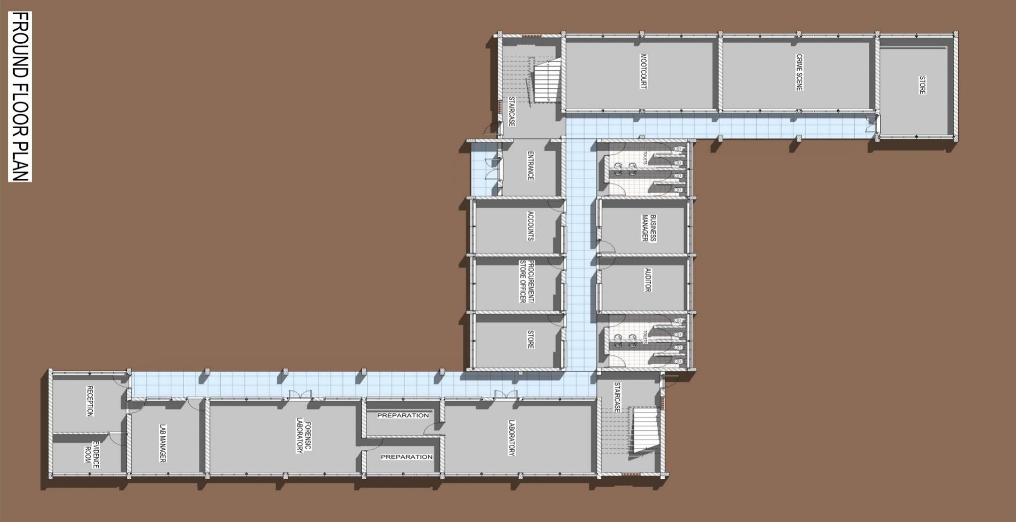

##### Figure 2.1: Ground Floor Plan

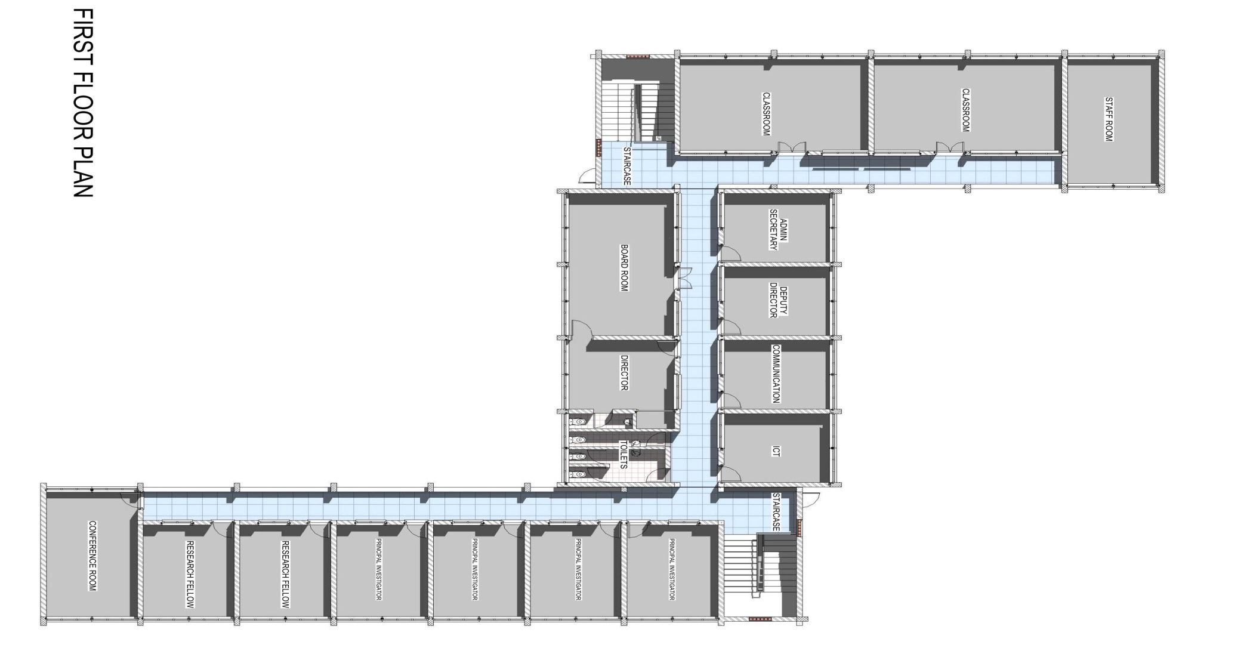

##### Figure 2.2: First Floor Plan

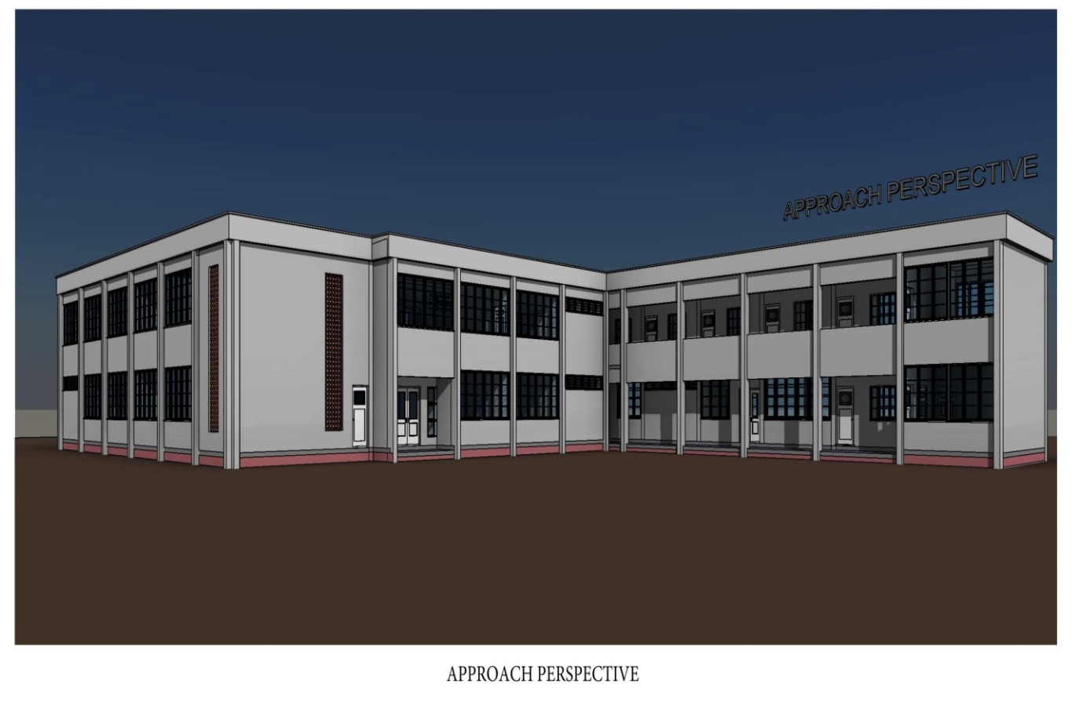

##### Figure 2.3: Approach Perspective

2.7 Project Location

The project will be located within the main Campus of the Ahmadu Bello University Zaria in between the Biochemistry and NTD Building and behind the foreign Students Hostel near the Sassakawa Parking Lot. The project site is located on Latitude 110 5’ 7” N, Longitude 70 43’ 11” E with elevation of 640m above sea level. Ahmadu Bello University Zaria is one of the largest educational institutions in Nigeria also in Africa.

The closest building to the proposed site, 100 m from the proposed site is NTD Centre, on the left side of the proposed. The ACENTDFB shares common entrance into all the University main campus gates at Samaru. The ABU main campus entrance gate is located about 500 m from the T-junction Zaria to Kano road. There are three access routes into the school campus. There are no alternative routes into the campus.

## 2.7.1 General Description of the Proposed Project Site

The proposed construction site is a virgin land NW of the university Master Plan. . It sits on a flat level land free from any encumbrances. The soil type is sandy-clay, with minor vegetation cover that have been cleared during this study as the weeds and grasses are not grown, but eucalyptus trees and other economic trees visibly seen on the land. The land has a gentle slope in the NW direction to the Gangauku Stream. The Figure 2.4 below shows the aerial view of the construction site with vegetation cover and structures.

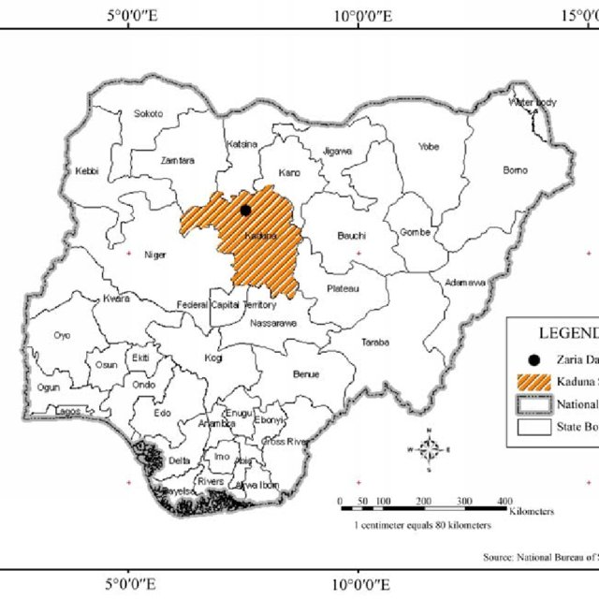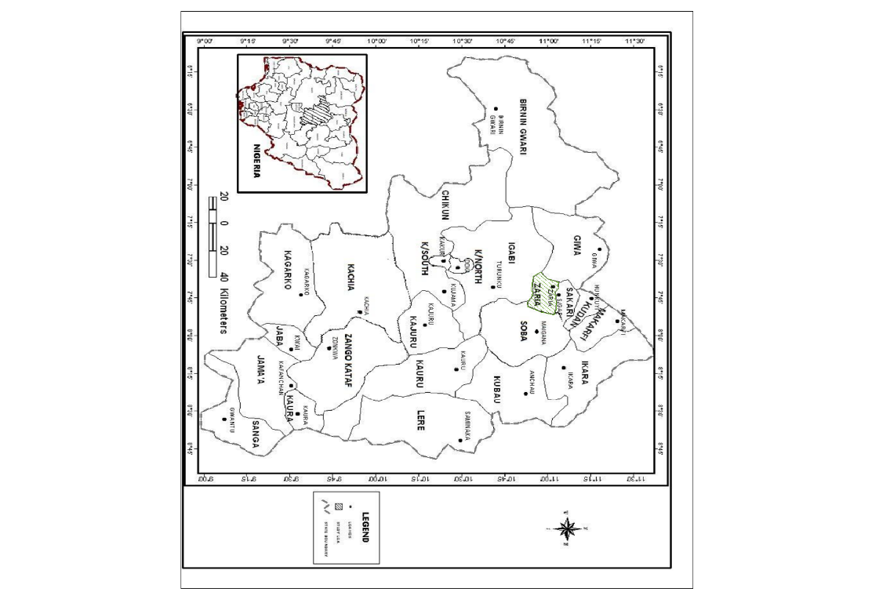

Map of Nigeria showing Kaduna State Map of Kaduna showing Zaria local government area

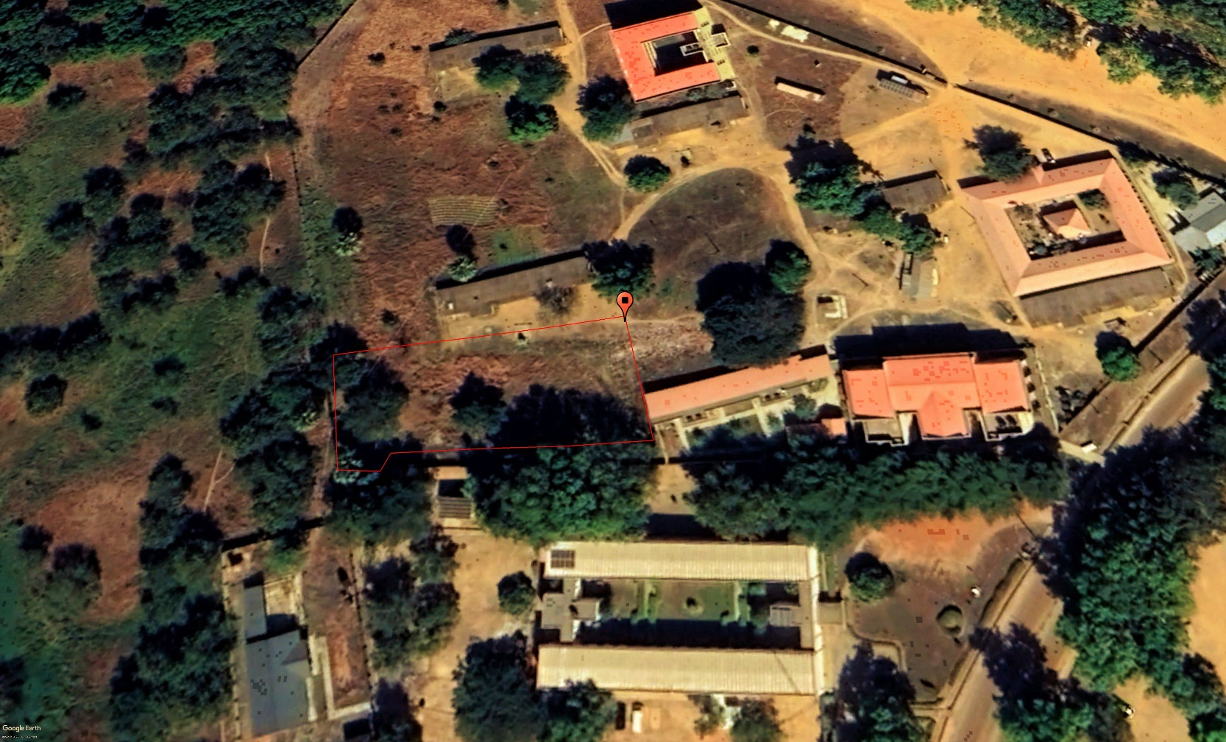

Aerial map showing study location, ABU Zaria, April, 2022

##### Figure 2.4: Map of Nigeria Showing Zaria, Project Location

2.7.1 Project Site Setting

The proposed project site was allocated by the University Authority, following a transparent consultation and stakeholders’ engagements. All necessary documentations for the allocation of this land have been concluded.

ACENTDFB followed the requirements as provided by the international sponsor (WB) during the selection of the site with due consideration to feasible project design in order to avoid any encumbrances. At the project location, the site for the construction covers a land area of approximately 1,800 square meters. The site is selected for ease of intervening opportunities, on fallow vegetation, open space and unoccupied, mainly to avoid any form of physical displacement or economic resettlement as well as impacts on biodiversity in accordance with the WB OP/BP. It was selected such that infrastructures and critical properties are not close, but fenced on one side. An electric power line crosses part of the land and will require slight adjustment. Plate 1 & 2 shows the proposed project site.

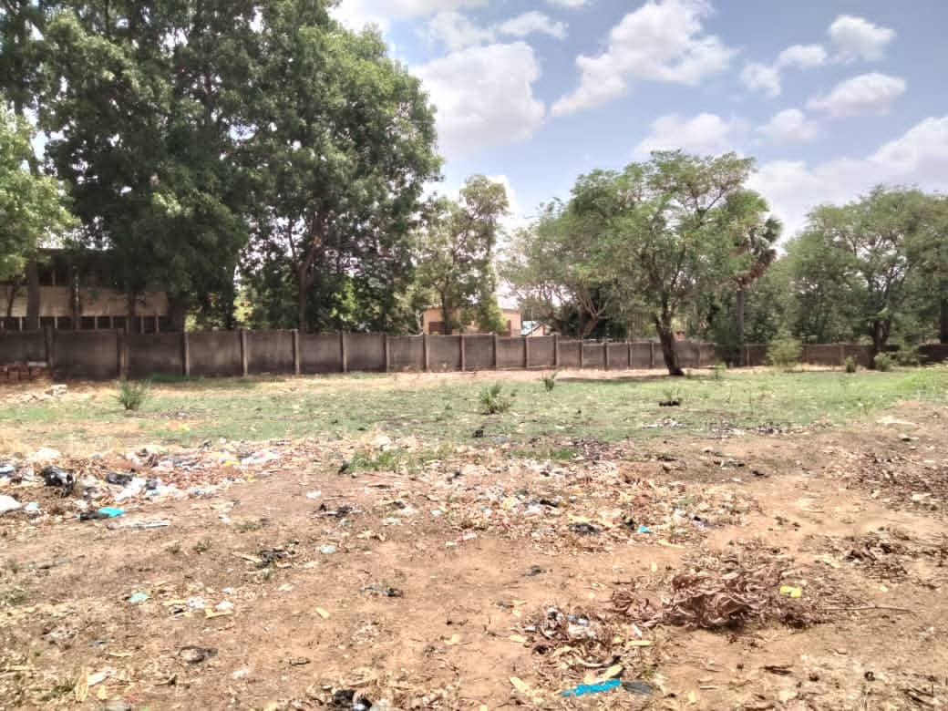

**Plate 2.1: Project Site**

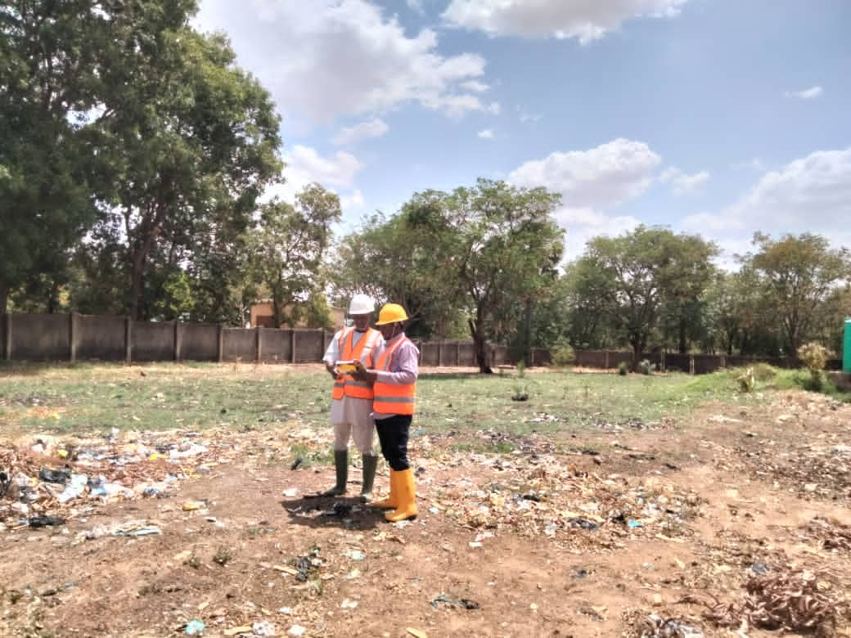

**Plate 2.2: Project Site showing consultant at project site**

2.8 Summary of activities to be undertaken during each of the project phases

**Pre-construction phase**

This will include carrying out land survey, building design review with reference to regulatory organization recommendations, planning for storm water drainage and containment, undertaking site preparation, procurement of items and transporting the required components and construction equipment to site and construction of the base camp.

**Construction phase**

Establishment of construction area, construction of the entire structure, other onsite structures and ancillary infrastructure

**Operational phase**

This will include building operation and maintenance, site remediation, clearance and deposition of debris off the site, restoration of areas where construction activities temporarily disturbed the environment as well as the repairs and replacements of failed parts.

**Decommissioning phase**

If after its life span, decommissioning of all facilities above and below ground infrastructure on the site will be removed and the site will be returned to conditions, which are close as possible to its original state

2.9 Project Schedule

The development of this project is expected to cover a period of Six months. This will include pre-construction (site clearing, procurement of equipment, transport of materials to site) construction (bricks masonry, plumbing, electrical works, roofing and landscaping). To achieve this, ACENTDFB will require a Project Manager (PM) and site supervisor/foreman or to be provided by the PM in his negotiation.

#### Table 2.1 Gantt chart showing Project Schedule

|  |  |  |  |  |  |  |  |
| --- | --- | --- | --- | --- | --- | --- | --- |
| **S/N** | **ACTIVITY/MONTH** | **1** | **2** | **3** | **4** | **5** | **6** |
| 1 | Mobilization to Site /Site Clearing | x |  |  |  |  |  |
| 2 | Transportation of materials and equipment to site | x |  |  |  |  |  |
| 3 | Construction of temporary site office, Setting out, excavation and substructure (building of foundation trench) |  | x | x |  |  |
| 4 | Construction of superstructure |  |  | x | x | x |  |
| 5 | commissioning |  |  |  |  | x |  |
| 6 | Operation/maintenance |  |  |  |  |  | x |

**Source: Consultant Work Schedule, 2022**

# CHAPTER THREE

## BIOPHYSICAL AND SOCIO ECONOMIC CHARATERISTICS

# 3.1 INTRODUCTION

# 3.1.1 Data Acquisition Methodology and Approach

This section of the report puts together the baseline environmental data/characteristics of the study area. For the purpose of baseline data acquisition, an integrated and interdisciplinary team of professionals and practitioners were engaged. The team as a formidable one made up of seasoned environmental and social practitioners with adequate training and experiences. The various areas covered in course of this study are: Air quality, Soil, Hydrogeology, Noise, Meteorology, Vegetation and Socio-economics. Geographic information systems (GIS) expert was engaged in the mapping of the sites and data generated alongside.

Data collection for this ESMP study commenced with a formal forum with the various stake holders likely to be impacted by the proposed project. The formal interactive forum began on 13th of April, 2022. However, the actual sampling began on the 22nd & 23rd April, 2022. An environmental baseline study was carried out to establish a benchmark of existing environmental conditions in the proposed project site prior to the commencement of the project against which potential impacts of the planned project on the site could be assessed. Thus, the data presented and information given was gathered from a combination of both primary and secondary sources. Climatic data were acquired from NIMET and analyzed by a climate change expert with results presented subsequently in the report. That is, field observation and laboratory analyses as well-established facts in literature derived through literature review process. The data presented here were analyzed in line with national and internationally acceptable standards. The environment in this context includes the biophysical, economic and social components.

#### Table 3.1: Summary of the baseline data collected during the fieldwork

| **Component** | | **Data collected and methods** |
| --- | --- | --- |
| **Physical Environment** | ambient air | Air quality data sampling were carried out at 5 locations around the project environment based on identified sensitive receptors. In situ air quality parameters were collected as indicated below.   |  |  | | --- | --- | | **Parameter Measured** | **Equipment** | | Sulphur (IV) Oxide (SO2), | In-situ single gas SO2 monitor (ToxiRAE Model PGM-1130) | | Nitrogen (IV) Oxide (NO2) | Single gas NO2 monitor (ToxiRAE Model PGM-1110) | | Carbon Monoxide (CO) | CO monitor (MultiRAE Pro Model PGM-6248) | | Ammonia (NH3) | NH3 monitor (MultiRAE Pro Model PGM-6248) | | Volatile Organic Compounds | MultiRAE gas monitor (MultiRAE Pro Model PGM-6248) | | Hydrogen Sulphide (H2S) | MultiRAE gas monitor (MultiRAE Pro Model PGM-6248) | | Particulate Matter (PM) | Haz-Dust Model EPAM-500 | | Oxygen (O2) | Gas alert microclip XL (4-in-One) (Model MCXL XWHM-Y-NA) | | Noise Level | Extech Multifunctional sound level meter | |
| Surface and Groundwater | Water samples of ground water and surface water were collected within the project environment to evaluate the quality. In situ data were collected from existing borehole around the project area while the samples for surface water were collected from Samaru Stream (Gangauku Stream) about 50m away from the project area which discharge to the ABU dam (Kubanni Dam). |
| **Biological Environment** | Ecological biodiversity | * Vegetation and flora surveys were assessed to determine the plant characteristics, identification and an inventory of economic crops within the project locations. Line transect method was used while attributes considered were frequency, cover, density, production, structure and composition of plant species. * Two soil samples were collected within the project area. Soil characteristic was evaluated based on soil morphology. An approximate classification was made by spreading a sample on a flat surface and examining it, noting particular grain size, gradation, grain shape and particle hardness. |
| **Socioeconomic Environment** | Stakeholder Engagements and baseline data collection | * Socio economic study focused on the project site and communities within its immediate environment (ABU Campus). Data were collected using household questionnaires, Key informant interviews, and participatory observations and Stakeholders Consultation. |
| **Laboratory Analysis** | | Laboratory analyses were conducted for soil, surface water and groundwater samples collected during the field sampling exercise at the Federal Ministry of Agriculture and Rural Development. Department of Agriculture and Climate Change Management Services. National Soil and Water Laboratory, Km 2 Kaduna Express way Goni Gora Kaduna. |

Source: Field Study, May, 2022.

3.2 Description of Biophysical Environment

***3.2.1. Climate of Project Site***

The major climatic feature of the region is the alternating wet and dry seasons alternatively called, rainy and dry seasons. This is as a result of the migration of the ITD or ITCZ. This line is formed by the meeting of the Tropical Maritime Airmass (TM) which is wet and the Tropical Continental Airmass (TC) which is dry. Generally, the climate of Zaria region Nigeria like elsewhere in Nigeria is controlled by temperature, wind, pressure, atmospheric humidity and precipitation (Ojo, 1977). In Zaria the wet season is oppressive and overcast, the dry season is partly cloudy, and it is hot year-round. Over the course of the year, the temperature typically varies from 54 0F to 96 0F and is rarely below 48 0F or above 102 0F

### *3.2.1.1 Ambient Air Temperature*

Relative humidity is high in the state throughout the year and decreases slightly in the dry season. Figure 2.1 and 2.2 clearly depicts a positive trend in minimum (y=0.0554x+7.838 and R² = 0.1424) and positive maximum temperature (y = 0.0823x + 37.667 R² = 0.2763) which is a clear indication of climate change in the area. The increase in temperature could be an exacerbating factor to occurrences of African trypanosomiasis, Lymphatic Filariasis (LF) Onchocerciasis, Rabies, Dengue fever, Schistosomiasis and Trachoma in Northern Nigeria (See Figure 3.1 and 3.2).

**Figure 3.1: Minimum Temperature of Zaria from 1991 to 2021 (NIMET, 2022)**

### *3.2.1.2 Wind Speed and Direction*

The long-term wind distribution data retrieved and analyzed for ABU Zaria (Figure 3.3 and 3.4) shows that the wind blows generally from the North-Easterly direction for both wet and dry seasons, calm periods are frequently observed in the middle of the raining season (June July and August) when the atmosphere is saturated with atmospheric moisture.

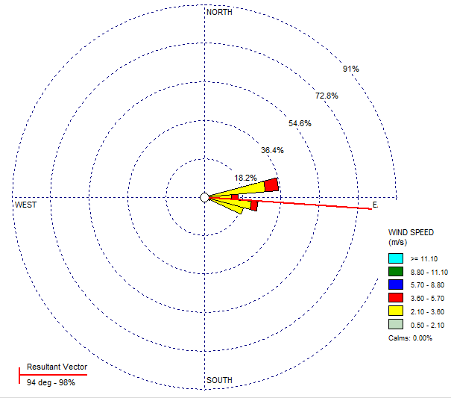

##### Figure 3.3: Typical Wind Rose for the Prevailing Direction of wind across the project area (NIMET, 2022)

The major destination of this wind is West-South and West-North of Nigeria. Information on frequency distribution of wind speed and direction is important since it provides the basis for accurate estimation of the dispersion patterns of pollutants in the atmosphere which plays significant role in spread of diseases.

### *Relative Humidity*

Monthly average relative humidity from 1991 to 2021 for the project area is presented in Figure 3.5. This shows that relative humidity values are low all year round at an average of 60.58%, which are typical of savannah climate. This is clear indication of climate change (changing relative humidity) in the project area which could be an exacerbating factor to the occurrences of the Neglected African diseases such as trypanosomiasis, Lymphatic Filariasis(LF)/Onchocerciasis, Rabies, Dengue fever, Schistosomiasis and Trachoma in Northern Nigeria.

### *3.2.1.4 Rainfall Pattern*

Trend of rainfall in the project area depicts depreciation from 1991 to 2021 with trend line equation of y=-12.691x+1413.8 with regression of R² = 0.1013. This rainfall change (See Figure 3.6) is an indication of climate change as also observed in Figure 3.1, 3.2 and 3.5. It should be noted that rainfall is very important in epidemiology studies because of its ability to cause wet deposition. Less rain reduces the capacity to environmental wash there by making the environment viable to the spread and development of diseases. (See Figure 3.6)

### Figure 3.6: Average Annual Rainfall distribution from 1991 to 2021 (NIMET, 2022)

### *3.2.2 Air quality and noise level within the proposed site*

Balsas (2003) from ABU Main Campus and the built-up area structures (houses, markets, shops, institution etc.) should be provided or maintained or expanded without jeopardizing the surrounding environment, observing that many built-up areas/surrounding have gone through many physical changes and further development of structures will surely stimulates more changes. Therefore, a proactive plan to establish mutual beneficial relationship between infrastructural needs and micro-climate of area being developed is key in developmental strategy.

#### Table 3.2: Air quality and noise level measurement within the proposed site

|  |  |  |  |  |  |  |  |  |
| --- | --- | --- | --- | --- | --- | --- | --- | --- |
| Sampling  Point | Spm mg-3 | H2S  PPM | So2  PPM | CO  PPM | NO2  PPM | TVOC  PPM | NOISE  Db | Coordinates |
| FLA1 | 0.08 | ND | 0.03 | 1.92 | ND | 0.21 | 31.2 | 11.152619N  7.64747E |
| FLA2 | 0.03 | ND | 0.01 | 2.05 | ND | 0.18 | 30.6 | 11.152619N  7.647240E |
| FLA3 | 0.12 | <0.02 | 0.10 | 2.64 | ND | 0.22 | 36.3 | 11.152409N  7.646968E |
| MEAN | 0.08 | <0.01 | 0.05 | 2.20 | ND | 0.20 | 32.7 |  |
| FMENV L | 0.25 | 0.05 | 0.26 | 10 | <0.06 | 0.51 | 90 |  |

**Source: Field Survey, April 20th, 2022. (NIMET, 2022)**

***3.2.2.1 Noise Level***

The mean value of noise level recorded in the propose site is 32.7dB. This is far below FMENV maximum limit of 90dB (See Figure 3.3). Generally, the air quality parameters and noise level in the area were observed to be very low indicating that the purposed site is environmentally safe for the project. This is likely due to the absent of the students in school as a result of the ASUU, NASU and SSANU strike during this in-situ environmental parameters measurement. Rainfall has just set in and most importantly, Ahmadu Bello University Samaru Campus has established greenbelt within and around the campus, this established network of trees is capable of cleaning the air with respect to suspended particulate matter and carbon IV oxide removal. Also, the recorded low values for most of the parameters might be connected to the Greenbelt environment that is in place around the propose project site.

***3.2.3 Vegetation of the Propose Project Site***

The vegetation of Zaria province can be defined as the Northern Guinea zone by the presence of some species of trees observed in the site surroundings to include; *Uapaca Togoensis, Isoberlinia Doka, Adenodolichos paniculatus and Dichrostachys glometratoa etc. While the ground layer grasses include; Andropogon gayanus, Sporobulus festillus and Laudetia togoensis* amongst others. In detail, however, little is known about the ecology of this species and accordingly a survey was undertaken to examine the general distribution of the more common tree species in Zaria Province, during this study in Ahmadu Bello University. The nomenclature of the woody species follows that of various studies in the past.

The project site is a cleared area within the surrounding of the Ahmadu Bello University, Samaru which is made up of several species of ornamental plants. The soil type, climatic conditions (rainfall, humidity, temperature and rainfall) of the project site influences the soil type in the propose site. These conditions favorably support the vegetation as the period of environmental sample collection and site visitation; the dryness of the weather at the time might have caused the fauna life to go into hibernation.

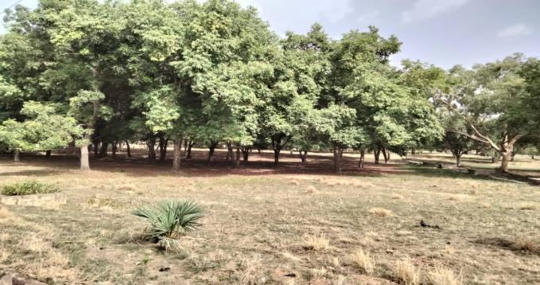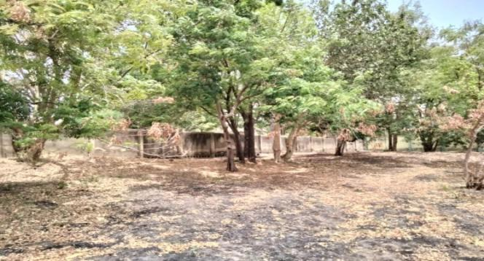

**Plate 3.1: Vegetation in the study area**

Source: Field Survey, 2022

* + 1. ***Soils of the Project Sites***

The geology, climatic conditions (rainfall, humidity rainfall) and vegetation of the project site influences the soil type in the propose site.

***3.2.4.1 Textural Composition***

The Textural composition of soil in proposed site shows that both the topsoil and subsoil are loamy soil. The clay content of topsoil is 1.64 while silt and sand contents are 21.56 and 76.80 respectively. Whereas, clay content of subsoil was 2.64 while silt and sand are 20.64 and 76.50 respectively. With respect to textural composition, the soil within the propose site will healthily support safe environment in all ramification. (See Table 3.3).

***3.2.5 Geology and Hydrology***

The proposed site is part of the undulating peneplain that extends form lake Chad to Sokoto and northward from southern Kaduna into the Republic of Niger Zaria is underlain by Precambrian rocks typical of Nigeria basement complex. These Precambrian rocks are made of gneiss, migmatites and metasedimentary rocks, trending north-south and intruded by granitic rocks of late Precambrian to early Paleozoic age The upper layer of the basement complex rock in Samaru is described as highly weather, refers to as weathered mantle (Obihan *et. al.,* 2021).

Previous studies of ABU main Campus Samaru Zaria indicates that ground water is not too difficult to access as depth of between 20-40m is enough to reach ground water in the area. The closest ground water to proposed site (Borehole) is located in Sassakawa parking lot and its sample was collected for analysis. **See Annex 10.**

Adjacent to the proposed site about 100m away is the Samaru stream which discharge to the ABU dam (Kubanni dam) this dam is one of the main sources of available water to ABU Campus Community Samaru Zaria. Other surface water bodies that Dam Zaria area is: Kubani River, Galma River and Saye River. However, around the Ganga Uku stream where surface water samples were collected, (100m away from site) some aquatic lives were observed in the stream e.g., Tadpole, flies and other insects.

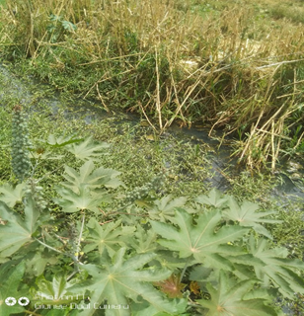 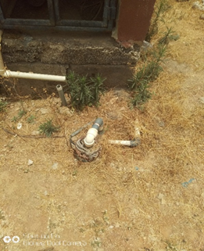

**Plate 3.3: Ganga uku stream and Sassakawa parking lot Borehole.**

**Source: Field Survey, April 20th, 2022.**

***3.2.5.1 Water Temperature***

The temperature of ground water (Sassakawa parking lot borehole) around the propose site is 27.20C while that of surface water (Ganga Uku Stream) is 26.90C both are less than 400c maximum value specified by FMENV (See Annex 5).

***3.2.5.2 Water pH***

The ground water pH within the proposed site is 6.90 mg/L and surface water pH is 6.90 mg/L (See Annex 5).

***3.2.5.10 Micro-organisms of Water***

The following microorganisms were sought for in the water within the proposed site to determine their portability with respect to microorganisms.

1. Most probable number of microorganisms in ground water within the site:128/100ml. while it is 600/100ml in surface
2. E.coli spp. It was absent in ground water and present in surface water
3. Salmonella spp. Absent in ground water and present in surface water
4. Shigella spp. Absent in ground water and present in surface water.

This indicates that the surface water (Ganga Uku stream) around the proposed site is not safe for human consumption with respect to microorganisms.

Note: All the parameters analyzed for in these media (water and soil) are subject to seasonal variation (See Annex 5).

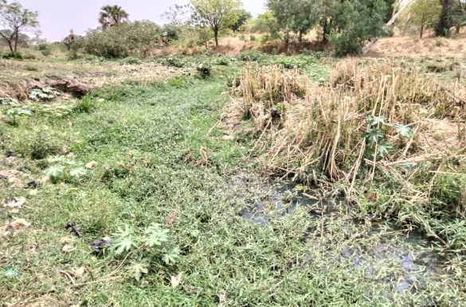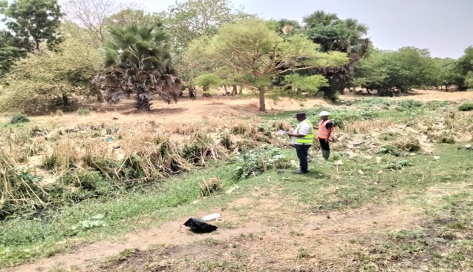

Plate 3.4: Freshwater vegetation on Ganga Uku Seasonal Stream Consultant taking water sample

Source: Field Survey, April 20th, 2022

**3.3 Land Use of the Project Site**

The project area is in an academic institution (Ahmadu Bello University, Main Campus Samuru, and Zaria). Outside the campus/project site fallow land was observed and agricultural land use is one of the major categories outside the campus. Apart the land being put into urbanization due to the present of ABU, farming is also a major utilizer of land around the project site. Common crops cultivated include sugar cane, maize, millet, guinea corn and vegetables. Subsistence fruit crops like mango, cashew, and pawpaw were spotted around existing and farmlands.

## 3.4 Socio-Economic Environment

## *3.4.1 Population*

The population of the study area is inhibited by students, lecturers, staff, business men and women found within the Campus and its environs in Samaru Zaria. The total student enrollment in the university's degree and sub-degree programme is about 35,000, drawn from every state of Nigeria, Africa, and the rest of world. There are about 1,400 academic and research staff and 5,000 support staff. The metro area population of Zaria in 2021 was estimated at 736,000, a 1.38% increase from 2020. The area population in 2020 was 726,000, a.9. 7% increase from 2019.

## *3.**4.2 Socio-economic Characteristics and Health Condition*

The project area is sited in an academic community with a common socio-cultural characteristic. The community is universal in nature some practise Christianity, some Islam and some Traditional religious believe and some Atheist. The major socio-economic activities are academic related with business centres to service the academic institution.

### 3.5.1 Gender Base Profile

As presented in Table 3.5, Gender base profiling of the responded in the project community on household size, education and employment is dominated by male.

#### Table 3.3: Gender Base Profile for Study Community

|  |  |  |  |  |  |  |
| --- | --- | --- | --- | --- | --- | --- |
| **ABU COMMUNITY** | | | | | | |
| **COMMUNITY GENDER BASE PROFILE FOR SELECTED HOUSEHOLD** | **HOUSEHOLD SIZE** | | **EDUCATION PER HOUSEHOLD** | | **EMPLOYMENT PER HOUSEHOLD** | |
| **HOUSEHOLD /** | **M** | **F** | **M** | **F** | **M** | **F** |
| HOD, PP&MS | 4 | 3 | 3 | 2 | 4 | 3 |
| MOHAMMED SULE | 2 | 1 | 2 | 1 | 2 | 1 |
| SALISU ISAH | 3 | 2 | 2 | 2 | 3 | 2 |
| NANEY BELLO | 1 | 1 | 0 | 0 | 2 | 1 |
| FATIMA USMAN | 3 | 2 | 3 | 2 | 3 | 2 |
| ABDULLAHI SHEHU | 5 | 3 | 3 | 4 | 4 | 4 |
| SASSA KAWA | 4 | 4 | 3 | 2 | 4 | 3 |
| SECURITY RESEARCH OFFICER | 3 | 2 | 3 | 2 | 3 | 2 |
| AFRICAN CENTRE FOR EXCELLENCE | 3 | 1 | 3 | 1 | 3 | 1 |
| JOHN | 2 | 3 | 1 | 3 | 2 | 3 |
| **TOTAL** | **30** | **23** | **23** | **19** | **30** | **22** |

**Source: Field Survey, April 20th, 2022.**

#### Table 3.4: Demographic characteristic of the respondents in ABU Community

|  |  |  |  |
| --- | --- | --- | --- |
| **PARAMETERS** | **RESULT** | **DISCUSSION OF RESULT** | **GRAPHIC PRESENTATION OF RESULTS** |
| Age distribution |  | The respondents were all adults from 17 years and above. Significantly, the workforce age constitutes of 54% of the population (26-64 years old), while the older age (65 years and above) is 13% and represent the age bracket that may be vulnerable. Similarly, the constitution of respondents from widespread age groups implies that varying views from younger to older respondents concerning the project activities were incorporated. |  |
| Category | **No of respondents** |
| 0-5 | 0 |
| 6-17 | 4 |
| 18-25 | 6 |
| 26-64 | 16 |
| 65 + Above | 4 |
|  | |
|  |  |
| **Gender** | **No of respondents** | A sample of 15 respondents was randomly drawn from households across the proposed project area. It was gathered from the field survey that majority of the respondents (about 67%) are Male while Female are 33%. This illustrates an even representation of both genders in the survey. |  |
| **Female** | 10 |
| **Male** | 20 |
|  |  |
|  |  |
|  |  |
|  | |
| Married | 30 |
| Single | 0 |
| Widow | 0 |
|  | |

**Source: Field Survey, April 20th, 2022.**

# 3.5.2 Discussion of socioeconomics result

The result on education attainment of the respondents shows that 20% of the respondents have had at least one form of formal education. There are significant number of those who have completed secondary school and those that have attained tertiary education (47% and 33% respectively). Education is an important characteristic that can affect attitudes and understanding of social phenomenon, hence the higher level of education in the area could imply a better understanding and community ownership of proposed intervention.

The respondents were all adults from 17 years and above. Significantly, the workforce age constitutes of 54% of the population (26-64 years old), while the older age (65 years and above) is 13% and represent the age bracket that may be vulnerable. Similarly, the constitution of respondents from widespread age groups implies that varying views from younger to older respondents concerning the project activities were incorporated

The result on education attainment of the respondents shows that 20% of the respondents have had at least one form of formal education. There are significant number of those who have completed secondary school and those that have attained tertiary education (47% and 33% respectively). Education is an important characteristic that can affect attitudes and understanding of social phenomenon, hence the higher level of education in the area could imply a better understanding and community ownership of proposed intervention.

83% of the respondents attested that there has been an outbreak of malaria in the community. 11% opined that have witnessed typhoid while the remaining have witnessed cholera

On communicable diseases, all the respondents (100%) opined to have witnessed an outbreak of cholera. None has witnessed COVID 19 and Ebola.

83% of the respondents attested that there has been an outbreak of malaria in the community. 11% opined that have witnessed typhoid while the remaining have witnessed cholera.

99% of the respondents attested to know Rabies, 1% claimed to know Lymphatic Filariasis. None of them has heard of the other diseases listed.

Bush dumping of refuse is popular among the respondents as 93% of them attested to bush dumping of refuse. The remaining 7% used the burning method. The Contractor will liaise the ABU PPMSD and the KADSUPDA to ensure that waste generated on site are properly disposed

The respondents (90%) of them agreed that noise pollution is a major environmental problem, while the remaining 10% opined that the problems were air pollution and waste generation. In this aspect the contractor will ensure construction time and hour are programmed in such a manner that noise level is reduced or avoided when necessary.

On security Challenges, all the respondents (100%) agreed that there is indeed no security challenge in the community. That ensure that the community is well safe in terms of security and safety of workers and equipment as such, the PM and the contractors should ensure they work in synergy with existing security of the university to continue with the existing peace and safety in the community.

## 3.5.3 Vulnerable Groups

Vulnerable groups identified during the field assessment are discussed. The criteria for selection included: (i) easy predisposition to SH and SEA, contracting STIs and STDs or unwanted pregnancies (social vulnerability); (ii) occupation; and (iii) socioeconomic status.

* **Female workers and onsite vendors:** They stand the risk of suffering SH, SEA, contracting STIs, STDs or unwanted and/or early pregnancies caused by workers, especially at the pre-construction and construction phases. Stringent conditions for engagement may discourage female participation, and constraint them to succumb to advances for sexual favours in return for an opportunity by their male counterparts or contractors.
* **Occupation (Petty traders):** who reside or offer petty trading services within project communities where contractor’s personnel may go to buy commodities. They may also stand the risk of being cheated by Contractor’s personnel who may buy “on-credit” with a promise to pay, and never do so.
* **Socioeconomic status:** those earning below the government minimum wage (N30, 000) who may depend on the payments for services to sustain themselves and their dependents. Delay in payments on the part of contractors may cause ripple effect for the workers and their dependents. In view of these challenges to be faced by such groups, priority should be given to them as positive intervention.
* **Persons Living with Disability (PLWD):** Thesepeople are to be considered when it comes to site work so as to reduce any form of discrimination against them. The building plan should also include Ramp facilities for use by such persons as may reduce any hardship for the blind and disabled persons.

# CHAPTER FOUR

## 4.0 POTENTIAL ADVERSE ENVIRONMENTAL AND SOCIAL IMPACTS

4.1 Introduction

This chapter therefore presents methods and techniques used in assessing and analyzing the environmental and social; impacts of the proposed rehabilitation and construction activities. The findings from the overall assessment of the potential and associated environmental impacts of the proposed building construction are also discussed. It includes consideration of potential impacts related to abnormal occurrences in addition to those that might result from normal operations. The rationale used in this impact’s evaluation is based on WB.OP/BP and FMEnv simplified ESIA/ESMP for building construction. The assessment process was as follows:

* Identification of the various potential impacts using interaction matrix to show the relationship/ interaction between the project environmental components and planned project activities.
* A screening of potential impacts associated with each phase of the project is performed using a Risk Assessment Matrix; and
* A detailed evaluation of the individual impact producing factors that comprise each aspect of the project phases is then performed. The significance of the potential impacts is quantified using the same rationale as for the screening.

The assessment approach generally involved matching the various activities of the different stages of the proposed project with the components of the existing environment. Consequently, the possible changes (and extent of changes) in the environment as a result of the interactions have been identified/evaluated, hence mitigation measures proffered in order to reduce, offset or ameliorate such changes.

In predicting impacts, the experiential/practical ‘worst case scenario’ approach has been applied to determine the extreme effects of project activities on environmental components, while ‘consensus of opinions’ has been made use of to determine the importance of affected environmental components.

Evaluation of the identified impacts were carried out and compared using specific criterion such as legal/ regulatory requirements, magnitude of impact, risk posed by impact, public perception and importance of affected environmental component. Results of identification and evaluation are presented in this chapter.

**4.2 Impact Identification**

A number of project activities would be carried out in phases. These planned activities are what would impact on the environmental components positively or negatively. The project activities are grouped into four phases as discussed in Chapter Two.

The first step in identifying impacts associated with the project is the development of an interaction matrix which shows the relationship/ interaction between the project environmental components and planned project activities.

A risk assessment matrix (Table 4.1) was used to determine the risk of each individual environmental aspect relevant to the Construction of design studio complex and installation of ancillary equipment’s. The level of risk determined from the matrix identifies the level of control measures required for that environmental aspect. These risks are to be mitigated through the application of measures identified in this EMP.

#### Table 4.1: Risk Assessment Matrix

|  |  |  |  |  |  |  |
| --- | --- | --- | --- | --- | --- | --- |
|  | Probability | | | | | |
| Consequences |  | A | B | C | D | E |
| 1 | H | H | H | H | M |
| 2 | H | H | H | M | M |
| 3 | H | H | M | M | L |
| 4 | M | M | M | L | L |
| 5 | M | L | L | L | L |

Explanatory notes on the selection of the consequence and probability for each issue are presented in Below – Risk Matrix Explanation.

#### Table 4. 2: Risk Matrix Explanation

|  |  |  |  |  |  |
| --- | --- | --- | --- | --- | --- |
| Probability | | | Consequence | | |
| A | Almost Certain. | Expected to occur, quite common. | 1 | Major | Major environmental harm. e.g., major pollution incident causing significant damage or potential to health or the environment, loss on vegetation cover.  Fines and prosecution likely |
| B | Likely | Will probably occur, has happened | 2 | Significant | Long term or serious environmental damage.  Numerous complaints received.  Potential for prosecution.  Loss of reputation |
| C | Possible | Might occur at some time | 3 | Moderate | Moderate environmental impact.  Will cause complaints.  Possible fine |
| D | Unlikely | Could occur at some time although unlikely | 4 | Minor | Minimal environmental harm.  Potential for complaints.  Fine unlikely. |
| E | Rare | Might occur at some time in exceptional circumstances. | 5 | Insignificant | Little or no environmental harm.  Little potential for fines or complaints. |

4.3 Potential Social and Environmental Impacts

The project is expected to have high positive environmental and social impacts for impacted communities in the project area and the West African coast at large as it provides incentives for establishing innovation platform for knowledge flow and collective dialogue between, researchers, industries and educational institutions in the region and improved environmental management and livelihoods. The negative environmental and social impacts will largely be localized in spatial extent, short in duration, occurring within less sensitive environmental areas and are manageable through the implementation of appropriate mitigation measures. Based on the assessment, the potential environmental and social impacts are outlined in Table 4.3.

4.4 Impact Discussion

The identified, evaluated and ranked impacts are further discussed in this section. The impacts mentioned in the preceding sections for the proposed ACENTDFB construction of Forensic Laboratory and Administrative Offices are grouped into two:

* Beneficial impacts, and
* Adverse impacts

The impacts are then discussed in line with the two major project phases; construction (merged with pre-construction phase) and operational phase (includes maintenance and decommissioning). Discussions made here are intended to provide an insight into the significance or otherwise of identified impacts.

4.4.1 Beneficial Impacts

Construction Phase

The project benefits to stakeholders during pre-construction, construction and installation phases are as follows:

* Stimulate economic growth through local contractor participation in providing construction materials, equipment and services;
* Ensure social development through job creation (both direct and indirect);
* Increased economic activities in proposed project community from influx of workers and visitors to the project site;

*Operational Phase*

Benefits accrued from project during operations include:

* Providing a reliable template to address problems of NTD and its impact on the socioeconomic development and health of the community in developing countries;
* Providing the setting that will launch the center to attain higher heights;
* Training of skilled human resources and provide facilities for diagnosis, management and prevention of neglected tropical diseases;
* Providing epidemiological baseline data and updates on neglected tropical diseases in the study region;
* Developing and producing vaccines for use in the prevention of neglected tropical diseases;
* Equipping human resources with requisite skills in the general area of molecular biotechnology technique and forensic science for solving related problems;
* Stimulates regional development and job creation (both direct and indirect), thereby also promoting secondary social development/ services such as healthcare and hospitals service delivery, etc.;
* Meets other goals of the Federal and State Government (e.g., small-medium enterprise promotion, etc.);
* Support technology development through technical assistance and training for Nigerians as part of overall strategy of institutionalizing local content in Nigeria.
* Generation of income from temporary jobs during the construction phase;
* Revenue from locally placed orders for goods and services, including contracts for the provision of building materials and services, maintenance repairs and equipment servicing, and the establishment of supply contracts (e.g., security, waste disposal, catering, laundry).

4.4.2 Adverse Impacts

The potential adverse impacts from project activities are grouped into the following subjects and discussed further according to the different applicable phases.

* Land use
* Impacts from movement of equipment, and personnel.
* Impacts from service vehicles emissions;
* Impacts from noise and vibration;
* Impacts from waste generation;
* Impact on traffic;
* Social economic impacts;
* Health impacts; and
* Impacts from work place hazards.

***Land Use Impact – Land Degradation***

The occupied surface mainly determined the impact on ecosystem quality and the impact of land use on natural ecosystems is dependent upon specific factors such as the topography of the landscape, the area of land covered by the structure / building, the type of the land, the distance from areas of natural beauty or sensitive ecosystems, and the biodiversity. The impacts and the modification on the landscape are likely to come up during construction stage by construction activities, such as earth movements and by transport movements.

***Impacts from Equipment, Personnel and Material Movement***

In executing this construction project, a great deal of haulage/ movement would be undertaken all through the phases of the project. Movements would include:

* Transportation of equipment and personnel during construction and operational phases; and
* Movement of building materials to project site for construction.

*Construction Phase*

As part of the construction phase, personnel and materials would be transported to site daily. Transportation could be from ACENTDFB arrangement or visitors to the site. Vehicles to be deployed for construction purposes would include saloon, SUVs and heavy-duty vehicles (such as trucks, cranes etc.).

Movement of vehicles during this phase is important and cannot be avoided as such would impact significantly on the environment as well as on people living within the area in the following ways:

* Vehicular emission of pollutant gases (such as CO, SO2 and NO2) from vehicle exhaust;
* Contribution to global gas warming and ozone layer depletion from pollutant gases emitted from vehicles;
* Increased traffic and road blocks from movement of heavy-duty truck within community roads en-route project site;
* Potential accident to personnel and asset from vehicle movement during construction; and
* Dust emission arising from construction activities at the project site. Although, the potential for dust nuisance is unlikely at locations beyond 200m from the source except in the most extreme wind conditions.

***Air pollution Impact***

Emissions of air pollutants would occur from a wide variety of activities during the project development phases. Air emissions are categorized based on the origin or source of the emission (i.e., point sources) and further, by process such as combustion and material storage. Air emissions may be in form of combustion gases; NOx, SO2 and CO from diesel engines (cranes, trenchers, excavators, etc.) Air pollutant gases contribute to global emission load leading to global warming and increased greenhouse effect.

Air pollution may lead to global warming

*Construction Phase*

At construction phases of the project, the potential sources of emissions would include dust, particulate matter (PM), emissions from heavy trucks and earth moving equipment that will be operated on the site. Exhaust emissions during material transportation, stockpiling and equipment during construction activities. These emissions will be site specific and will be short-term, the extent of impact would therefore be moderate and its significance low.

*Operational Phase*

The use of generator release CO2, SO2, or NO2 gases while the use of solar energy releases no CO2, SO2, or NO2 gases and don't contribute to global warming.

Decommissioning activities may also generate emission of fugitive dust caused by a combination movement of air materials, machinery contact with soil, and exposure of bare soil and soil piles to wind. A secondary source of emissions may include exhaust from diesel engines of equipment used for dismantling.

Also, Sulphur hexafluoride, a potent greenhouse gas is used in power generation. Upon decommissioning, measures should be taken such that this gas is not released to the atmosphere, but be domesticated for other use (if possible).

***Noise Pollution Impact***

*Construction Phase*

The primary short-term noise and vibration impacts are associated with construction and decommissioning activities. At a distance of 50 feet’s (equivalent to 15 meters), noise level from use of machinery is expected.

During site preparation and construction activities, work equipment will result in increased noise level and vibration in the area, the noise would cause a major disturbance to Project community, workers at the site, nearby facilities close by would be impacted. Also, there would be increased noise level during site construction activities from movement of heavy trucks, earth moving equipment and other machinery, welding, etc.

Heavy construction equipment is the principal source of noise and vibration during construction activity, and the pattern would constantly change as construction progresses. For the most part, construction activity occurs during daytime hours when higher sound levels are generally more tolerable. In addition, any adverse noise impacts due to construction activities would be short term. There may also be some incidences during transportation of materials, site preparation activities such as vegetation clearance and trench digging.

*Operational Phase*

The use of generator for power supply makes noise and causes pollution in operation. Solar energy is clean, silent, and freely available. Another significant source of noise that may arise at this phase will be from vehicular activity.

***Waste Generation Impact***

Wastes from the project are grouped into solid wastes, liquid (wastewater) and air emissions. Solid wastes would include; wood, metals, food remains, glass, and refuse etc., while gaseous air pollutants (NOx, SOx and CO) would be from exhausts of vehicles and generator.

*Solid Waste*

Solid wastes generated can be hazardous or non-hazardous in nature. Improper handling of these wastes or their discharge into the surrounding environment without proper treatment would increase the level of micro-organisms (bacteria, viruses and fungi) that could be pathogenic to staff working in the area or to aquatic organisms. The project contractor intends to manage wastes through [waste minimization,](http://en.wikipedia.org/wiki/Waste_minimisation) and [recycling.](http://en.wikipedia.org/wiki/Recycling)

*Oil Spill and Diesel/ Lube Oil Leakage*

Also, to be considered is the possibility of oil spill and diesel/ lube oil leakage from vehicle, storage containers especially during the construction phase. A major oil spill may not be possible but the possibility of oil spilling or leaking during transportation, loading and offloading is very high. Spill over time and not managed properly could accumulate and become an issue. It could lead to loss in aesthetic quality and a factor to fire incident.

Impact from waste generation is medium to major significance and should be treated with great priority.

***Water Pollution Impact***

The operational phase of the project is not expected to have significant effect or bearing on the water aquifer of the area and soil over time. Water for drinking and domestic use will be sourced from the ground using constructed boreholes.

Also, diesel and oil leakage from vehicle movement, stored oil, maintenance and workshops for vehicles are likely to sip into the soil if not handled properly and may find its way groundwater where they become nuisance. The possibility of this occurring is rather low, hence has been ranked minor significant.

***Traffic Congestion Impact***

It is envisaged that movement of personnel and equipment along the local road leading to the site would increase once the project commences. The road within the community is slightly busy during the day and as such may lead to intermittent traffic build up which may not last long with proper coordination.

During the operation phase of the project, traffic around the project area may also be increased due to migration and movement of materials to the site. The impacts increase as in the construction phase would likely exist and potentially be extended during the project’s operation phase.

***Social Economic Impacts***

*Direct Beneficial Impact*

The major beneficial impact arising from the construction, operation of the proposed construction is the number of jobs it would provide. It is estimated local dwellers (skilled and unskilled) would be trained and engaged during the construction phase of the project.

It is estimated that the proposed project will boost urban development and strengthen economic activities in this community.

*Indirect Impact*

The project would also mean change in the quality of life for workers who are to be employed and source of income to contractors in the host community who would seize the opportunity to provide services and goods to contractor or its workers.

A key aspect of contractor’s activity in the area is to ensure continuous consultation with community members in order to avoid the following:

* Bitterness and hatred towards the government and university authority
* Lack of trust or confidence in future endeavors;
* Trespassing of community sacred or no-go areas;
* Increased social vices such as armed robbery, theft etc. due to individuals not being recognized; and
* Student restiveness and disturbance etc.

Issues such as job creation, settlement of conflict etc. between contractor and the community would be settled through the grievance mechanism to be activated. The project will not result in any disruption or disturbance of other economic activities beyond those positive elements that are associated with the addition of power and job creation that will be directly and indirectly beneficial to the populace. No negative impacts on Employment or economic activities are predicted to occur.

It should also be recognized that once operation commences, another group of individuals would emerge. There are those who would want to cash in on the workers. These groups are the commercial sex workers, miscreants, hoodlums etc. They may be camped outside the facility or stationed within the community and ready to interact with workers. Interactions of this nature often lead to increased rate of STDs and other communicable diseases in the area, theft and conflict.

***Impacts on Economic Activities***

Environmental impacts of the project can vary in their severity and time scale, be direct or indirect and can differ according to phase of development with which they are associated. A range of economic impacts which can result from the construction and operation of the proposed project are discussed under the following headings:

* Demographic impacts;
* Impacts on social infrastructure;
* Impacts on natural resources;
* Impacts on lifestyle;
* Impacts on cultural property; and
* Social equity of impacts.

***Demographic Impacts***

Demographic impacts are those impacts which cause a change in the size or make-up of a population. The principal demographic factor which the construction project is likely to affect is migration. The project would generate inward migration of Employees as well as attract other industrial development to the area in the hope of taking advantage of economic opportunities and power supply.

***Social Infrastructural Impact***

The social characteristics of the community would be determined in part by the nature of, and access to, social infrastructure. This includes items such as:

* Health care facilities;
* Educational facilities;
* Transport and roads;
* Waste collection, treatment and disposal facilities;
* Housing;
* Water supply;
* Recreational facilities;
* Public safety (fire, police, etc.); and
* Power supply.

The negative impacts on social infrastructure are usually associated with demographic changes. Existing infrastructure in the proposed project communities may only be able to serve the local population. Infrastructure facilities in the area are in various functional states and may be strained by an influx of people resulting in further social or health impacts. The proposed project is expected to have some very positive impact on the economy, which include:

Employment: As discussed earlier, the project would entail some construction, from land clearing to erection of physical structures. All of these would necessitate the hiring of skilled and unskilled hands which, if properly managed would benefit the community. Several community residents may have worked at skilled and unskilled jobs in the construction of existing structures in the area. There is, therefore a pool of experienced labour in the community.

Increased Economic Activities: Employment and rentals would imply more income, increased purchasing power, and increased economic activities as residents spend their incomes on local goods and services.

***Health Impacts***

As the project progresses, risks to the community may arise from inadvertent or intentional trespassing, including potential contact with hazardous materials, contaminated soils and other environmental media.

Increased incidence of communicable and vector- borne diseases attributable to construction and operational activities represents a potentially serious health threat to project personnel and residents of the community.

In the case of infection, residents and workers would contend with malaria, diarrhea diseases, RTI and STDs. In general, itinerant workers could be transmitters of these and other diseases. As has been commonly experienced in other places, construction work tends to attract commercial sex workers who also are a high-risk group in terms of transmitting STDs and HIV/AIDS. The magnitude and duration of work expected at the construction phase is such that this phenomenon could be expected.

Migrant project workers may have little or no resistance to prevalent diseases within the project area. Non-resident workers and their families may be quartered in camps with inappropriate living conditions. Additionally, social interactions between workers and the local community could lead to pregnancies with the attendant complications and problems of illegal abortions or orphanages. Enhancement of socio-economic status and health infrastructure can result in an improvement in public health care system.

***Work Place Hazards***

Accidents or injuries to personnel during the project construction, installation and operation phases can occur if proper HSE awareness or supervisions are not carried out. The impact of such accidents/ injury is very significant; given the nature of the job which requires work team commitment. Injury of a person or group of people can easily bring resentment and possible temporary close of the project. This may lead to capital and time lost. Likely sources of accident and injury associated with construction project include:

* Loading and offloading of equipment for installation and construction purposes;
* Over-exertion, ergonomic injuries such as repetitive motion and manual tool handling;
* Paint spraying or removal leading to hazardous inhalation;
* Metal cutting and fabrication works;
* Trip and fall from elevated surfaces, ladders, scaffolds and gangways;
* During electrical installation and routine maintenance works:
* During oil and fuel removal and tank cleaning;
* Operations involving cranes, winch, lift;
* Cutting and welding operations that make use of compressed gas; and

During pre- construction, construction/installation, operation and decommissioning activities, there could be occupational health and safety impacts. The following are derived from the IFC/ World Bank Environmental, Health, and Safety (EHS) Guidelines for Construction and Decommissioning (2007):

***Over-exertion***

Over-exertion, ergonomic injuries and illnesses, such as repetitive motion and manual tool handling, are among the most common causes of injuries.

***Slips and fall***

Slips and fall associated with poor housekeeping, such as excessive waste debris, loose construction materials, liquid spills, and uncontrolled use of electrical cords and ropes on the ground, are also among the most frequent cause of lost time accidents at construction and decommissioning sites. Falls from elevation associated with working with ladders, scaffolding, and partially built or demolished structures are among the most common cause of fatal or permanent disabling injury.

***Strike by Objects***

Construction and demolition activities may pose significant hazards related to the potential fall of materials or tools, as well as ejection of solid particles from abrasive or other types of power tools which can result in injury to the head, eyes, and extremities.

***Confined Spaces and Excavations***

Examples of confined spaces that may be present in the construction or demolition phase and include: utility vaults, tanks, sewers, pipes, and drainages. Ditches and trenches may also be considered a confined space when access or egress is limited.

CHAPTER FIVE

5.0 ENVIRONMENTAL SOCIAL MANAGEMENT AND MONITORING PLAN

5.1 Impact Mitigation Measures

This chapter presents the mitigation measures proffered for the associated and potential impacts of the proposed building construction project. A comprehensive risk assessment matrix, as indicated in **Figure 5.1**, was used to determine the mitigation requirements for each of the impacts identified. The frequency, severity, sensitivity, scale, longevity, political, economic, legal, reputation/image and communication/complaints were factors taken into consideration during these assessment

## 5.2 GBV Risks and Management Measures

The continuous social interaction between contractor’s personnel and community members, onsite food and petty items vendors, and staff of the ABU may trigger GBV/SEA/SH issues.

**Gender-based violence (GBV)[1]** – including sexual harassment, exploitation and abuse – is a prevalent feature in settings across countries where the World Bank operates. In order to understand and address more effectively key drivers that contribute to incidence of GBV, the recently released report by the Global GBV Task Force emphasizes the need to improve social risk assessment and specifically assessment and identification of key risks of Sexual Exploitation and Abuse (SEA) and GBV. In particular, the report highlights the extent to which existing World Bank-supported projects may compound broader contextual risks of GBV in a society, community or relationship that already contribute to prevalence of gender-based violence.

### 5.2.1 Measures taken to Mitigate GBV/SEA/SH Risks

Key actions to be implemented by the ACENTDFB/ABU project include the following:

* Include information on SEA/SH prevention and mitigation considerations in all relevant documents such as ESMPs, C-ESMPs ToRs, bidding documents
* Ensure the inclusion of qualified GBV officer on the PIU
* Strengthen the Counselling Unit for ethical handling of GBV/SEA through training and capacity building. Designate a GBV focal person who will be trained by the project on handling cases in line with the section 5.4 of this ESMP on GBV GRM protocol to ensure confidentiality, survivor-centered approach and referral of cases.
* Produce GBV Code of Conducts (CoCs) for all staff/workers and conduct training on CoC.
* Establish collaboration with the Federal Ministry of Women Affairs.
* Identify local NGOs with capacity as first respondents to provider psychosocial support services to survivors in an ethical and survivor-centered approach.
* Produce posters and billboards to discourage and disabuse any form of GBV, including SH and other workplace related GBV risks.

The ACENTDFB Project team, particularly the gender/GBV officer and the Environmental & Safeguard Officer will conduct periodic monitoring to ensure the project is implemented in accordance with the relevant SEA/SH preventive contractual provisions.

## 5.3 Environmental and Social Management and Monitoring Plan

The environmental and social management and monitoring plan for matrix presents site-specific mitigation measures for potential negative impacts of the project. The matrix also presents the plan for monitoring compliance, defines the costs for mitigation and monitoring, frequency of monitoring, parameters to be monitored, and responsibilities for mitigation and monitoring. This is presented in the Table 5.1 below

#### Table 5.1: Potential Impact Mitigation and Monitoring

**Preconstruction Phase**

| **S/No** | **Activities** | **Potential Impact** | **Mitigation Measures** | **Responsibility for Mitigation** | **Mitigation Cost (NGN)** | **Parameters to be measured** | **Method of measurement** | **Performance indicator** | **Sampling Location** | **Monitoring Frequency** | **Institutional Responsibility (Monitoring)** | **Costs (NGN)** |
| --- | --- | --- | --- | --- | --- | --- | --- | --- | --- | --- | --- | --- |
| **A. Environmental & OHS Impacts** | | |  |  |  |  |  |  |  |  |  |  |
| **1A** | Movement of materials, vehicles, and equipment to site | Air pollution from exhaust fumes of vehicles, equipment can lead to health risks such as Respiratory Tract Infections (RTIs)  Worsen road condition  Destruction existing landscape and structures of ABU ZARIA | Ensure that all vehicles are serviced; undergo vehicle emission testing (VET) and vehicle exhaust screening (VES). Use fuel efficiency techniques, catalytic converters etc. on machinery  Use road worthy vehicles/ maintain regularly  Limit area of movement and use closest access route (ARi-1 and AR-1) from the school gate. See Figure 5 | Contractor | 300,000 | SO2, NOX, CO, VOC, PM2.5, PM10  Type of vehicles/sites  Access route marked out | In-situ measurement  Site inspection | Air Quality Parameters are within permissible limits as documented by NESREA[2]  Evidence of VET and VES  Evidence of compliance | Project area and within 1km  Project area | Bi-monthly  Weekly  Before movement of vehicles | ACENTDFB E&S Team  PPMSD  FRSC  KASUPDA | 250,000 |
| **2A** | Land and site clearing, staging area | Minimal vegetation cover removal  Vegetative waste | Limit land clearing to specific zone needed for the construction work.  Collaborate with FMU/KASUPDA for onsite waste removal | Contractor | 500,000 | Cleared area  Vegetative waste onsite | Site inspection | Contractor compliance | Project site & area | Before and during land clearing | ACENTDFB E&S Team  KASUPDA | Covered in 1A above |
| **3A** | Creation of Staging area for equipment | Temporary removal of topsoil, Oil leakages from stacked equipment and dis-colouration of topsoil | Segment a safe and specific area for equipment parking  Service equipment and install a non-permeable membrane/ drip pan | Contractor | 80,000 | Soil Quality | Visual observation | Soil Quality parameters are within FMEnv permissible limits | Equipment Staging Area | Bi-monthly | ACENTDFB E&S Team  PPMSD  KASUPDA | Covered in 1A |
| Minimal noise impacts | Retrofit vehicle exhausts with sound-control or sound -proofing devices  Maximize off-work hours, especially for activities with potentially high noise generation | Contractor | 50,000 | No. of complaints from nearby offices | Noise measurement | Evidence of Compliance | Project Area | Weekly | ACENTDFB E&S Team  KASUPDA | Covered in 1A |
| **4A** | Sourcing and mobilization of construction materials to site | Debris may fall off from trucks or other lighter materials like sand may be blown into the environment causing dust and disturbance on roads and to other road users.  Protruded metals, rods, woods, roofing sheets may constitute hazard and nuisance to other road users who may not notice the protrusion. Also, these materials may fall off from the vehicle and may lead to road accidents. | Use tarpaulin material to properly cover conveying truck.  Ensure that materials are tightly packed and belted firmly to avoid rolling off the truck.  Convey materials using most suitable trucks.  Ensure caution tapes are attached to the ends of protruded rods /woods in transit to notify oncoming vehicles and road users. | Contractor | 30,000 | Use of tarpaulin to cover truck conveying materials to site  Use of belts to secure materials in position  Use of caution tapes attached to protruded rods/woods. | Inspection | Contractor’s compliance | Along access road to site | During mobilization | ACENTDFB E&S Team  PPMSD | 50,000 |
| **4A** | Mobilization to site and clearing activities | Risk of accidents and injuries to contractor workers  Respiratory diseases to Workers due to inhalation of exhaust fumes and dusts  Noise Pollution | Submit and implement company HSE Manual/ Implement site specific Occupational Health and Safety Management Plan (OHSMP) see annex 5 for sample  The OHSMP will entail: - Provision of Hazard Communication Procedures (HAZCOM); Job Hazard Analysis (JHA); OHS Training program  Provision of adequate first aid, first aiders, PPE, safety signages  Ensure qualified HSE officer on every team  Workers should get a daily induction/toolbox before work commences  Use reflective tapes and signage integrated in all worksites for safety at night | Contractor | 100,000 | Compliance with OHSMP  No of workers Trained on HSE/OHS  No of accidents, incidents or injuries  Noise level  Availability and use of appropriate PPEs  First Aid Kits  Security Management Plan | Site inspection  Consultation | HSE/OHS Training reports and list of attendees  Evidence of Compliance to OHSMP  Evidence of use of PPEs, caution signs onsite, well-stocked first aid kits  Compliance with Security Management Plan | Project area | Weekly | ACENTDFB E&S Team,  PPMSD | Covered in 1A |
|  | **Sub-Total (Environmental & OHS)** | |  |  | **1,060,000** |  |  |  |  |  |  | **300,000** |
|  | **B. Social Impacts** | |  |  |  |  |  |  |  |  |  |  |
| **1B** | Movement of materials and equipment to staging area | Obstruction to access route for staff, and students of ABU ZARIA  Disturbances from increased noise levels  Grievance from poor recruitment of local labour for semi- & unskilled labour by contractor  Grievance for women who may not be able to satisfy stringent recruitment requirements | Limit movement to off-peak hours (peak hours are: 7:30AM – 10:00AM; and 4:00PM – 5:30PM; Mondays – Fridays) Liaise with the personnel at the security checkpoint for traffic management.  Ensure collaboration with community leadership for recruitment of local labour.  Establish effective GRM for receiving and resolution of complaints  Special consideration and less stringent recruitment requirement for women and PWD to encourage women participation  Ensure adequate sensitization of the GRM process and the Complaint form | Contractor  Project level GRC | 150,000 for  GRM | No of locals recruited  GRCs established, compliant boxes on site  No. of sensitizations held and No. of community members sensitized | Site inspection  Recruitment records | No of complaints received  Contractor’s compliance  Documentation from consultations  Implementation of GRM and sensitization attendance sheet | Project vicinity | Weekly  Monthly | ACENTDFB E&S team  GRC | 100,000 |
| **2B** | Land and site clearing, staging area | Delay in removal of vegetative wastes from site, which may lead to pollution | Collaborate with FMU and KASUPDA for timely removal of waste materials from site | Contractor  FMU | Same as 2A above | MoU with FMU /KASUPDA | Site inspection | Signed MoU  Timely removal of vegetative waste from site | Cleared area and surrounding | Staging | ACENTDFB E&S Team | covered in 2A above |
| **3B** | Labor Influx | Potential for SEA/SH/GBV  Potential for spread of STDs, sexual relations with community members, onsite vendors, female students and staff | Sourcing of local workforce from project community (Samaru)  All contractors’ workers to be trained/sensitized and sign Code of Conduct (CoC) (see annex 7 for sample CoC) and zero tolerance for sexual integration with students, staff, community  ACENTDFB to establish a GRM equipped to handle GBV cases with reporting channels that are easily accessible and community members feels safe reporting to  ACENTDFB to establish collaboration with Federal Ministry of Women Affairs and local NGOs for responding to and managing GBV related grievances  ACENTDFB to sensitize school staff, Community leaders, women group, youth group on SEA/SH preventive measures and response plan  Signage against tolerance for SEA/SH/GBV to be installed along the project communities/corridor  Use of minors (below 18) will be prohibited and stated in the CoC  Ensure separate toilets for male and females workers with locks | Contractor  Contractor, ACENTDFB GBV Officer, GBV Experts/ Service Providers  ACENTDFB GRM/GBV Officer  ACENTDFB  ACENTDFB GBV Officer, GBV Experts/ Service Providers  Contractor / ACENTDFB E&S Team  Contractor  Contractor | Same as 1B above  100,000  Captured as part of 1B above  20,000  800,000 | No. of local labour  Number of trained/sensitized Personnel  Signed Code of Conducts  Established GBV-GRM  MoU  Attendance List/ sensitization reports  Signages onsite  Designated toilets | Attendance list / training report  Observation/ review of CoCs  List of GBV focal persons  List of identified NGOs  Review sensitization report/ attendance list  Observation  Observation | Compliance to SEA/SH measures  Signed Code of Conducts  Available GBV-GRM  MOU Signed  Sensitization conducted  Evidence of signages onsite/ project communities  Separate toilets available for male and female | Project vicinity | Bi-weekly | ACENTDFB Gender/GBV Officer  ACENTDFB GBV Officer | 80,000 |
|  |  |  |
| **4B** | Labor Influx | Risk of social conflicts between the local community and the construction workers, which may be related to religious, cultural or ethnic differences, or based on competition for local resources | Provision of information regarding Worker Code of Conduct in English and local language(s),  Provision of cultural sensitization training for workers regarding engagement with local community.  Consultations with and involvement of local communities.  Contractors to provide resources for workers including water, health, toilet (WASH) | Contractor  GRCs | 50,000 | Reports/ Complaints  Workers welfare | Review grievance logbook, interviews/ consultations  Observation, workers GRM/ Complaints | Absence of complaints | Project vicinity | Weekly | ACENTDFB E&S Team | Covered in 3B above |
| **5B** | Movement of vehicles and operationalization of equipment | Health & safety risks such as accidents | Ensure contractor drivers adhere strictly to traffic management plan (TMP) and road safety rules. see annex 5 for sample:  Avoid night hours for fleet movement, use trained drivers, ensure drivers do not use substances, comply with fleet management standards, vehicles should not be overloaded with materials, use of flagmen and safety cautions in built up areas, limit movement during religious activities such as Fridays etc. | Contractor  FRSC | 150,000  (drivers training) | Training Records  No of Complaints | Review of training records  Accident/ incident reports  Grievance records | Drivers trained by FRSC on road safety and fleet management  Installed caution and safety signs in strategic places  Absence of traffic incidents | Project site/ Communities | Weekly | ACENTDFB E&S Team  FRSC | 50,000 |
| **7B** | Onsite storage / staging area | Theft of construction materials and equipment from staging area | Engage onsite security personnel  Liaise with ABU ZARIA chief security officer (CSO) | Contractor  ACENTDFB | 150,000 | Engaged security personnel  Incidents of theft | Security/ incident reports | Letter of engagement for security personnel  Absence of incidents | Staging area | During staging area | ACENTDFB E&S Team  ABU ZARIA CSO | 30,000 |
|  | **Sub-Total (Social)** |  |  |  | **1,600,000** |  |  |  |  |  |  | **260,000** |
|  | **Total Preconstruction Phase ( Environmental & OHS and Social)** | | | | **2,660,000** |  |  |  |  |  |  | **560,000** |

**Construction Phase**

| **S/No** | **Activities** | **Potential Impact** | **Mitigation Measures** | **Responsibility for Mitigation** | **Mitigation Cost (NGN)** | **Parameters to be measured** | **Method of measurement** | **Performance indicator** | **Sampling Location** | **Monitoring Frequency** | **Institutional Responsibility (Monitoring)** | **Costs (NGN)** |
| --- | --- | --- | --- | --- | --- | --- | --- | --- | --- | --- | --- | --- |
|  | **C. Environmental & OHS Impacts** | |  |  |  |  |  |  |  |  |  |  |
| **1C** | Movement of vehicles | Increase in particulate matter, vehicular emissions which could cause air pollution & eye / respiratory diseases for contractor workers | Use road worthy vehicles and conduct routine maintenance  Provide PPEs including eye protectors, nose masks to be worn by workers | Contractor | 300,000 for PPEs | Air Quality  Vehicle quality  PPEs availability and usage by contractors’ personnel | Site inspection / observation  Vehicle inspection and maintenance reports  Use of PPEs | Compliance with air quality standards (see 1A)  Vehicle Maintenance records  Compliance to use of PPEs | Project vicinity | Bi-weekly  Monthly  Daily | ACENTDFB E&S Team,  PPMSD  FMU/KASUPDA | 200,000 |
| **2C** | Civil Works | Indiscriminate defecation or open defecation by construction workers | Provision of WASH & toilet facilities for workers | Contractor | Same as 3B | Evidence of useable toilets | Site Inspection | Contractor’s compliance  Absence of open defecation by workers | Project site  Around project site | Weekly | ACENTDFB E&S Team,  Supervising Consultant  FMU/KASUPDA | Covered in 3B |
| **3C** | Civil works, use of materials and machinery | Land degradation and increased susceptibility from sourcing of materials | Ensure sourcing of earth materials from registered quarries and licensed construction vendors/ building materials market nearby with appropriate quarry lease to prevent illegal sand mining. | Contractor | Part of contract cost | Primary supplier E&S checklist  List of licensed vendors | Site inspection  Completed E&S checklists and periodic compliance monitoring | Compliance to E&S requirements | Project site | Monthly | ACENTDFB E&S Team | Covered in 1c above |
| **5C** | Civil works, Roofing, fixing of doors, Wall finishing and painting | Accidental spillage of lubricants and paints chemical | Buy only required quantity  Collect slurry into labelled container  Ensure workers use protective PPEs | Contractor | 50,000 (labelled waste collection containers)  Same as 1C | Number of waste collection containers  PPEs available | Site inspection  Observation  Incident reports | Contractor’s Compliance  Use of appropriate PPEs  Absence of incidents | Project Site | Weekly | ACENTDFB E&S Team  Supervision Consultant | Covered in 1C |
| Accumulation of solid wastes including construction waste and debris  Generation of human waste (fecal waste)  Burning of e-waste and debris as poses risks of air pollution leading to health diseases such as RTIs | Ensure proper sorting; storage and final disposal of waste, liaise with FMU/KASUPDA to collaborate with a licensed waste operator.  Implement Waste Management Plan (see annex 4).  Ensure recycling of removed materials from site through approved recycling facilities to conserve resources.  Ensure no waste is left behind at project site after construction | Contractor  FMU/KASUPDA/ Licensed waste operator | 250,000 | Waste Management on site  Waste Manifest  Manifest for waste reuse | Site inspection  Verification of documents | Good waste management practices  Evidence of waste disposal records | Project site | Weekly | ACENTDFB E&S Team,  FMU  PPMSD | Covered in 1C |
| **6C** | Civil works, material handling, machinery usage | Worker’s accidents such as Injuries, explosions, electrical fires, leakages, falls from height, slips, release of hazardous energy, deaths etc. | OHS training and education, implementation of OHSMP:  Provision of Hazard Communication Procedures (HAZCOM); Job Hazard Analysis (JHA); OHS Training program  Provision of adequate first aid, first aiders, PPE, safety signage (Hausa and English languages).  Ensure qualified HSE officer on every team  Workers should get a daily induction/toolbox before work commences, use of hazard signs | Contractor | 200,000 | Compliance with OHSMP  No of workers Trained on HSE/OHS/ Training reports  No of accidents, incidents or injuries  Availability and use of appropriate PPEs  First Aid Kits | Consultation with workers  Site Observation  Incident Reports | HSE/OHS Training reports and list of attendees  Evidence of Compliance to OHSMP  Evidence of use of PPEs, caution signs onsite, well-stocked first aid kits  Absence of incidents/ accidents | Project site | Weekly | ACENTDFB E&S Team,  Supervision  Consultant  PPMSD | Covered in 1C |
|  | **Sub-Total ( Environmental & OHS)** | |  |  | **800,000** |  |  |  |  |  |  | **200,000** |
|  | **D. Social Impacts** | |  |  |  |  |  |  |  |  |  |  |
| **1D** | Civil works, material handling, machinery usage | Health & safety risks such as accidents | Limit movement to off-peak hours (peak hours are: 7:30AM – 10:00AM; and 4:00PM – 5:30PM; Mondays – Fridays)  Ensure contractor drivers adhere strictly to road safety rules. Liaise with the personnel at the security along the route and in the school for traffic management. Avoid night hours for fleet movement, use trained drivers, ensure drivers do not use substances, comply with fleet management standards, vehicles should not be overloaded with materials, use of flagmen and safety cautions in built up areas, limit movement during religious activities such as Fridays etc. | Contractor | Same as 1 and 5B | Training Records  No of Complaints  Grievance records | Review of training records  Review of compliance to TMP  Accident/ incident reports  Review of Grievance records | Drivers trained by FRSC on road safety and fleet management  Installed caution and safety signs in strategic places  Absence of traffic incidents  Absence of complaints | Project site | Monthly | ACENTDFB E&S Team, | Covered in 1c |
| **2D** | Civil works, material handling, machinery usage  Movement of vehicles, materials, and equipment | Fugitive Dust may likely affect the ABU ZARIA immediate community health & safety especially during digging, excavation and drilling  Noise: disturbance in a serene environment may affect their daily work schedule, psychology and peace of mind | Construction should be maximized during off peak periods/ weekends/holiday  Vehicles conveying materials should be covered with tarpaulin  Ensure all vehicles and machines undergo service before being brought to site with continuous regular maintenance.  Retrofit vehicles/ equipment with sound mufflers  Ensure vehicles/ equipment not in use are turned off  Ensure the GRM is effective to allow for associated complaints | Contractor  ACENTDFB/ GRCs | -  300,000 for GRM operations: complaint boxes, GRCs, toll free lines, sensitization on GRM | Air quality  Vehicles with tarpaulin  Noise level  Complaints/ Grievances | In-situ measurement  Vehicle inspection  Consultation with ABU ZARIA staff workers and students at the campus | Air quality is within permissible limits  Contractor’s Compliance  Absence of grievances/ resolved grievances | Project vicinity and its corridor | Weekly | ACENTDFB E&S Team, | - |
| **3D** | Recruitment of workers | Unfair and discriminatory recruitment practices which may be exploitative, cause conflicts, potential litigation.  Poor terms and conditions of employment which could lead to poor wages, unsafe work conditions, suboptimal welfare etc. | Comply with and implement the Labor Management Plan in the ESMP including:  inclusive recruitment especially for women and PWD, safe work conditions, provision of basic amenities etc.  Workers will have freedom of association and should be sensitized on the available grievance redress channels | Contractor | - | Consultations with workers  Recruitment records  Complaints/ grievances  Workers strike action  Dismissal records | Review: Minutes of meetings, Grievance records, recruitment records  Consultations/ interviews | Compliance to LMP  Minimal complaints  Resolved strike actions  Workers are not victimized for association/ unions | Project site | Monthly | ACENTDFB E&S Team | 50,000 |
| **4D** | Staging Area, equipment and material parking | Obstruction to free movement within the ABU ZARIA premises | Limit parking to selected zones | Contractor | - | Area selected  In-school access route  Grievance records | Site inspection  Review of grievance logs | Contractor Compliance  Absence of complaints/ resolved complaints | Project site | Monthly | ACENTDFB E&S Team  PPMSD | - |
| **6D** | Continuous civil works | Risk of Child Labour which can lead to Violence Against Children and litigation against existing child protection laws | Ensure that children and minors are not employed directly or indirectly on the project by requesting legal proof of age during recruitment process  Implement sensitization campaign against child labour  Regular stakeholders’ meetings  All employees and contractor must sign the code of conduct | Contractor  ACENTDFB Gender Officer | - | Categories of employees  Number and reports of campaigns and meetings  Signed Code of Conduct  Prepared & approved CESMP | Documentation  Consultations | Contractor Compliance  Absence of under aged children  Number of complaints | Project vicinity | Bi-monthly | ACTEL E&S Team  Federal Ministry of Women Affairs  Partnering NGO | Covered in 1C |
| **7D** | Civil works, movement of vehicles conveying materials and equipment | Labour Influx; which may lead to conflicts amongst locals and employees; competition for limited resources such as water, materials etc. | Engage local workforce especially as unskilled workers  Provide basic amenities for workers like water, health, toilets etc. implement labor influx plan | Contractor | 850,000 (supplementary costs) | Number of local work-force  Availability of basic amenities | Contract Verification  Site inspection  Document verification | Contractor compliance to E&S LMP  Number of local employees | Project site | Monthly | ACENTDFB E&S Team  PPMSD | Covered in 1C |
| **8D** | Labor Influx and presence of Followers | Occurrence of onsite/off-site, social vices (Fights, harassments, theft, vandalization, drug use etc.)  Threat to health and safety of locals  Increase in SH/SEA  Abuse of minors  Abuse of cultural norms  Potential for spread of STDs, sexual relations with community members, female students and staff  Use of illicit drugs | Sourcing of local workforce from project communities  All contractors’ workers to be sensitized and sign Code of Conduct (CoC) (see annex 7 for sample CoC) and zero tolerance for sexual integration with students, staff, community  Prohibition of drug and alcohol use by workers while on the job through awareness & sensitization on side effects of drug abuse  Provide cultural sensitization training to improve awareness of and sensitivity of workers to local cultures, traditions, and lifestyles.  Ensure implementation of the GBV-GRM protocol and appoint GBV focal persons in the project sites  Ensure effective services from GBV service providers in the project area to enable survivors access to quality care  Sensitize staff, Community leaders, women group, youth group on SEA/SH preventive measures and response plan  Signage against tolerance for SEA/SH/GBV to be installed along the project communities/corridor | Contractor  Contractor in liaison with GBV Experts  Contractor  SPIU Gender Officer/ GBV Focal persons | Same as 3B  200,000  (Training cost) | Number of trained Personnel  Code of Conducts  GBV-GRM  Attendance List/ Training reports  Monitoring Reports  Signage onsite  Reports/ complaints | Attendance list / training report  Observation/ review of CoCs  Consultations with PAPs/ List of GBV focal persons  Review List of Service Providers  Review training report/ attendance list  Observation | Compliance to SEA/SH Action Plan  Signed Code of Conducts  Available GBV-GRM  MOU Signed between the SPIU and the Service Providers  Sensitization conducted  Evidence of signage onsite/ project communities  Absence of minors as workforce | Project site | Monthly | ACENTDFB E&S Team  ACENTDFB Gender/GBV Officer  Ministry of Women Affairs  Partnering NGO | 100,000 |
| **9D** | Onsite storage / staging area | Theft of construction materials and equipment from staging area | Engage onsite security personnel  Liaise with ABU ZARIA chief security officer (CSO) | Contractor  ACENTDFB | 250,000 | Engaged security personnel  Incidents of theft | Security/ incident reports | Letter of engagement for security personnel  Absence of incidents | Staging area | During staging area | ACENTDFB E&S Team  ABU ZARIA CSO | 20,000 |
|  | **Sub-Total(Social)** |  |  |  | **1,650,000** |  |  |  |  |  |  | **170,000** |
|  | **Total Construction Phase ( Environmental & OHS and Social)** | | | | **2,450,000** |  |  |  |  |  |  | **370,000** |

**Operation Phase**

| **S/No** | **Activities** | **Potential Impact** | **Mitigation Measures** | **Responsibility for Mitigation** | **Mitigation Cost (US$)** | **Parameters to be measured** | **Method of measurement** | **Performance indicator** | **Sampling Location** | **Monitoring Frequency** | **Institutional Responsibility (Monitoring)** | **Costs (US$)** |
| --- | --- | --- | --- | --- | --- | --- | --- | --- | --- | --- | --- | --- |
|  |  | | | | | | | | | | | |
|  | **E. Environmental & OHS Impacts** | |  |  |  |  |  |  |  |  |  |  |
| **1E** | Continuous usage of WASH and other facilities | Generation of different types of wastes – solid waste, e-waste, sewage. | Provide colour coded waste bins that are immovable but can be easily tipped off from down or up  FMU in collaboration with KASUPDA to ensure routine removal of waste  E-waste to be sent to recycling centers  Sewage evacuation as may be needed periodically | ACENTDFB  FMU/KASUPDA | Part of operation cost | Waste management practices  Waste Manifest | Document inspection  Site inspection/ Observation | Good housekeeping | ACENTDFB Centre | Monthly | ACENTDFB E&S Team  PPMSD | Part of annual budget |
| Poor maintenance of WASH Facilities may lead to damage of facilities & public health issues  Water unavailability may impact cleaning & usage  Sanitary pads may clog the sewage | Prepare a maintenance schedule  Reticulate water to WASH Facilities.  Provide covered waste bins for disposable of sanitary pads  Liaise with SURWASH, UNICEF or similar programs for maintenance of WASH facilities | ACENTDFB Project  FMU | Part of operational cost | Design  Maintenance schedule  Water points  Waste disposal system | Physical inspection | Good waste management practices  Good housekeeping  Routine maintenance | WASH Facilities | Quarterly | ACENTDFB E&S Team  PPMSD | Part of annual budget |
| **2E** | Use of Overhead Tanks | The tank could fall and cause accidents.  The tank could also rust and pollute the water produced over time | The stand should be adequate and well installed. The tank should be galvanized to prevent rust and should be periodically washed out to remove sludge. | Contractor  ACENTDFB/FMU | Part of project installation costs  FMU Budget | Reports of incidents  Water quality | Review of reports  In-situ/ laboratory water analysis | Tanks are well mounted and accidents avoided  Absence of rust in tanks/ periodically maintained | ACENTDFB Building` | Quarterly | Supervision Consultant  PPMSD | Part of annual budget |
| **3E** | Continuous use of mini clinic  Routine rehabilitation | Discharge of wastewater into drainage which may lead to downstream contamination  Generation of maintenance wastes such as cement, paint etc. | Provide treatment of wastewater before discharge  Wastewater from clinic to be discharged into sewage tank  Liaise with FMU for maintenance works and continuous waste removal; Ensure proper handling of hazardous wastes. | Contractor  Engineering Design Consultant | Part of design cost  ACENTDFB/FMU routine maintenance budget | Termination of hand wash and floor drain of mini clinic to sewage  Removed waste | Site inspection | Discharge points are terminated into sewage  Timely removal of wastes | ACENTDFB Centre | Monthly | PPMSD | Part of annual budget |
| **4E** | Lawn maintenance | Overgrown lawn may pose hazards as it may become hideouts for reptiles such as snakes  Vegetative waste generation from lawn maintenance activities | Routine lawn maintenance by FMU  Ensure full removal of wastes | FMU | FMU routine maintenance budget | Lawn maintenance schedule  Mowed lawn | Site inspection | Mowed lawns | ACENTDFB environs | Monthly, especially during rainy seasons | PPMSD  ACENTDFB | Covered in 3E |
| **5E** | Operation of the clinic | Poor management of healthcare waste could end up in the environment/ stream and cause pollution | Implement WMP | ACENTDFB | ACENTDFB/FMU routine maintenance budget | Compliance with WMP | Site inspection | Presence of designated waste bins | ACENTDFB Centre | Monthly | ACENTDFB  FMU | Covered in 3E |
| **6E** | Operations of facilities | OHS risks such as electrical shocks, slips, and falls from stairs | Ensure proper termination of electrical points, and efficient insulation of cables.  Ensure all electrical appliances are properly earthed.  Installation of breakers  Routine inspections and maintenance of electrical appliances | FMU / PPMSD | FMU maintenance budget | Installations and cabling | Inspection  QA/QC | Use of only approved electrical materials | ACENTDFB Centre | Routine (FMU routine maintenance schedule) | PPMSD  ACENTDFB Centre |  |
|  | **Sub-Total** | |  |  | - |  |  |  |  |  |  | **-** |
|  | **F. Social Impacts** | |  |  |  |  |  |  |  |  |  |  |
|  |  |  |  |  |  |  |  |  |  |  |  | - |
| **1F** | Operations of Facility | Theft of equipment and devices | Install surveillance (CCTV) with manned monitoring and record room  Provide security for the ACENTDFB Centre  Login and Logout book for staff and visitors into the ACENTDFB Centre and prior to entrance into the Lab  Restrict access to Labs | ACENTDFB  PPMSD | 1,000,000 | CCTV and Security | Site inspection | Presence of CCTV and security personnel on site | ACENTDFB Centre | Routine monitoring | ACENTDFB Centre |  |
|  | **Sub-Total** |  |  |  | - |  |  |  |  |  |  |  |
|  | **Grand Total** |  |  |  | **6,110,000** |  |  |  |  |  |  | **930,000** |

B

5.2 Roles and Responsibilities for ESMP Implementation

ACENTDFB shall be responsible for ensuring that all environmental standards and guidelines throughout the project life cycle are followed and implemented. ACENTDFB safeguard officer is also responsible for environmental operation, including environmental supervision of contractors through the Site Project Manager and HSE Officer. He/She shall ensure implementation of the Environmental Management Plan during the project phases. ACENTDFB shall also be responsible for liaising with the relevant stakeholders as well as the local community members. The responsibilities were highlighted in table 5.2 above .and 5.2.1 below

### 5.2. Roles and Responsibilities in Implementing the ESMP

| **No** | **Category** | **Responsibilities** |
| --- | --- | --- |
| 1 | ACENTDFB E&S Team  (Environmental, social, GRM, gender officers) | * Assists the Centre to comply with and fully implement World Bank OPs and other relevant laws in Nigeria. * Ensure adequate review of all safeguard reports before sending to the World Bank. * Supervision of the contractors, training of contractors and workers, monitoring of the implementation of the ESMP, CESMP and other safeguard instruments. * Review of ESMP performance and implementation of correction actions if any. Specifically:   **Environmental & Social Officer (ESO)**   * Analyse potential environmental and social risks and impacts. * Identify and liaise with all stakeholders involved in environment and social related issues in the project; and be responsible for the overall monitoring of mitigation measures and the impacts of the project during implementation. * Ensure that the project design and specifications adequately reflect the recommendations of the ESMP * Ensure the operationalization of Grievance Redress Mechanism (GRM) * Coordinate and ensure the implementation of the environmental and social aspects of the ESMP * Ensure project beneficiaries and host communities are sensitized about the available reporting channels and how to access them * Periodically monitor the GRM to ensure it is effective and fit for purpose * Lead the process of Disclosure of the ESMP   **Gender/GBV Officer**   * Plan and implement all GBV related activities for the project * Operationalization of GBV Grievance Redress Protocol |
| 2 | ACENTDFB Centre | * Overall responsibility for the implementation and monitoring of the implementation of the ESMP including disclosure * Monitoring of project/contractor performance and taking appropriate action to ensure ESMP provisions are met. * Inclusion of relevant provisions in the bidding document for contractors. * Liaise with other relevant Government MDAs such as Federal Ministry of Women Affairs, Kaduna State Environmental Protection Board (KDSEPA), Non-Governmental Organizations, and community leadership/groups. |
| 3 | Contractor | * Compliance to BOQ specification in procurement including the provisions in the ESMP * Prepare and implement C-ESMP in line with the project ESMP * Ensure all contractor management and workers sign the Code of Conduct (CoC) and are routinely trained on the contents of the CoC * Prepare C-ESMP for approval of ACENTDFB E&S Unit * Implement C-ESMP during project implementation * Ensure that all construction personnel and subcontractors are trained on the content of the CESMP and are made aware of the required measures for environmental and social compliance and performance * Provide adequate basic amenities and PPEs to workers and ensure that the PPEs are worn by workers during work. * Prepare and maintain records and all required reporting data as stipulated by the ESMP, for submission to the Supervising Consultant |
| 4 | Facility Management Unit (FMU), | The FMU have the primary responsibility for all maintenance works, waste management, electrical, plumbing, water supply, and lawn maintenance. They will also play key roles during the construction and operation phases of the project |
| 5 | Physical Planning and Municipal Services Department (PPMSD) | The PPMSD is made of professionals who provide supervisory roles for various aspects or phases of construction works within the ABU. The department constitutes other units including Project Planning & Development (PP&D), Project Monitoring & Evaluation (PM&E), Electrical Engineering Works (EEW), Mechanical Engineering Works (MEW), Civil/Building Works (C&BW), and Estate & General Duties (E&GD). |
| 6 | Kaduna State Environmental Protection Board | * Liaise with contractors to support the collection/evacuation of waste from the project sites * Ensure management of project waste in line with best environmental practices as not to degrade or pollute the environment. * Conduct periodic monitoring of environmental parameters to ensure compliance with environmental regulations |
| 7 | Federal Road Safety Corps (FRSC) | * Control and manage traffic and road safety throughout project implementation * Discourage counter road safety practices among road users * Support the contractors in training their drivers |
| 8 | Federal Ministry of Environment | * Review of Draft ESMP report, provide disclosure letter, receive comments from stakeholders. * Disclose the ESMP in the FMEnv corporate site |
| 9 | NGOs/CSOs | * Assisting in their respective ways to ensure effective response actions, conducting scientific researches alongside government groups to evolve and devise sustainable environmental strategies/techniques. |
| 10 | World Bank | * Overall supervision and provision of technical support and guidance. * Recommend additional measures for strengthening management framework and implementation performance; |
| 11 | ESMP Consultant | * Liaise with the ACENTDFB /PIU /Environmental Safeguard Officer to prepare an ESMP report in line with the National and International regulations. * Work in close collaboration with the engineering design consultants and the project team. The consultant will have to consider the technical variants of the proposed activities and in return, inform the technical design consultants of any major constraint or recommendation that may arise due to the social and environmental situation on ground. * The Consultant will consider the proposed civil, electrical and refrigeration engineering designs, remodeling, landscaping, drainage construction, alternative power sources provision and other activities that would be carried out within the project location. |

## 5.3 General Health and Safety Procedures

The guidelines provided in the Section 47 of the Factory Act in line with the National Policy on Occupational Safety and Health developed in 2006, shall be strictly complied with at the Construction, Operation and Maintenance phases of the project. These regulations cover the major safety areas.

## 5.4 Grievance Redress Process

To establish a channel to resolve grievances, it is necessary to put together a Grievance redress mechanism (GRM). A GRM is basically the institutions, instruments, methods, and processes by which a resolution to a grievance is established and provided. The consultations of project affected persons and other key stakeholders will ensure that their concerns during project implementation and would help reduce the rate of conflicts. Avenues have been created for project affected persons to express a grievance related to the proposed construction activities.

### 5.4.1 Objective and Purpose of Grievance Redress Mechanism

The objective of the GRM is to provide a procedure which will be used to address and resolve grievance or complaints from affected persons promptly, and fairly in a manner that is acceptable to all parties. It is intended to provide an alternative form of dispute resolution to avoid or minimize litigation.

### 5.4.2 Potential Grievances/Disputes

Potential issues of grievances and disputes envisaged during the project implementation are expected to be related to the following:

* Disruption of traffic flow along the East West Road
* Noise generation
* Dust dispersal
* Poor housekeeping at project site
* Improper behavior by artisans towards members within the university environment.

### 5.4.3 Redress Mechanism

The general steps of grievance process comprise:

* Registration of complaints.
* Screening/sorting of the grievance
* Determining and implementing the redress action.
* Verifying the redress action.
* Monitoring and Evaluation.
* Achieving of Grievance Resolution Documents

**Grievance Dedicated Phone Lines**

* Dedicated GRM phone numbers will be provided by the SPIU to stakeholders (The ACENTDFB dedicated lines for grievances are: **080337001988; 07068798264**. *These lines are not tollfree*: *it is recommended that the project upgrades them to toll-free lines*).
* This number will be provided on the project signpost and the complaint box for easy access of stakeholders
* All complaints received on the phone will be recorded in the grievance logbook
* ACENTDFB to sensitise student, staff and community members on the phone numbers
* The cost of maintaining the phone lines will be borne by the ACENTDFB Project

**Meetings/consultations/Focus Group Discussions (FGDs)/Oral reports**

* Complaints and suggestions could be received during on-site project progress meetings, focal group discussions, community meetings or other forms of oral receipt etc.
* This complaints from such meetings will be channelled to the GRC and documented
* This will also follow the complaints resolution process

**Grievance Redress Committees**

* Complaints/suggestions can be received through Grievance Redress Committees (GRCs)
* GRCs will be set up at the project level, the Management level and the governing council
* Members of the communities would be sensitized on the GRM use, process and procedure.
* Stakeholders can channel their concerns through any member of the GRC, who will in-turn inform the committee for proper recording and subsequent action

#### Table 5.2: Grievance Redress Committee Members

|  |  |  |
| --- | --- | --- |
| **Committee Level** | **Members** | **Function** |
| 1st Level – Project Level GRC | 1. ACENTDFB Centre Coordinator - Chairperson 2. ACENTDFB E&S Officer 3. Director, DPPW&S 4. Director, DLSS (Counsellor & Gender Officer, ACENTDFB) 5. ACENTDFB M&E Officer   Adhoc members may be called in to serve on the committee depending on the case:   * Risk Mitigation Officer (RMO) * Student Representative – ACENTDFB | * Receive, investigate and resolve complaints related to the project. (With the exception of GBV related complaints which will follow a different path as stated in section 5.3 below, due to the sensitive nature of such cases) * Unresolved complaints at this level will be channeled to the Management level GRC |
| 2nd Level–Management Level GRC | 1. Vice Chancellor, NOUN (Chairperson) 2. Deputy Vice Chancellors 3. Centre Coordinator, ACENTDFB 4. Management Team Directors 5. Technical Professionals (DPPW&S) | * Receive, investigate and resolve outstanding complaints from the project level GRC * Directly receive, investigate and resolve complaints related to the project * Unresolved complaints at this level will be channeled to the Governing Council |
| 3rd Level – Governing Council | In line with existing protocol | * The highest level of grievance redress related to the project, within NOUN * Where grievances remain unresolved, the complainant is advised of their right to seek judicial redress. * In this instance, the Centre coordinator will inform the World Bank officially including all steps taken to resolve the issue |
| Judiciary | State Judiciary | Act on the case |

## 5.3 Processing and Resolution of Grievances

The grievances from the stakeholders or their representatives may be communicated through the designated channels (complaints boxes, designated phone numbers, online complaint forms, direct complaints lodged with any member, complaints raised at progress review meetings/FGDs/public consultations etc., anonymous complaints amongst others). All grievances communicated in any of these mediums will be recognized and recorded by the GRCs as and when it is expressed.

**Grievance Logbook/Database**

All project related grievances will be logged in the grievance logbook/database.

* The grievance logbook will be maintained by the GRCs at the project level
* This will be used to record grievances and how they are resolved
* The project will provide the logbook for the project GRC
* The logbook will be kept by the GRC secretary/GRM officer at each level
* A separate GRM log would be available for recording GBV related issues. The log will contain minimum information and be manned by the Guidance Counsellor at the project level and kept in a confidential manner.

#### Table 5.3: Logbook Format

|  |  |  |  |  |  |  |  |  |  |  |
| --- | --- | --- | --- | --- | --- | --- | --- | --- | --- | --- |
| N | Date & Time | Grievance No. | Name of Complainant | Department/  Designation | Name of Recording Officer | Medium of  Communication | Details of Grievance | Action Taken and Date | Status* | Remarks** |
| 1. |  |  |  |  |  |  |  |  |  |  |
| 2. |  |  |  |  |  |  |  |  |  |  |
| 3. |  |  |  |  |  |  |  |  |  |  |

**\* Status** – Open/Closed/Referred

**\*\*Remarks** – provide a summary feedback and any strategy the project has put in place to prevent re-occurrence of such complaint

The principal steps in grievance processing and resolution are stated in table 21 below

#### Table 5.4: Steps in Handling Grievances

|  |  |  |  |
| --- | --- | --- | --- |
| **N** | **Steps** | **Responsibility** | **Timeline** |
| 1 | Receipt of the grievance and acknowledgement to the complainant | Environmental and Safeguard Officer (ESO) | 1 day |
| 2 | Entry of the complaint into the grievance database/ logbook | ESO | 1 day |
| 3 | Preliminary assessment of grievance to ascertain whether it is project related. Where it is not project-related, the complainant should be duly informed and advised on the appropriate authority to report to. This is updated in the logbook and closed | ESO | 2 days |
| 4 | Convene project level committee meeting to investigate the grievance | Centre Coordinator/ ESO | 2 days |
| 5 | Agree on a resolution strategy, timeline, costs in conjunction with all parties involved | Complainant/ GRC/Accused | 2 – 5 days |
| 6 | Response letter and register in the database/logbook if the solution is accepted, resolution (including any payments) and close the case. Monitor implementation of resolution | ESO | 1 - 2 weeks |
| 7 | If the resolution is not accepted by any/both parties, it is referred to the Higher-Level Committee for resolution | Centre Coordinator/ Vice Chancellor/ Governing Council | 2-4 weeks after registration of grievance |
| 8 | Resort to judicial measures | State Judiciary | At any stage in the process though complainant would be persuaded to exercise patience until thorough utilization of this mediation path |

* ***Where grievances remain unresolved, the complainant is advised of their right to seek judicial redress.***
* ***In this instance, the Centre coordinator will inform the World Bank officially including all steps taken to resolve the issue***

#### 5.4.3.1 Registration of Complaints

Complaints can be logged verbally or in writing or phone call to the ACENTDFB project coordinator at the ABU Main Campus. The elected consultant for the project i.e., Physical Planning and Municipal Services Department can also receive complaints. The ACENTDFB Project Manager will inform the team leader for the grievance redress committee within 24 hours on any complaint lodged.

#### 5.4.3.2 Determining and Implementing the Redress Action

When a grievance/dispute is recorded as per above-mentioned registration procedures, the dedicated redress team will be called into action, and mediation meetings will be organized with the interested parties. Minutes of meetings will be recorded. The grievance issue will be resolved within 5 working days of receipt of complaints.

#### 5.4.3.3 Verifying the Redress Action

The grievance redress team will visit the affected property or get in touch with the complainant to confirm that the redress action is carried out. If the complaint is not satisfied with the outcome of the redress action, additional steps will be taken to reach an amicable agreement.

Verification will be completed within 5 days of the execution of the redress action.

#### 5.4.3.4 Monitoring and Evaluation

The monitoring and evaluation team will monitor the activities of the Grievance Redress Team to ensure that complaints and grievances lodged are followed-up and resolved amicably as much as possible.

## 5.6 Functions of the Grievance Redress Team/Committee

* Resolving of grievances, disputes, complaints, and conflicts from project affected persons.
* Aid the Safeguards Officer in the smooth implementation of the ESMP.
* Ensure that concerns of affected stakeholders and suggestions are incorporated and implemented during the construction phase.

## Capacity Building Plan

For effective implementation of the ESMP, however, the Project team/PIU will undergo specific trainings on ESMP implementation, GRM, GBV in order to enhance its capacity in Environmental Assessment (EA), Implementation and Monitoring. Training is essential for ensuring that the ESMP provisions are implemented efficiently and effectively. The ACENTDFB Project shall therefore ensure that all persons who have assigned roles in the implementation of the ESMP are competent with appropriate education, skills, training or experience.

Based on the assessment of the institutional capacities of the different agencies that will be involved in the implementation of the ESMP, the following areas of capacity building have been identified and recommended. The proposed training program, course content and estimated costs for the proposed project are shown in Table 5.2 below.

#### Table 5.5: Capacity Building Content

| **No** | **Training Modules** | **Participants** | **Duration** | **When** | **Training Responsibility** | **Cost (N)** |
| --- | --- | --- | --- | --- | --- | --- |
| 1. | ESHS Guidelines, ESMP mitigation measures and procedures for implementation and monitoring Management  GRM Implementation | CC – ACENTDFB, E&S Team of ACENTDFB, and Procurement | 1 days | During project preparatory stage | Technical Consultant | 200,000 |
| 2 | GBV Action Plan, Referral pathways, Mitigating GBV risks in line with the WB-GPN | CC – ACENTDFB, E&S Team of ACENTDFB, | ½ day | During project preparatory stage | GBV Experts/ World Bank | 100,000 |
| 3. | Construction HSE  Overview of Health and Safety Hazards in Construction  Incidents: Causation, Investigation & Reporting  Site Specific OHS  Construction Site Inspection  Personal Protective Equipment | Contractors and their personnel | ½ day | During project preparatory stage | Certified OHS Consultant | Part of OHS costs in the ESMP Matrix table |
| 4. | Training on Code of Conduct, Labour influx, OHS, C-ESMP, GRM, GBV-GRM, stakeholder engagement | Contractors and their workers | ½ day | During project preparatory stage | Technical Consultant  Contractor | Part of OHS cost in the ESMP Matrix table |
| 5. | Training of Contractor Drivers, provision of required FRSC standards, Use of substance prohibition etc. | Contractor drivers, HSE officers | 1 day | 1 day during pre-construction.  1 day during construction phase | FRSC | 200,000 |
| **Total** | | | | | | **500,000** |

* In addition to the trainings, it is recommended that the ACENTDFB Project E&S officers be supported by time-based technical assistant for 6 months.

**5.7 Disclosure of ESMP**

After the ESMP review and clearance by the World Bank, the ESMP shall be disclosed in line with the Nigerian EIA laws. This will include a formal registration of the ESMP with the FMEnv and receipt of guidelines for the disclosure from them. The Environmental Officer at the Project level is required to coordinate the disclosure process. Upon disclosure in the national dailies, the ESMP will be made available to the University Library website, other public places and the Physical Planning and Municipal Services Department of the ABU Zaria as part of the tender documents for contractors to bid in tendering process which will be published in a national newspaper.

5.8 Estimated Costs to Implement the ESMP

The summary of the cost for the implementation of the ESMP is presented in the Table 5.3 below. The total costs of the ESMP including costs for mitigation and monitoring and capacity building is estimated as: Ten Million, Three Hundred and Twenty-Nine Thousand Naira (₦10,329,000.00.00) only.

#### Table 5.6: Summary of ESMP Implementation Budget

|  |  |  |  |
| --- | --- | --- | --- |
| **S/N** | **Item** | **Responsibility** | **Estimated Cost (NGN)** |
| 1 | Mitigation | Contractor / PIU (Project) | 6,110,000 |
| 2 | Monitoring | ACENTDFB Project, MDAs | 930,000 |
| 3 | Capacity Building | ACENTDFB Project, Contractor, GRCs, DPPW&S, FMU | 500,000 |
| 4 | Disclosure Costs | PIU | 1,850,000 |
| 5 | **Sub Total** | | 9,390,000.00 |
| 6 | Contingency (10%) | | 9390,000 |
| 7 | **Total Budget** | | 10,329,000.00 |

\**Some of the costs will be embedded in the contractors BOQ.*

# CHAPTER SIX

# 6.0 STAKEHOLDER ENGAGEMENT

## 6.1 INTRODUCTION

The thrust for consultation with stakeholders is to identify and address legislation, community and environmental consciousness, to proffer solutions for negative impacts. The objectives of community and stakeholders’ consultations for this assignment include;

* Prevent conflict between stakeholders, particularly principal stakeholders by addressing issues promptly.
* To promote citizens and community participation in the project with a view to ensuring project sustainability.
* To establish a communication system that will generate a feedback mechanism for effective service delivery.
* To identify and defend the interests of project affected persons and the vulnerable groups.
* To elicit support and synergy among stakeholders towards successful project implementation through institutional responsibility participation.
* Enhance awareness to remove apprehension about the environmental and health impact following the processes of commissioning and de – commissioning.
* Integrate stakeholder’s views on the installation, operations and de- commissioning of the building Construction project.
* Foster further understanding between ACENTDFB and the principal stakeholders in order to obtain early warning of any changes in the environment that is due to the operation of the building Construction project in the communities.
* Sensitize, animate and mobilize host communities to maintain and sustain beneficial impact.

## 6.1 Stakeholders Engagement Programme

The consultation was done in the project community (ABU, main campus Samaru Zaria) which involves the Centre Management Team, Estate department, Security department, some staff and student residents in the hostels and the school medical centre. It is however on note that the institution is on a nationwide strike (ASUU/NASSU) as such our consultation were limited to the availability of persons found within the campus that may be affected by the project directly or indirectly. Presented in Table 6.2 is summary of consultation with stakeholders.

### 6.2 Methodology for Community and Stakeholder Engagement

The method for this community engagement during the consultation processes is as follows:

* Introduction of the assignment (Environmental and Social Management Plan) and aim of the meeting;
* Determination of respondent/stakeholders’ knowledge of the project;
* Determination of capacity and the extent of participation in project implementation and monitoring;
* Community/stakeholders’ complaints/concerns;
* Remark/Recommendations.

### 6.2.1 Instruments of Data Collection/Feedback Mechanism

To establish a comprehensive community/stakeholder consultation, the Consultant engaged a combination of instruments of data collection/feedback mechanism including the use of structured questionnaire, Personal Interview/interaction. Table 6.1 below provides details of the instruments used and their applications for different target groups.

#### Table 6.1: Instrument of data collection

|  |  |  |  |  |  |  |  |  |
| --- | --- | --- | --- | --- | --- | --- | --- | --- |
| **Stakeholder** | | **Objectives** | | **Communication method/tool** | | **Time frame** | | **Responsibility** |
| **Persons or groups who are directly/or indirectly affected by the project/or ACENTDFB’s operation** | | | | | | | | |
| Community members; which include lecturers, students, staffs, local businesses and enterprises in the project community | To disclose proposed project activities, resultant adverse/beneficial impacts, how the project work, construction, operating, decommissioning, using of equipment appliances | | Meeting was held at the various meeting points to raise awareness and provide project information using English & Hausa languages understandable by all the people of the community which focused mainly on relevant information that is transparent and meaningful. | | One time prior to commencement of construction | | ACENTDFB (Safeguard Officer) Project Manager/ Environmental Consultant | |
| To promote public participation and understand issues of environmental and social importance that may affect project development;  Obtain existing information that will be of assistance for assessment of project impacts | | Meetings was held at the various meeting point to discuss issues arising | | One time – every quarter of the year | | ACENTDFB/ESO Community Leaders | |
| To disclose environmental and social management plan, outcome of stakeholders’ consultation and grievance mechanism | | Hard copy of the ESMP Report to be made available to the proponent. | | Once before construction | | Environmental Safeguard Officer (ESO) Environmental Consultant | |
| Management staffs, lecturers, students, staffs, local businesses and enterprises in the project community | To understand their views and perception of the project | | Conducting survey using structured questionnaire; interviews and canvassing | | One time prior to construction works | | ACENTDFB (Safeguard Officer) and Environmental Consultant | |

#### Table 6.2: Instruments of Consultation/ Data Collection and Target Groups

|  |  |  |  |
| --- | --- | --- | --- |
| Samaru Community, ABU | | | |
| Project LGA | Project Community | Locations | Instrument of consultation |
| Zaria - Samaru | ABU | ACENTDFB office | FGD |
| Zaria – Samaru | ABU, Main Campus | Sassakawa / PG hostel | Questionnaire/FGD |
| Zaria – Samaru | ABU, Main Campus | Security Department | FGD |
| Zaria – Samaru | ABU, Main Campus | Physical Planning and Municipal Department | FGD |
| Zaria – Samaru | ABU, Main Campus | Medical Department | FGD |

Source:  Field Survey, (April, 2022)

### 6.3 Summary of the Consultation with Stakeholder

The community/stakeholder consultations were held at two levels, these include meetings with Project proponent and consultations with project community. The outcome of the consultations with the project community shows a common pattern of concern in areas of sustainable management of the project, and their perceptions were highly interesting and appreciated the effort of the project proponent. The following section presents a summary of the consultation meetings. Consultation is a continue process throughout the project life cycle. See table 6.2 below for the summery and Photos shown in annex below.

#### Table 6.3: Summary of Consultation with Stakeholders

|  |  |  |  |  |  |  |  |  |
| --- | --- | --- | --- | --- | --- | --- | --- | --- |
| **Stakeholder** | | **Objectives** | **Communication method/tool** | | **Timeframe** | | **Responsibility** | |
| **Persons or groups have “interests” in the project or parent company that determine them as stakeholders** | | | | | | | | |
| Investor/Lenders and other interested parties | Provide updates on project planning, implementation including environmental and social issues and public consultation | | | Organize meeting with partners | | Regular meeting – time and duration to be agreed between the parties | | ACENTDFB (Safeguard Officer) |
| Copy of ESMP Report (electronic or hard copy) to be made available | | Once upon conclusion of final report | | ACENTDFB Environmental Consultant |
| Submission of annual environmental report | | Annually | | ACENTDFB (Safeguard Officer) |
| **Persons or groups have the potential to influence project outcomes or company operations** | | | | | | | | |
| Physical Planning and Municipal Services Department/Contractors | To understand requirements set by these institutions for the building construction | | | Provide projection information including capability and capacity; | | One time during project planning and design | | ACENTDFB Environmental Consultant |
| To obtain approval for development of project | | | Submit written application/completion of relevant forms or data sheet. | | One time during project planning and design | | ACENTDFB (Safeguard Officer) |
| Medical Department | To understand their level of involvement in providing medical services to the community and its environs and ascertained their involvement in case of accident at place of work and treatment of workers. | | | Provide projection information including capacity and capability to handle cases. | | One time during project planning and design. | | ESO / Environmental Consultant |
| Security Department | To understand the security apparatus in the community and level of operation within. | | | To provide information on their capacity and capability to handle any security treats to the project and the community | | One time during project planning, operation and completion. | | ESO/ Environmental Safeguard |

**Photos and attendance sheets of consultation are provided in annex 1 and 2 below.

# Conclusion and Recommendations

The project implementation shall be committed to ensuring sustainable environmental management and safeguarding the health and safety of the construction workers and the public during the implementation of the proposed project. The project implementation team is aware of the national building regulations and the national environmental policies and laws of Nigeria and the Sponsor, and will ensure that the project follows the guidelines and requirements. This ESMP has identified and assessed key environmental and social impacts and concerns that may arise from the implementation of the proposed project. Consultations, field inspections and studies helped in the identification of the project’s adverse environmental and social impacts. A monitoring program to help detect changes arising from the predicted adverse impacts has also been presented in this ESMP.

* It is recommended that the design should be reviewed to make provisions for increasing the headroom to 4m as opposed to 3m. The project should also consider the use of fire-resistant materials for the ceiling to help in preventing incidence of fire considering the large presence of ICT materials to be used in these Centre.
* It is recommended to use local labour (from within the community) to reduce impacts associated with labor influx and create opportunity for employment for locals
* Limit movement to off-peak hours (peak hours are: 7:30AM – 10:00AM; and 4:00PM – 5:30PM on Mondays – Fridays
* Waste should be managed in line with the waste management plan stated in the annex. The contractor to liaise with the personnel at the security post and the ABU Main Campus gate security on traffic control
* The recommendations outlined in the ESMP for the project will ensure a high level of health, safety, and environmental management for the proposed project.

REFERENCES

* Addax, 2010: Environmental Impact Assessment of Shoreline Logistics Base Expansion Project, Calabar, Cross Rivers State.
* AAU Environmental and Social Management Framework (ESMF), Revised version 28 November 2018
* Beyond Africa Centre of Excellence for Neglected Tropical Disease and Forensic Biotechnology (ACENTDFB)
* Designing Buildings, the Construction Wiki (Sept. 2021) Risk in Building Essential Construction
* DUO Associates, (April 2022) Designs report of a Proposed Construction of Forensic Laboratories& Administrative Offices for ACENTDFB, Zaria.
* IFC (International Finance Corporation 1998) “doing better business through effective public consultation and disclosure”. IFC Washington, DC.
* IFC (International Finance Corporation1998) “Procedure for Environmental and Social Review of Projects” IFC. December, 1998
* Muktar S. Yusuf Y, Abdullahi J. (2017), Comparative Analysis of Streams Discharged Measurement upstream of River Kubanni, Zaria Nigeria.
* World Bank Environment Department. (1991).Environmental Assessment Source Book. Technical Paper 154Vol3
* World Bank Group (2007) Environmental Health and Safety (EHS) Guidelines-General EHS Guidelines; Waste Management
* World Bank Group (2007) Environmental Health and Safety (EHS) Guidelines-General EHS Guidelines; Construction and Decommissioning
* World Health Organization WHO (2000). Environmental Health Criteria 171p
* *https://techsafety.com/blog/commissioning-a-laboratory*

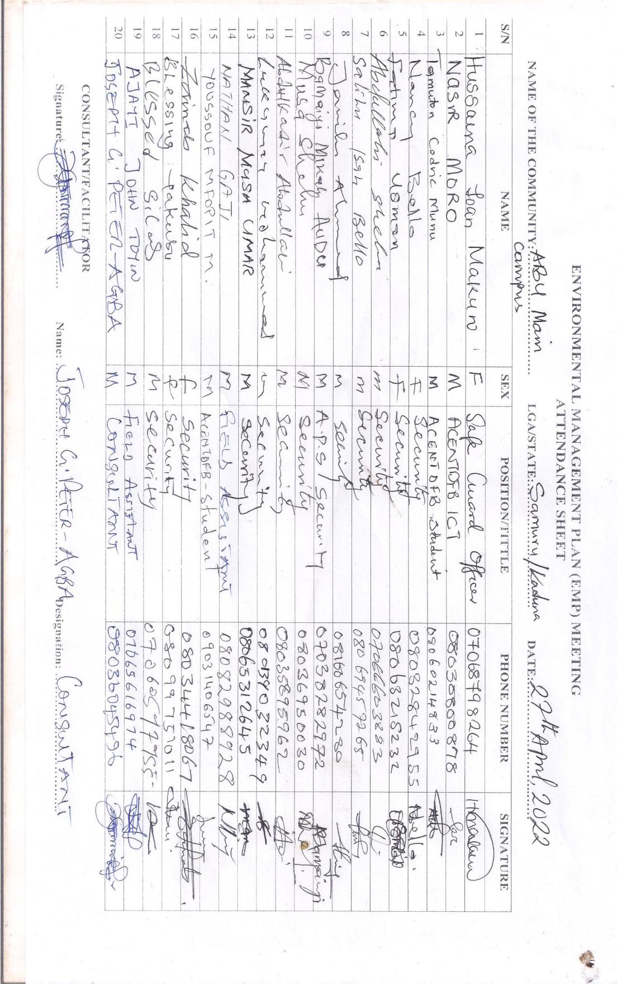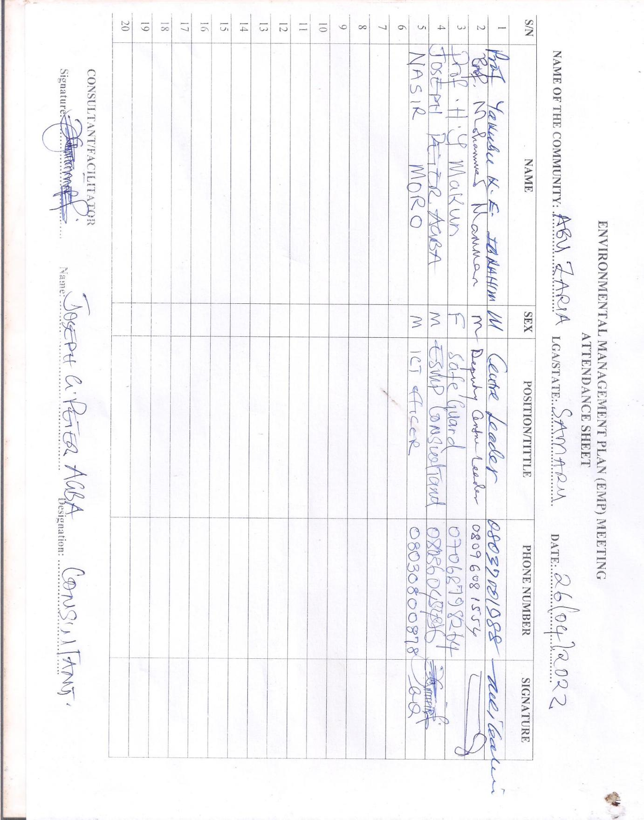Annex 1: Stakeholders Consultation Attendance Sheet

*Annex 2: Consultation programme Photos*

|  |  |
| --- | --- |
| Consultant having consultation with stakeholders | Consultant having consultation with the physical planning officer |
| Consultant having consultation with staff of PG hostel near the site | Consultant having consultation with security personnel |
| New post-graduate hostel for foreign students | Non-functional central sewage chamber on the site |

Annex 3: Assessment Instrument

**Environmental and Social Management Plan for the Construction Forensic Laboratories and Administrative Offices for Africa Centre of Excellence for Neglected Tropical Diseases and Forensic Biotechnology (ACENTDFB) Main Campus, Samaru, Zaria**

ANY INFORMATION PROVIDED HERE IS STRICKLY FOR THE PURPOSE OF THIS STUDY AND HIGHLY CONFIDENTIAL.

**PARTC: Socio-Economic Attributes of the Community**

**PARTA: General information**

1. Name of Household Head/Department…………………………………………………………………...
2. Name of Respondent………………………………………………………………………………………
3. Relationship of Respondent to Household Head/Department……………………………………………...
4. House/Office Address……………………………………………………………………………………
5. Sex Respondents a. Male( ) b. Female( )
6. Age of Respondents……………….
7. Marital Status of Respondents a. Single( ) b. Married( ) c. Divorced( ) d. Widow/Widower( )
8. How long have you lived/worked in this community………………………….?
9. Specify any society, group or association which you belong to within your community…...…………

……………………………………………………………………………………………………

1. How many persons live in your Household (i.e., Eat from the same pot)…………
2. How many persons/staff in your department falls into the following age categories?

|  |  |  |  |
| --- | --- | --- | --- |
| Categories | Male | Female | Total |
| 0-4yrs |  |  |  |
| 5-9yrs |  |  |  |
| 10-14yrs |  |  |  |
| 15-19yrs |  |  |  |
| 20-24yrs |  |  |  |
| 25-29yrs |  |  |  |
| 30-34yrs |  |  |  |
| 35-39yrs |  |  |  |
| 40-44yrs |  |  |  |
| 45-49yrs |  |  |  |
| 50-54yrs |  |  |  |
| 55-59yrs |  |  |  |
| 60-64yrs |  |  |  |
| 65-above |  |  |  |
| Total |  |  |  |

1. What is your highest educational qualification? a. WASC/SSCE ( ) b. TCII/OND ( ) c. HND/Degree ( ) d. M.Sc./PhD e. others (specify)……………………………
2. Main Occupation/Job Description of house hold respondents…………………………………………

16. What is your Annual Income? i)~~N~~0–50,000…… (ii)~~N~~51,000-100,000……. iii)~~N~~100,101-500,000…… iv)~~N~~500,000andabove……

**If Not Known**, what is your Monthly income……………….**OR** Daily income…………….

17. Estimate the monthly/annual income of other members of your household. i)~~N~~0–50,000…… ii)~~N~~51,000-100,000…… iii)~~N~~100,101-500,000… iv)~~N~~500,000andabove…….

**Part D: Availability of Amenities**

18. How would you describe the condition of the following amenities in your community?

|  |  |  |  |  |  |
| --- | --- | --- | --- | --- | --- |
|  | Excellent | Very Good | Good | Fair | Poor |
| Roads to the community |  |  |  |  |  |
| Roads within the community |  |  |  |  |  |
| Schools in the community |  |  |  |  |  |
| Public Health Institutions |  |  |  |  |  |
| Potable Water |  |  |  |  |  |
| Public Electricity |  |  |  |  |  |
| Communication facilities (Postal Service, Telephone) |  |  |  |  |  |
| Public recreation facilities |  |  |  |  |  |

19. What is the major source of water available to your household? **(Please Tick One)**

i. River…………………… ii. Borehole (commercial)……………

iii. Pond……………………… iv. Borehole (private)………………

v public pipe-borne water………… vi. Water Vendor……………….

vii Well water………….**(Please Tick One)**

20. If a public pipe borne water, how regular does the tap flow in a week? a. Regularly ( ) b. Occasionally ( ) c. Rarely( )

21. How long does it take you in minutes/hours to get to your water source………………………………

22. How much do you spend/pay in a month for water bill …………………………………..

23. Estimate the number of gallons (20litres) of water you use in your household daily?………………….

24. What is the primary source of electricity/light to this community?**(Please Tick One)**

1. Hurricane Lamp……… ii) Private Generators…………………………………
2. Community Generators………iv) State Government Utilities Board…………………
3. Company Operating in your community…….vi) PHCN (National Grid)……………..

25. What is the **main** secondary source of electricity?**(Please Tick One)**

* 1. Hurricane Lamp……………ii) Private Generators…………
  2. Community Generators………iv)Company Operating in your community………

26. What is the **main** fuel you use for cooking?**(Please Tick One)**

i) Firewood……………. ..ii) Charcoal…………..

1. Kerosene/Oil………. iv) Gas……………

v) Electricity…………… .vi) Crop residue/Sawdust……………

1. Animal Wastes……… .viii) Others

27. What type of toilet facility do you use?**(Please Tick One)**

i) Pit………………ii) Bush…………

1. Prier Head………iv) Bucket…………

v) Water Closet……vi) Others (Specify)……

28. How do you dispose your household/office waste?

i) Burying………………ii) Bush…………

* 1. Burning……… iv) Open dump…………

v) Organized collection……vi) Others (Specify)……

**29. Please, kindly tick the availability of the existing facilities in the community listed below;**

|  |  |
| --- | --- |
| **Items** | **Tick** |
| * Nursery school |  |
| * Primary |  |
| * Secondary |  |
| * Tertiary |  |
| * Worship Centers |  |
| * Shops/minimart |  |
| * Business Centre |  |
| * Others(Specify) |  |

30. Comment on major environmental issues affecting the community………………………………………

……………………………………………………………………………………………………………….

31. What do you think are the likely environmental problems to be caused by this project? a. Noise pollution() b. Air pollution() c. Vegetal loss() d. Water pollution e. wildlife disturbance()Waste generation

32. Comment on any environmental issues recorded during the course of construction within the community in the past five (5) Years.…………………………………………………………………………………….

………………………………………………………………………………………………………………..

33. Is the community faced with security challenges? (a) Yes ( ) b no ()

34. If yes, are there any insecurity issues within the project area? a yes( ) b no( )

35. If yes, what effort are they making in eradicating the insecurity problems?

.....................................

36. What are the social problems to be experience as a result of the project? A………

b………………c…………………….d.…………………

37. What are the common diseases that are prevailing in your community? a Malaria Fever() b. Typhoid Fever() c. Cholera() d. Others specify………………

38. Have you had outbreak of any of the communicable diseases such as; a.Cholera () b.Covid-19() c.Ebola() d. Others specify………

39. Have you ever heard of any of the diseases listed below? If Yes()

1. African trypanosomiasis
2. Lymphatic Filariasis(LF)/Onchocerciasis,
3. Rabies
4. Dengue fever
5. Schistosomiasis
6. Trachoma

40. Have you ever had contact/any person contacted such before? If Yes()

41. Where has him/her been treated? a. Hospital () b. Clinic () c. Herbal () d. Others specify…..

Thank you.

Annex 4: Physiochemical and microbiological characteristics of soil of proposed site for

|  |  |  |  |  |
| --- | --- | --- | --- | --- |
| S/N | Particular size distribution $(\%)$ | Top Soil | Sub soil | FMENV LMT |
| 1 | Clay | 1.64 | 2.64 | N/A |
| 2 | Silt | 21.56 | 20.56 | N/A |
| 3 | Sand | 76.80 | 70.80 | N/A |
| 4 | TC | LS | LS | N/A |
| 5 | PH in H20 | 6.75 | 5.60 | 6.5-8.5 |
|  | PH in 0.01/m Cacl2 | 6.35 | 6.20 | - |
| 6 | 0/0 O.C | 1.805 | 1.152 | - |
| 7 | 0/0 TN | 0.266 | 0.140 | - |
| 8 | AV P mg/kg | 0.16 | 9.82 | <40 |
| 9 | Ca Cmold kg | 2.304 | 1.590 | 500 |
| 10 | Mg Cmold kg | 0.732 | 0.478 | 150 |
| 11 | K Cmold kg | 0.177 | 0.171 | 150 |
| 12 | Na Cmold kg | 0.971 | 0.968 | 100 |
| 13 | EA Cmold kg | 0.815 | 1.002 | - |
| 14 | ECEC Cmold kg | 5.019 | 3.209 | - |
| 15 | Zn mg/kg | 18.74 | 17.64 |  |
| 16 | Fe mg/kg | 56.545 | 16.33 | <50 |
| 17 | Mn mg/kg | 13.18 | 27.35 | 150 |
| 18 | Cu mg/kg | 3.78 | 3.65 |  |
| 19 | Pb mg/kg | 0.03 | 0.01 | 2 |
| 20 | As mg/kg | ND | ND | - |
| 21 | Ec ds/m | 0.0615 | 0.0312 | - |
| 22 | CD mg/kg | ND | 0.03 | 2 |
| 23 | %MC | 3.34 | 5.21 | - |
| 24 | HB | <6.0x103 | 3.8x103 | <9.0x103 |
| 25 | HUB | 5.1x103 | 3.3x103 | 5-5.5x103 |
| 26 | HF | 2.6x103 | 1.9x103 | 0-3.9x103 |
| 27 | HUF | 5.1x103 | 3.3x103 | 0-9.0x103 |
| 28 | TPH | 9.04 | 6.32 | 1000 |

**Source: Field Survey, April 20th , 2022.**

Annex 5: Physiochemical and Microorganism Characteristic of Water (Ground Water and Surface Water) Within the Proposed Site

|  |  |  |  |  |
| --- | --- | --- | --- | --- |
|  | PARAMETERS  Temperature oc  PH  TDS ppm  Turbidity NTU  Alkalinity mg/L  Chloride mg/L  Sulphate mg/L  Nitrate mg/L  Nitrite mg/L  Cadmium mg/L  Mg mg/L  Lead mg/L  Zinc mg/L  Iron mg/L  Calcium mg/L  Sodium mg/L  Potassium mg/L  BOD5  COD  DO  MPN/100ml  E.coli spp  Salmonella spp  Shigella spp. | GROUND H20  27.2  6.90  95  1.35  60  51.85  0.83  5.44  0.21  ND  2.72  0.33  ND  3.43  25.54  12.32  8.20  0.94  3.12  2.55  128  Absent  Absent  Absent | SURFACE  26.9  6.90  38  7.26  125  33.88  0.74  3.83  0.46  0.02  3.09  0.24  ND  1.40  50.5  28.93  40.11  7.62  18.56  5.18  600  Present  Present  Present | FMT LIMIT  <40  6.5-8.5  500  5  250  500  10  1  0.00  10  100  <1  10  100  200  =  10  8.0  7.5  400  Absent  Absent  Absent |

**Source: Field Survey Result , May, 2022.**

Annex 6: Waste Management Plan

A Waste Management Plan (WMP) plays a key role in achieving sustainable waste management. The purpose of this plan is to ensure that effective procedures are implemented for the handling, storage, transportation and disposal of waste that is generated from the activities on site. The plan prescribes measures for the collection, temporary storage and safe disposal of the waste streams associated with the project and includes provisions for the recovery, re-use and recycling of waste.

This WMP has been compiled as part of the project Environmental Management Programme (EMPr) and includes waste stream information available at the time of compilation. Construction practices and operations must be measured and analyzed in order to determine the efficacy of the plan and whether further revision of the plan is required. This plan should be further updated should further detail regarding waste quantities and categorization become available, during the construction and/or operational stages.

Waste generated on site, originates from various sources including:

* Concrete waste generated from foundations.
* Contaminated water, soil and vegetation due to accidental hydrocarbon spills.
* Hydrocarbon waste from vehicle, equipment and machinery parts (oil cans, filters, rags etc), and servicing.
* Recyclable waste in the form of paper, nylon, electronic materials, cardboard, glass, metal offcuts, wood/ wood pallets and plastic.
* Organic waste from food waste and alien vegetation removal. Sewage from portable toilets.
* Inert waste from excess rock and soil from site clearance and trenching works.

**Regulatory Framework**

ACENTDFB is committed to complying with main legislative frameworks for management of wastes in Nigeria which include the following:

* Environmental Impact Assessment Act, (EIA Act CAP E12 LFN, 2004).
* National Environmental Standards & Regulations Enforcement Agency (NESREA) Act, 2007
* National Policy on Environment (Revised), 2016
* Harmful Waste (Special Criminal Provisions etc) Act CAP HI LFN 2004

**The integrated waste management approach to waste**

* Reducing volumes of waste is a priority.
* If reduction is not feasible, the maximum amount of waste is to be recycled; and
* Waste that cannot be recycled is to be disposed of in the most environmentally responsible manner as possible.

**Construction phase**

A plan for the management of waste during construction is detailed below. As previously stated, construction practices must be measured and analysed in order to determine the efficacy of the plan and whether further revision of the plan is required. A Method Statement detailing specific waste management practices during construction should be prepared by the Contractor prior to the commencement of construction.

**Waste Assessment / Inventory**

* The Environmental Officer must develop, implement and maintain a waste inventory reflecting all waste generated during construction for both general and hazardous waste streams.
* Construction method and materials should be carefully considered in view of waste reduction, re-use, and recycling opportunities.
* Once a waste inventory has been established, targets for recovery of waste (minimization, re-use, recycling) should be set.

**Waste collection, handling and storage**

* Each subcontractor must implement their own waste recycling system, i.e. separate bins for food waste, plastics, paper, wood, glass cardboard, metals, etc. Portable toilets must be monitored and maintained daily.
* Below ground storage of septic tanks, if installed, must withstand the external forces of the surrounding environment. The area above the tank must be demarcated to prevent any vehicles or heavy machinery from driving around the area.
* Waste collection bins and hazardous waste containers must be provided by the principal contractor and placed at various areas around site for the storage of organic, recyclable and hazardous waste.
* A dedicated waste area must be established on site for the storage of all waste streams, before removal from site.
* Signage/colour coding must be used to differentiate disposal areas for the various waste streams (i.e. paper, cardboard, metals, food waste, glass etc.).
* Hazardous waste must be stored within a bonded area constructed according to Nigeria Federal Ministry of Environment requirements. The volume of waste stored in the bunds must not exceed 110% of the bund capacity.
* The location of all temporary waste storage areas must aim to minimize the potential for impact on the surrounding environment, including prevention of contaminated runoff, seepage, and vermin control.
* Waste storage shall be in accordance with all Regulations and best-practice guidelines and under no circumstances may waste be burnt on site.
* Vegetation removed from the site must be chipped, removed from the site and disposed of at an appropriate waste disposal facility or used as mulch on site.
* A dedicated waste management team must be appointed by the principal contractors’ EO, whom will be responsible for ensuring the continuous sorting of waste and maintenance of the area. The waste management team must be trained in all areas of waste management and monitored by the EO.
* All waste removed from site must be done so by a registered/ licensed subcontractor, whom must supply information regarding how waste recycling/ disposal will be achieved. The registered subcontractor must provide waste manifests for all removals at least once a month.

**Management of waste storage areas**

* The position of all waste storage areas must be located away from water courses and ensure minimal degradation to the environment. The main waste storage area must have a suitable storm water system separating clean and dirty storm water.
* Waste storage areas must be under roof or the waste storage containers must be covered with tarpaulins (or similar material) to prevent the ingress of water. Collection bins placed around site and at subcontractors’ camps must be maintained and emptied on a regular basis by the principal contractor.
* Waste must be stored in designated containers and not on the ground.
* Inspections and maintenance of bunds must be undertaken daily. Bunds must be inspected for leaks or cracks in the foundation and walls.
* It is assumed that any rainwater collected inside the bund is contaminated and must be removed and stored as hazardous waste, and not released into the environment. If any leaks occur in the bund, these must be removed immediately.

**Disposal**

* Waste generated on site must be removed on a regular basis, as determined by the EO. This frequency may change during construction depending on waste volumes generated at different stages of the construction process.
* Waste must be removed by a suitably qualified contractor and disposed at an appropriately licensed landfill site. Proof of appropriate disposal must be provided by the contractor.

**Record keeping**

The success of the waste management plan is determined by measuring criteria such as waste volumes, cost recovery from recycling, cost of disposal. Recorded data can indicate the effect of training and education, or the need for education.

It will provide trends and benchmarks for setting goals and standards. It will provide clear evidence of the success or otherwise of the plan.

* Documentation (waste manifest, certificate of issue or safe disposal) must be kept detailing the quantity, nature, and fate of any regulated waste for audit purposes.
* Waste management must form part of the monthly reporting requirements in terms of volumes generated, types, storage and final disposal.

**Training**

Training and awareness regarding waste management shall be provided to all employees and contractors as part of the toolbox talks or on-site awareness sessions.

**Operational Phase**

It is expected that the operational phase will result in the production of general waste consisting mostly of cardboard, paper, plastic, tins, metals and a variety of synthetic compounds. Limited hazardous wastes (grease, oils) may also be generated during maintenance activities. All waste generated will be required to be temporarily stored at the facility in appropriate sealed containers prior to disposal at a permitted landfill site.

The following waste management principles apply during the operational phase:

* The Environmental safeguard officer and Site Manager must develop, implement and maintain a waste inventory reflecting all waste generated during operation for both general and hazardous waste streams.
* Adequate waste collection bins at site must be supplied. Separate bins should be provided for general and hazardous waste.
* Recyclable waste must be removed from the waste stream and stored separately.
* All waste must be stored in appropriate temporary storage containers (separated between different operational wastes, and contaminated or wet waste) at each operational area prior to being taken to the waste storage area for final sorting (if required). Waste storage shall be in accordance with all best-practice guidelines and under no circumstances may waste be burnt on site.
* Vegetation removed from the site must be chipped, removed from the site and disposed of at an appropriate waste disposal facility or used as mulch on site.
* Waste generated on site must be removed on a regular basis throughout the operational phase.
* Waste must be removed by a suitably qualified contractor and disposed at an appropriately licensed landfill site. Proof of appropriate disposal must be provided by the contractor.

**Monitoring of Waste Activities**

Records must be kept of the volumes/ mass of the different waste streams that are collected from the site throughout the life of the project. The appointed waste contractor is to provide monthly reports to the operator containing the following information:

* Monthly volumes/ mass of the different waste streams collected.
* Monthly volumes/ mass of the waste that is disposed of at a landfill site; Monthly volumes/ mass of the waste that is recycled; and
* Data illustrating progress compared to previous months.

This report will aid in monitoring the progress and relevance of the waste management procedures that are in place.

Laboratory Waste Management differs in nature and procedure, because all anatomical waste requires special handling and packaging. Cold storage is necessary for non-preserved anatomical waste to minimize odours and leakage problems. Biomedical laboratory and veterinary research operations also generated anatomical waste such as pathological specimens and animal carcasses. Studies of animal and human infections may generate infectious anatomical waste.

The most important precautions for all personnel handling infectious waste are the wearing of protective gloves and frequent hand washing. Gloves and a laboratory coat are recommended for all activities involving manipulations of contaminated items. Gloves and clothing should be changed when soiled or damaged. Thorough hand washing is recommended after working with infectious materials. Scavenging through waste, as well as eating, drinking, and smoking while working with waste, must be prohibited.

The table below shows how this waste generated will be managed.

|  |  |  |
| --- | --- | --- |
| **Waste Category** | **Action** | **Timing** |
| Vegetative Waste | Liaise with PPMSD/KDSEPA for onsite waste removal | Pre-construction |
| Construction Waste | Implement good waste management practices: sorting, storage and timely evacuation of waste  Liaise with recyclers of e-wastes  Chemical waste should be properly labelled, well covered and stored | Construction |
| Operation and Maintenance |
| Gaseous Emissions | Undergo vehicle emission testing (VET) and vehicle exhaust screening (VES). | Pre-construction |
| Construction |
| Liquid Waste | Site oil and lubricants should be kept on an impervious base and should have drip pans | Pre-construction |
| Construction |
| Sanitary Waste | Contractors to make provision for male and female toilet facilities with locks for workers | Pre– Construction |
| Construction |
|  |  |  |

*All costs have been embedded in the ESMP Matrix table

**NB:** Laboratory Waste Management Plan need to be developed during commissioning

Annex 7: Traffic Management Plan

The objective of this TMP is to provide safe passage for community members, pedestrians, motorcyclist, cyclists and vehicular traffic in the project areas during the construction.

The Contractor should designate a TMP Supervisor who will oversee traffic management along major roads within the project corridors.

The following are the minimum requirements for traffic management on the project:

1. **Design and layout of Road Systems**

The contractor in conjunction with the community, ACENTDFB Project and FRSC must: -

a) Plan traffic routes to give the safest route between places within the project route

b) Make traffic routes wide enough for safe movement of the largest vehicle using them.

c) Ensure all drops and falls are adequately protected.

d) Avoid traffic routes passing close to vulnerable areas such as fuel tanks.

e) Ensure there are designated safe areas for loading, unloading and plant maintenance.

f) Avoid sharp corners or blind bends, if these cannot be avoided install mirrors.

g) Road crossings and junctions, should be clearly signed and marked.

h) Make entrances and gates wide enough.

i) Set speed limits and clearly mark on traffic routes; (5mph).

j) Give prominent warning of limited headroom and overhead cables.

1. Liaisons with Government Traffic Agencies

The TMP will ensure liaisons with the FRSC at the FCT level. In situations where heavy traffic impacts are envisaged, the Contractor will liaise with the FRSC to ensure traffic coordination and mitigate adverse traffic impacts.

1. **Pedestrians**

a) Provide separate routes for pedestrians and where needed provide suitable barriers.

b) If traffic routes are used by both pedestrians and vehicles they should be wide enough.

c) Provide suitable well marked crossing points.

| S/N | Aspects | Descriptions | Responsible Party |
| --- | --- | --- | --- |
| 1 | Traffic/Safety Signage | * Safety signage should be put at strategic locations (in such a manner not to become a possible hazard to workers, community members or vehicles) to warn road users of the ongoing construction activities, especially at the FMC junction, EFCC HQ Junction and within the ABU MAIN CAMPUS premises. | Contractor |
| 2 | Movement of Vehicles and Equipment | * Limit movement to off-peak hours (peak hours are: 7:30AM – 10:00AM; and 4:00PM – 5:30PM; Mondays – Fridays). * Enforce speed limit. * Ensure vehicles and equipment are parked at designated areas ONLY. * The contractor must ensure that trucks carrying sand/soil to and from the sites are well covered in order not to cause injury to the public. | Contractor |
| 3 | Training | * Hire drivers with appropriate driver’s license. * Liaise with FRSC to train drivers * As part of refresher course for construction workers, train drivers on defensive driving and enforce speed limits | Contractor |
| 4 | Communication | * All Traffic and Safety signages should be boldly written in English & local languages. * Any incident/ accidents should be reported immediately to the ACENTDFB Project within 24hrs. The Project will also report to the WB within 48hrs including immediate action taken | Contractor  ACENTDFB  Contractor |
|  | **Cost** | **All actions and costs have been embedded in the ESMP Matrix Table** | |

Annex 8: Security Plan

The project team led by the Site Project Manager shall ensure that adequate security arrangements are made to handle security-related issues effectively. The project team will identify, evaluate and manage the risks to personnel and property arising from routine operations, malicious practices, crime, civil disorder or armed conflict. Security is one of the greatest challenges to any project development, security management plan becomes fundamental to this project.

In addition, each contractor will be required to prepare a Project Site Security Plan and submit it to ACENTDFB for review and approval before mobilization to site. The project team will also organize a security workshop in collaboration with the ABU Security department to identify, evaluate and recommend contingency plans for all security risks. A Site Security Officer would be engaged at the site, after the completion of the project, the entire security operation would be handed over to the ABU Security department.

# Annex 9: Occupational Health and Safety (OHS)

This plan is developed to meet up with OHS standards and to achieve the objectives set for the project. The project team shall undertake to ensure high performance standards and conformity with contract requirements by managing the works in a systematic and thorough manner.

* ***Competency***

All personnel required to operate or work with any equipment or machine must be competent, be tested for each equipment that he/she shall be operating. All personnel who as part of their profession require licensing or certification must obtain the necessary certification before he/she shall be allowed to work on the site.

* ***Fitness***

All personnel working on site shall be required to be certified medically fit to do so by an approved medical facility or Medical Doctor (pre-employment medical examination)

* **HSE TRAINING**
  + **Induction/Orientation**

Every new or rehired employee and Subcontractors employees must undergo mandatory OHS orientation / induction. The purpose of the Induction is to educate workers and make them aware of the major potential hazards he or she shall come into contact with while working on the site; also, it is one more opportunity to stress the importance of HSE being the first priority in the operations.

The content of the HSE orientation / induction shall cover the following subjects:

* Site safety rules.
* Personnel protective equipment requirements (PPE).
* Environmental sensitivity and protection.
* Preparation and planning of the job (Daily Pre-task talk).
* Emergency plan and muster points.
* SEA/SH and GBV prevention strategies
* COVID-19 prevention strategies
  + ***Project Specific HSE Training***

In addition to the HSE orientation /induction, there shall be specific site HSE trainings which shall cover the following topics:

* Manual handling.
* Electrical Safety
* Emergency Prevention, Preparedness and Response
* Work at height training
* First Aid training ( for site First Aiders)
* Lifting and Rigging
* Safe Driving techniques (for drivers)
  + ***Emergency Preparedness and Response***

Emergency procedures and evacuation plan shall be developed by the HSE Department and displayed on the notice board. These procedures shall be communicated to all staff. Also there shall be at least a trained first aider at all times.

* **HSE IMPLEMENTATION AND PERFORMANCE MONITORING**
  + ***HSE Meetings***

HSE management meetings shall be held once a month. The meeting is to help identify safety problems, develop solutions, review incident reports, provide training and evaluate the effectiveness of our safety program. Some of the meetings shall be:

* Project/Site Management HSE Meeting for management and supervision (Monthly).
* Tool box talk meetings for all workforce (Weekly).
* Pre-task briefing for all workforces (Daily).
* Special situation meeting (As required).
  + ***HSE Reporting***

All incidents and illnesses must be reported to site supervisor after which investigation shall commence and recorded so that appropriate corrective actions shall be implemented to prevent any re-occurrence and report findings shall be forwarded to management for review.Reporting requirements shall include notification of incident, investigation report, and monthly report. Notification of Incident form shall be developed which shall be filled and submitted to HSE department for investigation.

* ***HSE Inspection and Audits***

For continual improvement of HSE management system, HSE inspection and audit shall be conducted. An inspection checklist shall be developed. This is to ensure that the HSE management system is being adhered to. The inspection shall be conducted by the HSE department together with site management.

**Corrective and Preventive Actions and Non-Conformities**

During the cause of inspections, concerns raised shall be addressed and closed out. It is expected that in a period of two weeks, a close out inspection shall take place to verify that the corrective actions have been closed.

***Project HSE Rules***

The project HSE rules shall be developed and supervision shall develop specific rules and procedures when necessary.

The following site rules shall be implemented at all times. The Site Manager shall draw these rules to the attention of their own workmen or staff. All sub-contractors must ensure that these rules are drawn to the attention of their workmen and staff.

The Principal Contractor may implement additional site rules during the contract programme. Any such additional rules shall be notified to all personnel engaged on the project prior to their implementation. The HSE rules shall include but not limited to:

1. Personal Protective Equipment must be worn at all times.
2. All instructions issued by the Site Manager regarding the storage, handling or cleaning of materials, plant and equipment must be followed.
3. All vehicles must be parked in the designated areas.
4. Any workman suffering from a medical condition that might affect his work and/or that could require specific medical treatment must inform the supervisor before commencing work.
5. All site tools shall either be battery operated or 110 volts.
6. No one shall be permitted on site if it is believed that they are under the influence of alcohol or drugs.
7. Vehicles must not reverse without a banks man in attendance.
8. All visitors to site must undergo a site-specific induction and operative Identity badges must be worn at all times.
9. All excavations must be secured.
10. Smoking and eating shall only be permitted in the designated area. This area shall be identified during induction.
11. No hot works operations are permitted without a hot work permit in place.
12. There shall be no radios or other music playing devices on site.
13. Good housekeeping practices to be adopted**.**
14. Compliance with all Ethical Power Permit to Work systems
15. The site keyed access procedure must be strictly adhered to.
16. All Contractors must comply with Site Health & Safety Guidelines / Site Safety Method Statement
17. No untrained worker shall be permitted to operate heavy machineries.
18. COVID-19 protocols to be adhered to including frequent hand washing, use of nose masks when in crowded spaces, timely reporting of any symptoms to HSE officer and immediate isolation

***Safe Work Practices/Personal Protective Equipment (PPE)***

* The basic PPE required for the project shall be Safety Glasses, Safety Boots, Hand Gloves, Hard Hat, ear plugs and Coverall. Any other PPE shall be used as applicable. Management is responsible for the provision of PPE and usage shall be enforced at all time.
* PPE shall be provided in circumstances where exposure to hazards cannot be avoided by other means or to supplement existing control measures identified by a risk assessment. An assessment shall be made to ensure that the PPE is suitable for purpose and is appropriate to the risk involved.
* Information, instruction & training shall be given to all employees on safe use, maintenance and storage of PPE. Employees shall, in accordance with instructions given, make full use of all PPE provided and maintain it in a serviceable condition and report its loss or defect immediately to the maintenance department where it shall be replaced.
* PPE shall be replaced when it is no longer serviceable and returned on a new for old basis. Employees shall sign to state that they have received PPE when issued.
* ***Welfare Facilities***

The provision of welfare facilities on the site shall be communicated to all operatives at site induction.

A cleaning regime shall be implemented and maintained for the duration of the construction phase to ensure the site welfare facilities remain in a clean and tidy condition.

Provisions for food and portable drinking water shall be made for all site workers

* ***Signage***

Adequate provision for warning and directional signs shall be made.

# Annex 10: Code of Conduct

**Contractor’s Company Code of Conduct**

1. The company is obliged to create and maintain an environment which prevents Gender Based Violence (GBV) and Sexual Exploitation & Abuse (SEA) issues. The company is also required to maintain an environment where the unacceptability of GBV and actions against children are clearly communicated to all those involved in the project. In order to prevent GBV and SEA, the following core principles and minimum standards of behavior will apply to all employees without exception:
2. GBV/SEA constitutes acts of gross misconduct and are therefore grounds for sanctions, penalties and/or termination of employment. All forms of GBV/SEA including grooming are unacceptable, be it on the work site, the work site surroundings, project neighborhoods or on site. Prosecution of those who commit GBV or SEA will be followed.
3. Treat women, children (persons under the age of 18), and men with respect regardless of race, colour, language, religion, political or other opinion, national, ethnic or social origin, property, disability, birth or other status.
4. Do not use inappropriate language or behavior towards women, children and men. This includes harassing, abusive, sexually provocative, derogatory, demeaning or culturally inappropriate words, gestures or actions.
5. Sexual activity with children under 18—including through digital media—is prohibited. Mistaken belief regarding the age of a child and consent from the child is not a defense.
6. Sexual favours or other forms of humiliating, degrading or exploitative behaviour are prohibited.
7. Sexual interactions between contractor’s and consultant’s employees at any level and member of the communities surrounding the work place that are not agreed to with full consent by all parties involved in the sexual act are prohibited. This includes relationships involving the withholding/promise of actual provision of benefit (monetary or non-monetary) to community members in exchange for sex – such sexual activity is considered “non-consensual” within the scope of this Code.
8. All employees are required to attend an induction training course prior to commencing work on site to ensure they are familiar with the GBV/SEA Code of Conduct.
9. All employees must attend a mandatory training course once a month for the duration of the contract starting from the first induction training prior to commencement of work to reinforce the understanding of the institutional GBV and SEA Code of Conduct.
10. All employees will be required to sign an individual Code of Conduct confirming their agreement to support GBV and SEA activities.

I do hereby acknowledge that I have read the foregoing Code of Conduct, do agree to comply with the standards contained therein and understand my roles and responsibilities to prevent and respond to GBV and SEA. I understand that any action inconsistent with this Code of Conduct or failure to take action mandated by this Code of Conduct may result in disciplinary action.

FOR THE COMPANY

Signed by ____________________

Title: _________________________

Date: _________________________

**Manager’s Code of Conduct**

Managers at all levels have particular responsibilities to create and maintain an environment that prevents GBV and SEA. They need to support and promote the implementation of the Company Codes of Conduct. To that end, Project Managers are required to sign up to Codes of Conduct applicable to their managerial duties within the context and also sign the Individual Codes of Conduct. This commits them to support and develop systems that facilitate the implementation of this action plan and maintain a GBV-free, child-safe and conflict-free work environment. These responsibilities include but are not limited to:

**Mobilization**

1. Establish a GBV/SEA Compliance Team from the contractor’s and consultant’s staff to write an Action Plan that will implement the GBV and SEA Codes of Conduct.
2. The Action Plan shall, as a minimum, include the
3. Standard Reporting Procedure to report GBV and SEA issues through the project Grievance Redress Mechanism (GRM);
4. Accountability Measures to protect confidentiality of all involved; and,
5. Response Protocol applicable to GBV survivors/survivors (including access to support coping and post-trauma management strategies) and perpetrators.
6. Engagement of the services of social service providers (NGOs) with requisite skill in the prevention and management of GBV and SEA.
7. Coordinate and monitor the development of the Action Plan and submit for review to the RAMP-PIU safeguards teams, as well as the World Bank prior to mobilization.
8. Update the Action Plan to reflect feedback and ensure the Action Plan is carried out in its entirety.
9. Provide appropriate resources and training opportunities for capacity building so members of the compliance team will feel confident in performing their duties. Participation in the Compliance tame will be recognized in employee’s scope of work and performance evaluations.
10. Ensure that contractor, consultant and client staff are familiar with the RAMP GRM and that they can use it to anonymously report concerns over GBV and SEA.
11. Hold quarterly update meetings with the compliance team to discuss ways to strengthen resources and GBV/SEA support for employees and community members.
12. In compliance with applicable laws and to the best of your abilities, prevent perpetrators of sexual exploitation and abuse from being hired, re-hired or deployed. Use background and criminal reference checks for all employees.
13. Ensure that when engaging in partnership, sub-grant or sub-recipient agreements, these agreements

a) Incorporate this Code of Conduct as an attachment;

b) Include the appropriate language requiring such contracting entities and individuals, and their employees and volunteers to comply with this Code of Conduct; and

c) Expressly state that the failure of those entities or individuals, as appropriate, to take preventive measures against GBV and SEA, to investigate allegations thereof, or to take corrective actions when GBV/SEA has occurred, shall constitute grounds for sanctions and penalties.

**Training**

1. All managers are required to attend an induction manager training course prior to commencing work on site to ensure that they are familiar with their roles and responsibilities in upholding the GBV/SEA Codes of Conduct.
2. Provide time during work hours to ensure that direct recruits attend the mandatory induction training which covers GBV/SEA training required of all employees prior to commencing work on site.
3. Managers are required to attend and assist with the NGO to facilitate monthly training courses for all employees. Managers will be required to introduce the trainings at the ABU Main campus as a result of consequential evaluations.
4. Collect satisfaction surveys to evaluate training experiences and provide advice on improving the effectiveness of training.
5. Prevention
6. All managers and employees shall receive a clear written statement of the company’s requirements with regards to preventing GBV/SEA in addition to the training.
7. Managers must verbally and in writing explain the company and individual codes of conduct to all direct recruits.
8. All managers and employees must sign the individual ‘Code of Conduct for GBV and SEA, including acknowledgment that they have read and agree with the code of conduct.
9. To ensure maximum effectiveness of the Codes of Conduct, managers are required to prominently display the Company and Individual Codes of Conduct in clear view in public areas of the workspace. Examples of areas include waiting, rest and lobby areas of sites, canteen areas, health clinics.
10. Managers will explain the GRM process to all employees and encourage them to report suspected or actual GBV/SEA
11. Mangers should also promote internal sensitization initiatives (e.g., workshops, campaigns, on-site demonstrations etc.) throughout the entire duration of their appointment in collaboration with the compliance team, service providers and in accordance to the Action Plan.
12. Managers must provide support and resources to the compliance tea and service provider NGOs to create and disseminate the internal sensitization initiatives through the Awareness-raising strategy under the Action Plan.

**Response**

1. Managers will be required to provide input, final decisions and sign off on the Standard Reporting Procedures and Response Protocol developed by the compliance team as part of the Action Plan.
2. Once signed off, managers will uphold the Accountability Measures set forth in the Action Plan to maintain the confidentiality of all employees who report or (allegedly) perpetrate incidences of GBV/SEA (unless a breach of confidentiality is required to protect persons or property from serious harm or where required by law).
3. Once a sanction has been determined, the relevant manager(s) is/are expected to be personally responsible for ensuring that the measure is effectively enforced, within a maximum timeframe of 14 days from the date on which the decision was made.
4. Managers failing to comply with such provision can be in turn subject to disciplinary measures, to be determined and enacted by the company’s CEO, Managing Director or equivalent highest-ranking manager. Those measures may include:

i. Informal warning

ii. Formal warning

iii. Additional Training

iv. Loss of up to one week’s salary.

v. Suspension of employment (without payment of salary), for a minimum period of 1 month up to a maximum of 6 months.

vi. Termination of employment.

I do hereby acknowledge that I have read the foregoing Code of Conduct, do agree to comply with the standards contained therein and understand my roles and responsibilities to prevent and respond to GBV and SEA. I understand that any action inconsistent with this Code of Conduct or failure to take action mandated by this Code of Conduct may result in disciplinary action.

FOR THE EMPLOYER

Signed by ____________________

Title: _________________________

Date: _________________________

**Individual Code of Conduct**

I, ______________________________, acknowledge that preventing gender-based violence (GBV) and violence against children (VAC) is important. The company considers that GBV or VAC activities constitute acts of gross misconduct and are therefore grounds for sanctions, penalties or potential termination of employment. All forms of GBV or VAC are unacceptable be it on the work site, the work site surroundings. Prosecution of those who commit GBV or VAC may be pursued if appropriate.

I agree that while working on the project I will:

* Consent to police background check.
* Treat women, children (persons under the age of 18), and men with respect regardless of race, colour, language, religion, political or other opinion, national, ethnic or social origin, property, disability, birth or other status.
* Not use language or behaviour towards women, children or men that is inappropriate, harassing, abusive, sexually provocative, demeaning or culturally inappropriate.
* Not participate in sexual contact or activity with children—including grooming or contact through digital media. Mistaken belief regarding the age of a child is not a defense. Consent from the child is also not a defense or excuse.
* Not engage in sexual favours—for instance, making promises or favorable treatment dependent on sexual acts—or other forms of humiliating, degrading or exploitative behavior.
* Unless there is full consent[3] by all parties involved, I will not have sexual interactions with members of the surrounding communities. This includes relationships involving the withholding or promise of actual provision of benefit (monetary or non-monetary) to community members in exchange for sex—such sexual activity is considered “non-consensual” within the scope of this Code.
* Attend and actively partake in training courses related to HIV/AIDS, GBV and VAC as requested by my employer.
* Consider reporting through the GRM or to my manager any suspected or actual GBV or VAC by a fellow worker, whether employed by my company or not, or any breaches of this Code of Conduct.

**With regard to children under the age of 18:**

* Wherever possible, ensure that another adult is present when working in the proximity of children.
* Not invite unaccompanied children unrelated to my family into my home unless they are at immediate risk of injury or in physical danger.
* Not sleep close to unsupervised children unless absolutely necessary, in which case I must obtain my supervisor's permission, and ensure that another adult is present if possible.
* Use any computers, mobile phones, or video and digital cameras appropriately, and never to exploit or harass children or to access child pornography through any medium (see also “Use of children's images for work related purposes” below).
* Refrain from physical punishment or discipline of children.
* Refrain from hiring children for domestic or other labour which is inappropriate given their age or developmental stage, which interferes with their time available for education and recreational activities, or which places them at significant risk of injury.
* Comply with all relevant local legislation, including labour laws in relation to child labour.

**Use of children's images for work related purposes**

When photographing or filming a child for work related purposes, I must:

* Before photographing or filming a child, assess and endeavor to comply with local traditions or restrictions for reproducing personal images.
* Before photographing or filming a child, obtain informed consent from the child and a parent or guardian of the child. As part of this I must explain how the photograph or film will be used.
* Ensure photographs, films, videos and DVDs present children in a dignified and respectful manner and not in a vulnerable or submissive manner. Children should be adequately clothed and not in poses that could be seen as sexually suggestive.
* Ensure images are honest representations of the context and the facts.
* Ensure file labels do not reveal identifying information about a child when sending images electronically.

**Sanctions**

I understand that if I breach this Individual Code of Conduct, my employer will take disciplinary action which could include:

* Informal warning.
* Formal warning.
* Additional Training.
* Loss of up to one week’s salary.
* Suspension of employment (without payment of salary), for a minimum period of 1 month up to a maximum of 6 months.
* Termination of employment.
* Report to the police if warranted.

*I understand that it is my responsibility to avoid actions or behaviors that could be construed as GBV or VAC or breach this Individual Code of Conduct. I do hereby acknowledge that I have read the foregoing Individual Code of Conduct, do agree to comply with the standards contained therein and understand my roles and responsibilities to prevent and respond to GBV and VAC. I understand that any action inconsistent with this Individual Code of Conduct or failure to take action mandated by this Individual Code of Conduct may result in disciplinary action and may affect my ongoing employment.*

Signature: _________________________

Printed Name: _________________________

Title: _________________________

Date: _________________________

Annex 11: Employer’s ESHS Requirements for Works

A. Overview

This section describes the Environmental, Social, Health and Safety (ESHS) requirements under the Works Contract. These requirements are to be implemented in accordance with site-specific Environmental and Social Management Plan (ESMP) for the works. The bidder shall prepare its bid to implement all measures necessary to avoid undesirable adverse environmental and social impacts wherever possible, restore work sites to acceptable standards, and abide by any environmental performance requirements specified in an ESMP. The bidder shall address these requirements in its ESHS Management Plans and Implementation Plans and plan to fully take into account specific site ESHS considerations. If there is failure to implement these ESHS requirements in the course of executing the works contract, the employer reserves the right to arrange through the Engineer for execution of the missing action by a third party on account of the Contractor.

B. Pre-Bid Environment, Social, Health & Safety Considerations

Prior to bid preparation, the bidder is expected to assess the Environment; Health & Safety plan specific to the requirements for the Work being bided for, taking into account the size and nature of the project as well as the nature and extent of potential Environmental, Social Health and Safety risks.

The Company’s assessment must include:

* A **“Hazard Assessment’’** of potential hazards associated with the Projects being bided for and formulated prevention control measures to address the identified hazards;
* List of equipment and resources required to perform the work in a manner that fulfills ESHS requirements of the works;
* Qualifications of Employees with the knowledge and skills to be used in performing the work in line with ESHS requirements;
* An understanding of the obligations expected of the Company in order to comply with the applicable Environment, Social, Health & Safety Acts, Regulations and procedures;
* A planned schedule for Environment, Social, Health & Safety inspections of the contract sites and facilities;
* Plan for reviewing, recording and reporting of Environment, Health & Safety related events that may arise in the Course of the Projects;
* Plan for reviewing Environment, Health & Safety performance measurement activities; and

C.1 Minimum Environmental, Social, Health and Safety outcomes

The bidder is expected to demonstrate capacity to produce sound ESHS results in the course of implementing the works in this contract. In general, the ESHS measures to be planned shall include shall include, but not limited to, those which will produce the following ESHS outcomes:

Reduction of Pollution Impacts: All works must be planned and implemented to minimize the effect of dust and noxious gases on the surrounding environment resulting from earth mixing sites, asphalt mixing sites, earth moving activities etc. to ensure safety, health and the protection of workers and communities living in the vicinity of project activities. All works must be planned and implemented to minimize noise levels emanating from machinery, vehicles and noisy construction activities (e.g., excavation, blasting) for the safety, health and protection of workers within the vicinity of high noise levels and nearby communities. All works must be planned and implemented to prevent oils, lubricants and wastewater used or produced during the execution of works from entering into rivers, streams and channels.

Restoration of Water Flow Regimes: All works must be planned and implemented in a manner that ensures that pre-existing water flow regimes in rivers and streams is maintained and/or re-established where they are disrupted due to works such as dredging, river draining etc. to be carried out.

Conservation of Natural Resources: All works must be planned and implemented to prevent and minimize the impacts of quarrying, earth borrowing, piling and building of temporary construction camps and access roads on the biophysical environment including protected areas and arable lands; local communities and their settlements. Such impacts shall be remedied to acceptable standards. Exploitation of natural resources such as hunting, fishing, collection of forest products or any other activity that might have a negative impact on the social and economic welfare of the local communities shall be avoided.

Ensure adequate Waste Management: All works must be planned and implemented to ensure that construction and other solid waste generated on all construction sites, site yards and workers’ camps are properly disposed. Sewage and wastewater from construction camps must also be satisfactorily managed through the provision of proper sanitation facilities on all premises under the works contract.

Reduce impact of construction activities on vehicular traffic, pedestrian movement and access within project corridors: All works must be planned and implemented to offset temporary disruptions to vehicular traffic and human movement. Temporary access facilities (roads, footbridges) shall be done in consultation with the local community especially in important or sensitive environments. They shall also be optimized to guarantee safety and protect users from freak accidents. Traffic management shall be inclusive of all relevant communal, local, state and federal institutions.

Ensure safety of workers and community residents: All works must be planned and implemented in a way that protects workers and residents of project areas from adverse impacts on their health and wellness. Work areas shall be cordoned off to prevent freak accidents. Workers shall use personal protective equipment such as safety boots, reflective jackets etc. Adequate road signs to warn pedestrians and motorists of construction activities, diversions, etc. shall be provided at appropriate points.

Community Health and Safety: All works must be planned and implemented in a way that guarantees the control of the spread of communicable diseases attributable to project staff: Workers and local residents shall be sensitized on health risks particularly of AIDS. Stagnant water in uncovered borrow pits shall be treated in the best way to avoid creating possible breeding grounds for mosquitoes, Work yards shall be organized in a way that prevents breeding of disease vectors.

8. Prohibition of all Forms of Forced of Harmful Child Labour

The Bidder shall not employ “forced or compulsory labor” in any form. “Forced or compulsory labor” consists of all work or service, not voluntarily performed, that is extracted from an individual under threat of force or penalty. In the course of the works contract, the firm shall not employ any child to perform any work that is economically exploitative, or is likely to be hazardous to, or to interfere with, the child's education, or to be harmful to the child's health or physical, mental, spiritual, moral, or social development.

9. Improving capacity for implementation of ESHS on Works Contract:

The Contractor shall provide sufficient training to his own personnel to ensure that they are all aware of the relevant aspects of these ESHS requirements, project ESIA/ESMP, and his own ESHS-MSIPs and are able to fulfil their expected roles and functions. Specific training should be provided to those employees that have particular responsibilities associated with the implementation of the ESHS-MSIPs.

General topics should be:

EHS in general (working procedures); emergency procedures; and social and cultural aspects (awareness rising on social issues)

Reduction of impacts of incoming workers: The works contract shall be planned and implemented in a way that reduces the temporary and permanent effects of incoming personnel into project beneficiary communities i.e., Labour Influx Impacts. Measures that will reduce conflict with host communities, reduce pressure on resources, reduce inflations of prices and promote social harmony will be required by the works contractor.

Avoidance of Gender Based Violence (GBV), Sexual Exploitation and Abuse (SEA) and Violence against Children (VAC): The works contract shall be planned and implemented in a way that addresses the risk of Gender Based Violence GBV (with zero tolerance), all forms of Sexual Exploitation and Abuse (SEA), Violence against Children (VAC), Alcohol and Substance abuse. The Bidder shall develop plans to mitigate such social risks at project execution sites. The Codes of Conduct and Action Plan for Preventing Gender Based Violence (GBV) and Violence Against Children (VAC) shall clearly define obligations on all project staff (including sub-contractors and day workers) with regard to implementing the project’s environmental, social, health and safety (ESHS) and help prevent, report and address GBV and VAC within the work site and in its immediate surrounding communities.

C. Other requirements that build on employer responsibilities

Avoidance of Impacts on Private Property: Except otherwise addressed by a Resettlement Plan implemented by the employer, the bidder’s plan must not include deliberate or accidental damage to private property. Such unplanned damage shall demand repair of the property to the owner’s satisfaction and at the contractor’s own cost. For each repair, the Contractor shall obtain from the owner a certificate that the damage has been made good satisfactorily in order to indemnify the employer from subsequent claims. In cases where compensation for inconveniences, land acquisition, damage of crops etc. are claimed by owner, the Employer has to be informed by the Contractor through the SE. This compensation is in general settled under the responsibility of the Employer before signing the Contract. In unforeseeable cases, the respective administrative entities of the Employer will take care of compensation.

Protection of cultural heritage: Upon discovery of ancient heritage, relics or anything that might or believed to be of cultural importance during the execution of works, the procedure for implementing the works contract is required to immediately report such findings through the process established by the employer aimed at protecting such cultural resources.

D. Contractor’s Environment and Social Management Plan (C-ESMP)

Within 6 weeks of signing the Contract, the successful bidder shall prepare a CESMP to ensure the adequate management of the environmental, social, health and safety (ESHS) aspects of the works, including implementation of the requirements of these ESHS requirements and any specific requirements of an Environmental and Social Management Plan (ESMP) for the works. The Contractor’s ESMP (C-ESMP) will serve two main purposes:

For the Contractor, for internal purposes, to ensure that all measures are in place for adequate EHS management,

As an operational manual for staff.

To ensure that the Contractor is fully prepared for the adequate management of the ESHS aspects of the project, and as a basis for monitoring of the Contractor’s EHS performance.

The Contractor’s ESMP shall provide at least: a description of procedures and methods for complying with these general environmental management conditions, and any specific conditions specified in an EMP; a description of specific mitigation measures that will be implemented in order to minimize adverse impacts; a description of all planned monitoring activities (e.g. sediment discharges from borrow areas) and the reporting thereof; and the internal organizational, management and reporting mechanisms put in place for such.

The Contractor’s ESHS-MP will be reviewed and approved by the Client before start of the works. It is expected to be reviewed every six months and every review will be reviewed and approved by the Employer. This review would ascertain that the Contractor’s ESMP covers all of the identified impacts, and has defined appropriate measures to counteract any potential impacts.

ESHS Payment Requirements

It is expected that compliance with these conditions is already part of standard good workmanship and state of art as generally required under this Contract. The item “Compliance with Environmental Management Conditions” in the Bill of Quantities covers this cost. No other payments will be made to the Contractor for compliance with any request to avoid and/or mitigate an avoidable EHS impact.

OR

The bidder will cost the delivery of the ESHS requirements as a subsidiary obligation covered under the prices quoted for other Bill of Quantity items. However, provisional sums will be set aside for specific activities such as ESMP Trainings, HIV counselling services/SEA awareness and sensitization as mandatory ESHS outcomes.

Incorporation of Environmental and Social Requirements into Contract Management

The findings of the environmental and social assessment will need to be mainstreamed into the entire process for managing the BRT project. The requirements include the following;

Pre-Award Considerations

Evaluation of the capacity of project bidders for implementation of ESHS requirements: The project proponent will undertake a due diligence on the capacity of potential contractors for the faithful execution of the ESHS requirements of the project. This shall include

A review of the Environmental, Social, health & Safety (ESHS) policy of bidding firms;

Due diligence of the circumstances necessitating the suspension or termination of previous contracts on the basis of non-compliance with ESHS requirements of contracts

A review of the academic qualifications and experiences of key staff proposed to man key ESHS implementation functions by bidding firms

Inclusion of a statement of ESHS requirements into bidding and contract documents: The findings of the environmental and social assessment undertaken will be inserted into the bidding documents in a systematic manner. This will include;

A statement of the outcomes of properly implemented ESHS measures (sampled included in annex)

An inclusion of particular conditions of contract or specific contract provisions to furnish specific considerations such as regulatory limits, target periods to General Conditions of Contract (GCCs) provisions.

Management Strategies and Plans for Identified ESHS Issues: Based on the environmental and social assessment which have been reduced into a concise statement of ESHS requirements of the project, the project proponent will request bidders to propose Management Strategies and Plans to address ESHS issues as part of their bids. The strategies will demonstrate the capacity and knowledge of the bidder to manage the identified risks, if successful.

Making provision in the Bill of Quantities (BoQ) of the project: This provision can be made in form of measured work items (in case of engineering mitigation measures) OR lump sum provisions (where the contractor is expected to propose costs based on his methodology) OR provisional sums (in case of mitigation measures which have been studies and cost by the client.

Inclusion of Supervisory Responsibility on ESHS issues into Terms of Reference of Supervision Firm: The proponent will include the qualifications, experience and responsibilities of E&S experts into the Terms of Reference of the Supervision Consultant’s team.

**Construction Phase**

Development Contractors ESMP: The proponent shall request the successful bidder to develop a detailed Cost Contractors ESMP based on the Management Strategies and Plans earlier detailed in the bids submitted. The C-ESMP will also contain all sub-plans stated in the environmental and social assessment carried out by the proponent such as the GBV Action Plan, Labour management procedures (LMP) manual, Traffic Management Plan, Occupational Health Management Plan etc. with specific details reflecting approved implementation methodology will be prepared and submitted for approval by the contractor.

Mobilization of ESHS Personnel: The contractor shall ensure that all personnel that are to implement the measures described in client’s E&S assessment and CESMP are available before construction works are initiated.

Training of on-site personnel: The personnel required for all construction and construction support services will be trained on the E&S requirements of the contract before works are launched.

Routine Monitoring of E&S Performance of Contracts: The monitoring plan described in this assessment will be implemented as scheduled. Data on identified monitoring indicators and other indicators that may be considered necessary will be collected by the various responsible persons.

Update of Contractors ESMP: In view of the dynamic nature of social risks of projects, the C-ESMP shall be reviewed and submitted for approval every six (6) months.

1. There are several forms of GBV, including i) intimate partner violence; ii) non-partner sexual abuse; iii) harmful practices; iv) human trafficking and v) child sexual abuse. It is expected that the country profile will highlight the most prevalent forms of GBV within each country. http://www.worldbank.org/content/dam/Worldbank/document/Gender/Arango%20et%20al%202014.%20Interventions%20to%20Prevent%20or%20Reduce%20VAWG%20-%20A%20Systematic%20Review%20of%20Reviews.pdf
2. National Environmental (Air Quality Control) Regulations, 2014
3. **Consent** is defined as the informed choice underlying an individual’s free and voluntary intention, acceptance or agreement to do something. No consent can be found when such acceptance or agreement is obtained through the use of threats, force or other forms of coercion, abduction, fraud, deception, or misrepresentation. In accordance with the United Nations Convention on the Rights of the Child, the World Bank considers that consent cannot be given by children under the age of 18, even in the event that national legislation of the country into which the Code of Conduct is introduced has a lower age. Mistaken belief regarding the age of the child and consent from the child is not a defense.